GCSE MATHEMATICS

Aiming for Grade 9

REVISION BOOKLET

Exam Dates:
________________
________________
________________

Name: ______________________________
Contents
Page:
Number:
Surds 3
Algebraic proofs 7

Algebra:
Transformations of graphs 12
Equations of circles 16
Quadratic and other sequences 18
Completing the square 21
Inverse and composite functions 24
Expanding more than two binomials 27
Nonlinear simultaneous equations 29
Solving quadratic inequalities 32

Shape, Space and Measure:
Circle theorems 34
Vectors 38
Sine and cosine rules 46
Area under graphs 50

Data Handling:
Histograms 55
Capture-Recapture 63

Probability:
Set theory 66

Ratio and Proportion:
Proportion 69
Percentages – reverse 73

Surds

Things to remember:
- √ means square root;
- To simplify surds, find all its factors;
- To rationalise the denominator, find an equivalent fraction where the denominator is rational.

Questions:
1. Work out
$\frac{(5 + \sqrt{3})(5- \sqrt{3})}{\sqrt{22}}$
Give your answer in its simplest form.

……………………………………
(Total 3 marks)

2. (a) Rationalise the denominator of $\frac{1}{\sqrt{3}}$

……………………………………
(1)
(b) Expand $(2+ \sqrt{3})(1+ \sqrt{3})$
Give your answer in the form $a+b\sqrt{3}$ where a and b are integers.

……………………………………
(2)
(Total 3 marks)
3. (a) Rationalise the denominator of $\frac{1}{\sqrt{7}}$

……………………………………
(2)
(b) (i) Expand and simplify ${(\sqrt{3}+ \sqrt{15})}^{2}$
Give your answer in the form $a+b\sqrt{3}$ where a and b are integers.

……………………………………

(ii) All measurements on the triangle are in centimetres.
ABC is a right-angled triangle.
k is a positive integer.
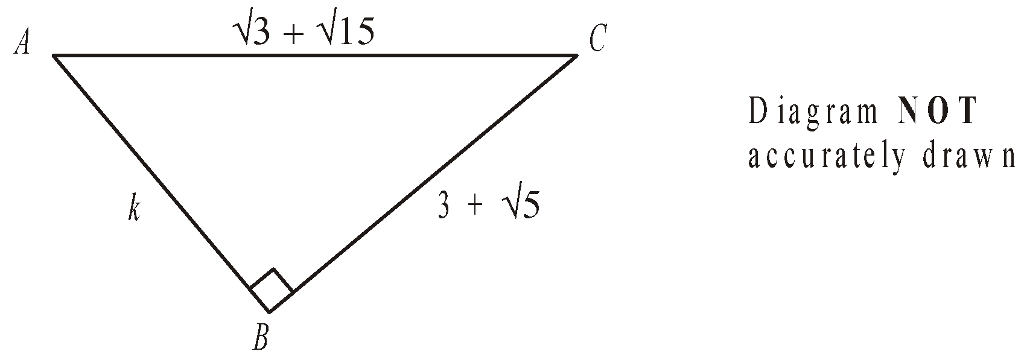

Find the value of k.

k = ……………………………………
(5)
(Total 7 marks)

4. Expand and simplify $(\sqrt{3}- \sqrt{2})(\sqrt{3}- \sqrt{2})$

……………………………………
(Total 2 marks)

5. (a) Write down the value of ${49}^{\frac{1}{2}}$
……………………………………
(1)
(b) Write $\sqrt{45}$ in the form $k\sqrt{5}$, where k is an integer.

……………………………………
(1)
(Total 2 marks)

6. Write $\frac{\sqrt{18} + 10}{\sqrt{2}}$ in the form $a+b\sqrt{2}$ where a and b are integers.

a = ……………………………………

b = ……………………………………
(Total 2 marks)

7. Expand and simplify $(2+ \sqrt{3})(7- \sqrt{3})$
Give your answer in the form $a+b\sqrt{3}$ where a and b are integers.

……………………………………
(Total 3 marks)

8. Rationalise the denominator of $\frac{(4 + \sqrt{2})(4 - \sqrt{2)}}{\sqrt{7}}$
Give your answer in its simplest form.

……………………………………
(Total for question = 3 marks)

9. Show that $\frac{(4 - \sqrt{3})(4 + \sqrt{3})}{\sqrt{13}}$ simplifies to $\sqrt{13}$

(Total for question = 2 marks)

Algebraic Proofs

Things to remember:
- Start by expanding the brackets, then factorise.
- Remember the following:
  - 2n 🡪 even number
  - 2n + 1 🡪 odd number
  - a(bn + c) 🡪 multiple of a
  - Consecutive numbers are numbers that appear one after the other.

Questions:
1. (a) Expand and simplify x(x + 1)(x − 1)

……………………………………
(2)
In a list of three consecutive positive integers at least one of the numbers is even and one of the numbers is a multiple of 3
n is a positive integer greater than 1
(b) Prove that n³ − n is a multiple of 6 for all possible values of n.

(2)
2⁶¹ − 1 is a prime number.
(c) Explain why 2⁶¹ + 1 is a multiple of 3

(2)
(Total for question = 6 marks)

2. Prove that
(2n + 3)² – (2n – 3)² is a multiple of 8
for all positive integer values of n.

(Total for Question is 3 marks)

3. (a) Expand and simplify (y − 2)(y − 5)

...........................................................
(2)
*(b) Prove algebraically that
(2n + 1)² − (2n + 1) is an even number
for all positive integer values of n.

(3)
(Total for Question is 5 marks)
4. * Prove algebraically that the difference between the squares of any two consecutive integers is equal to the sum of these two integers.

(Total for Question is 4 marks)

5. (a) Factorise x² + 7x

……………………………………
(1)
(b) Factorise y² – 10y + 16

……………………………………
(2)
*(c) (i) Factorise 2t² + 5t + 2

……………………………………
(ii) t is a positive whole number.
The expression 2t² + 5t + 2 can never have a value that is a prime number.
Explain why.
............................................................................................................................

............................................................................................................................
(3)
(Total for Question is 6 marks)

6. (a) Factorise 3t + 12

……………………………………
(1)
(b) (i) Expand and simplify 7(2x + 1) + 6(x + 3)

……………………………………
(ii) Show that when x is a whole number
7(2x + 1) + 6(x + 3)
is always a multiple of 5

(3)
(Total for Question is 4 marks)

7. Prove that (n – 1)² + n² + (n + 1)² = 3n² + 2

(Total for Question is 2 marks)

8. The product of two consecutive positive integers is added to the larger of the two
integers. Prove that the result is always a square number.

(Total for question = 3 marks)

Transformations of graphs

Things to remember:
- f(x) means the function of x.
- -f(x) is a reflection in the x-axis.
- f(-x) is a reflection in the y-axis.
- f(x – a) is a translation in the x-axis, a units.
- f(x) + b is a translation in the y-axis, b units.
- cf(x) is an enlargement in the y-axis, scale factor c.
- f(dx) is an enlargement in the x-axis, scale factor $\frac{1}{d}$.

Questions:
1. y = f(x)
The graph of y = f(x) is shown on the grid.
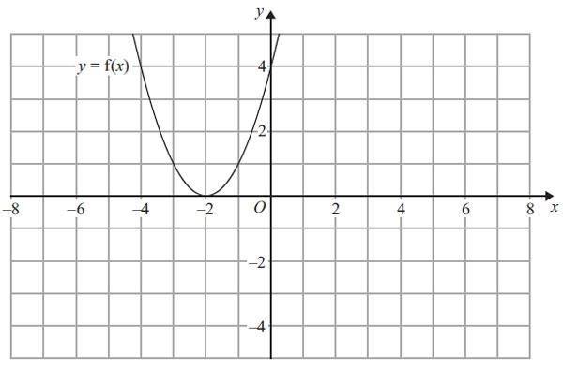
(a) On the grid above, sketch the graph of y = – f(x).
(2)
The graph of y = f(x) is shown on the grid.
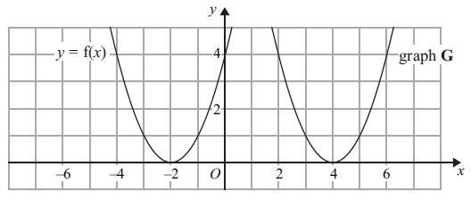
The graph G is a translation of the graph of y = f(x).
(b) Write down the equation of graph G.

...........................................................
(2)
(Total for Question is 3 marks)

2. The graph of y = f(x) is shown on both grids below.
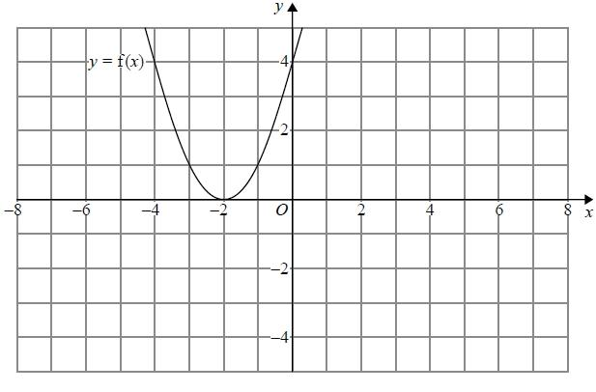
(a) On the grid above, sketch the graph of y = f(−x)
(1)
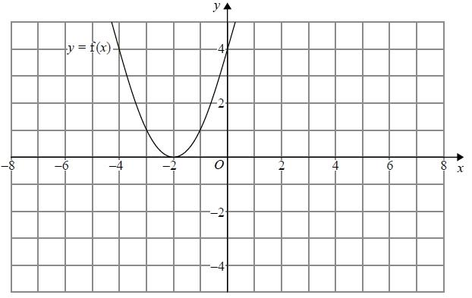
(b) On this grid, sketch the graph of y = −f(x) + 3
(1)
(Total for question = 2 marks)

3. The graph of y = f(x) is shown on each of the grids.
(a) On this grid, sketch the graph of y = f(x – 3)
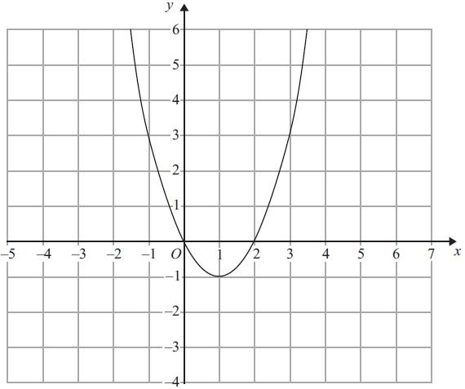
(2)
(b) On this grid, sketch the graph of y = 2f(x)
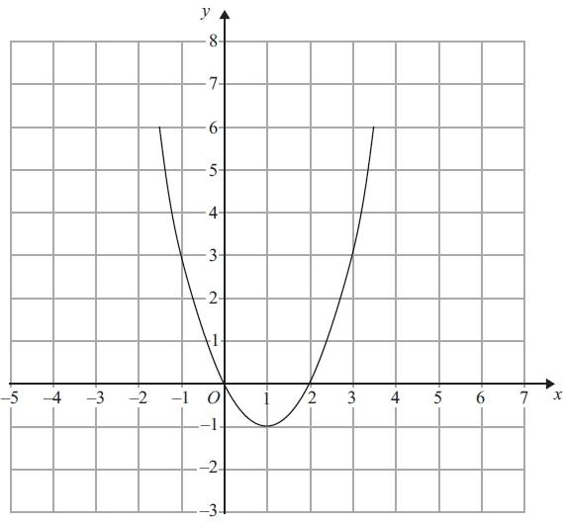
(2)
(Total for Question is 4 marks)

4. The graph of y = f(x) is shown on the grid.
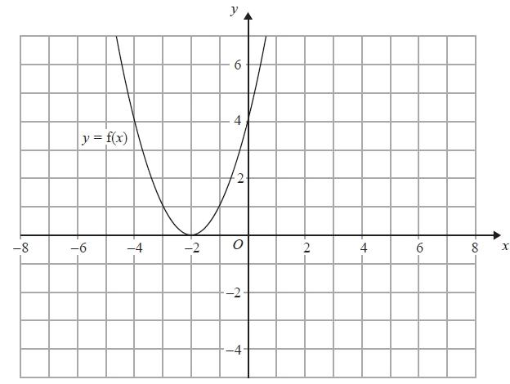
(a) On the grid above, sketch the graph of y = f(x + 3)
(2)
The graph of y = g(x) is shown below.
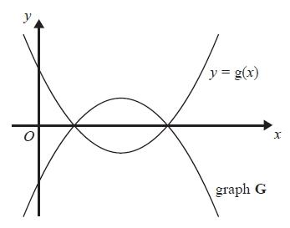
The graph G is the reflection of y = g(x) in the x-axis.
(b) Write down an equation of graph G.
...........................................................
(1)
(Total for question = 3 marks)

Equations of Circles

Things to remember:
- The general equation of a circle is (x – a)² + (y – b)² = r², where (a, b) is the centre and r is the radius.
- To calculate the equation of the tangent:
  - Calculate the gradient of the radius of the circle.
  - Calculate the gradient of the tangent of the circle.
  - Substitute the given coordinate and the gradient of the tangent into y = mx + c to calculate the y-intercept.

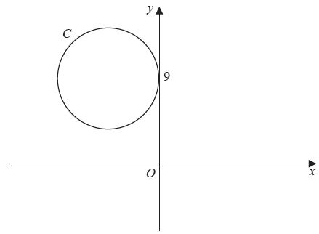
Questions:
1. The circle C has radius 5
and touches the y-axis at the point (0, 9), as shown in the diagram.
(a) Write down an
equation for the circle C, that is shown in the diagram.

...........................................................
(3)
A line through the point P(8, − 7) is a tangent to the circle C at the point T.
(b) Find the length of PT.

(3)
(Total 6 marks)

2. A circle C has centre (−1, 7) and passes through the point (0, 0). Find an equation for C.

...........................................................
(Total 4 marks)

3. The circle C has centre (3, 1) and passes through the point P(8, 3).
(a) Find an equation for C.

...........................................................
(4)
(b) Find an equation for the tangent to C at P.

...........................................................
(5)
(Total 9 marks)

Quadratic and Other Sequences

Things to remember:
- To calculate the nth term of a quadratic sequence:
  - Calculate the first difference.
  - Calculate the second difference.
  - How many n²s?
  - Subtract.
  - Calculate the nth term of the difference.
  - Write the quadratic nth term.

Questions:
1. Here are the first 5 terms of a quadratic sequence.
1 3 7 13 21
Find an expression, in terms of n, for the nth term of this quadratic sequence.
...........................................................
(Total for question is 3 marks)

2. Here are the first six terms of a Fibonacci sequence.
1 1 2 3 5 8
The rule to continue a Fibonacci sequence is,
the next term in the sequence is the sum of the two previous terms.
(a) Find the 9th term of this sequence.
...........................................................
(1)
The first three terms of a different Fibonacci sequence are
a b a + b
(b) Show that the 6th term of this sequence is 3a + 5b

(2)
Given that the 3rd term is 7 and the 6th term is 29,
(c) find the value of a and the value of b.

a = ...........................................................
b = ...........................................................
(3)
(Total for question = 6 marks)

3. Here are the first five terms of a sequence.
2 8 18 32 50
(a) Find the next term of this sequence.
...........................................................
(1)
The nth term of a different sequence is 3n² – 10
(b) Work out the 5th term of this sequence.

...........................................................
(1)
(Total for question = 2 marks)

4. Here are the first five terms of an arithmetic sequence.
1 5 9 13 17
(a) Write down an expression, in terms of n, for the nth term of this sequence.

...........................................................
(2)
The nth term of a different number sequence is 3n² + 7
(b) Find the 10th term of this sequence.

...........................................................
(2)
(Total for Question is 4 marks)

Completing the Square

Things to remember:
- To complete the square:
  - Halve the coefficient of x.
  - Put in brackets with the x and square the brackets.
  - Subtract the half-coefficient squared.
  - Don’t forget the constant on the end!
  - Simply.
- For (x - p)² + q = 0, the turning point is (p, q).

Questions:
1. (i) Sketch the graph of f(x) = x² − 5x + 10, showing the coordinates of the turning point
and the coordinates of any intercepts with the coordinate axes.
(ii) Hence, or otherwise, determine whether f(x + 2) − 3 = 0 has any real roots.
Give reasons for your answer.

(Total for question = 6 marks)

2. (a) Write 2x² + 16x + 35 in the form a(x + b)² + c where a, b, and c are integers.
...........................................................
(3)
(b) Hence, or otherwise, write down the coordinates of the turning point of the graph
of y = 2x² + 16x + 35
...........................................................
(1)
(Total for question = 4 marks)

3. The expression x² – 8x + 21 can be written in the form (x – a) ² + b for all values of x.
(a) Find the value of a and the value of b.

a = ...........................................................

b = ...........................................................
(3)
The equation of a curve is y = f(x) where f(x) = x² – 8x + 21
The diagram shows part of a sketch of the graph of y = f(x).
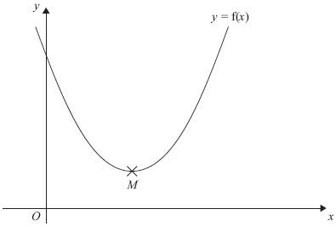
The minimum point of the curve is M.
(b) Write down the coordinates of M.

...........................................................
(1)
(Total for Question is 4 marks)

Inverse and Composite Functions

Things to remember:
- y = f(x) means that y is a function of x.
- f(a) means the value of x is a, so substitute x with a.
- The graph of the inverse is the reflection of the graph in the line y = x
- We find the inverse function by putting the original function equal to y and rearranging to make x the subject.
- We use the notation f⁻¹(x) for the inverse function.
- When a function is followed by another, the result is a composite function.
- fg(x) means do g first, followed by f.

Questions:
1. The functions f and g are such that
f(x) = 1 − 5x and g(x) = 1 + 5x
(a) Show that gf(1) = − 19

(2)
(b) Prove that f⁻¹(x) + g⁻¹(x) = 0 for all values of x.

(3)
(Total for question = 5 marks)

2. The function f is such that
f(x) = 4x − 1
(a) Find f⁻¹(x)

f⁻¹(x) = ...........................................................
(2)
The function g is such that
g(x) = kx² where k is a constant.
Given that fg(2) = 12
(b) work out the value of k

k = ...........................................................
(2)
(Total for question = 4 marks)

3. The functions f and g are such that
f(x) = 3(x – 4) and g(x) = $\frac{x}{5}$ + 1
(a) Find the value of f(10)
...........................................................
(1)
(b) Find g^{–1}(x)

g^{–1}(x) = ...........................................................
(2)
(c) Show that ff(x) = 9x – 48

(2)
(Total for question = 5 marks)

4. f(x) = 3x² − 2x − 8
Express f(x + 2) in the form ax² + bx

...........................................................
(Total for question is 3 marks)

Expanding more than two binomials

Things to remember:
- Start by expanding two pair of brackets using the grid or FOIL method.
- Then expand the third set of brackets.
- Use columns to keep x³, x² etc in line to help with addition.

Questions:
1. Show that
(x − 1)(x + 2)(x − 4) = x³ - 3x² - 6x + 8
for all values of x.

...........................................................
(Total for question is 3 marks)

2. Show that
(3x − 1)(x + 5)(4x − 3) = 12x³ + 47x² − 62x + 15
for all values of x.

...........................................................
(Total for question is 3 marks)
3. Show that
(x - 3)(2x + 1)(x + 3) = 2x³ + x² − 18x - 9
for all values of x.

...........................................................
(Total for question is 3 marks)

4. (2x + 1)(x + 6)(x - 4) = 2x³ + ax² + bx – 24
for all values of x, where a and b are integers.
Calculate the values of a and b.

a = ...........................................................

b = ...........................................................
(Total for question is 4 marks)

Nonlinear Simultaneous Equations

Things to remember:
- Substitute the linear equation into the nonlinear equation.
- Rearrange so it equals 0.
- Factorise and solve for the first variable (remember there will be two solutions).
- Substitute the first solutions to solve for the second variable.
- Express the solution as a pair of coordinate where the graphs intersect.

Questions:
1. Solve the equations
x² + y² = 36
x = 2y + 6

...........................................................
(Total for Question is 5 marks)

3. Solve the simultaneous equations
x² + y² = 25
y = 2x + 5

x = . . . . . . . . . . . . . . and y = . . . . . . . . . . . . . .
or
x = . . . . . . . . . . . . . . and y = . . . . . . . . . . . . . .
(Total for Question is 6 marks)

4. Solve the simultaneous equations x² + y² = 9
x + y = 2
Give your answers correct to 2 decimal places.

x = . . . . . . . . . . . . . . . y = . . . . . . . . . . . . . . .

or x = . . . . . . . . . . . . . . . y = . . . . . . . . . . . . . . .
(Total for Question is 6 marks)

Solving Quadratic Inequalities

Things to remember:
- Start by solving the quadratic to find the values of x, then sketch the graph to determine the inequality.

Questions:
1. Solve x² > 3x + 4
...........................................................
(Total for question = 3 marks)

2. Solve the inequality x² > 3(x + 6)
...........................................................
(Total for question = 4 marks)

3. Solve the inequality x² + 5x > 6

...........................................................
(Total for question = 3 marks)

4. Solve the inequality x² - 2x + 8 < 0

...........................................................
(Total for question = 3 marks)

5. Solve the inequality x² - x ≥ 12

...........................................................
(Total for question = 3 marks)

6. Solve the inequality x² ≤ 4(2x + 5)

...........................................................
(Total for question = 4 marks)

Circle theorems

Things to remember:
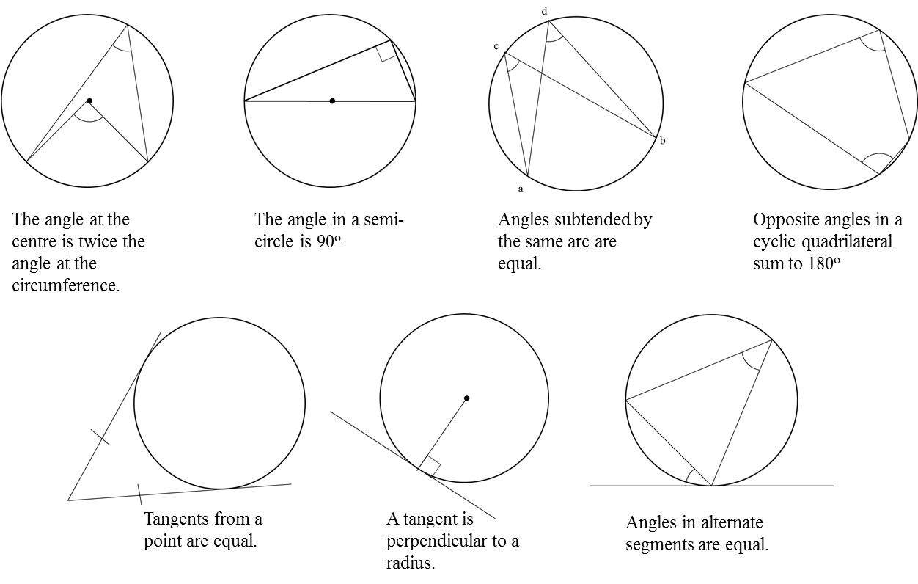
Questions:
1.
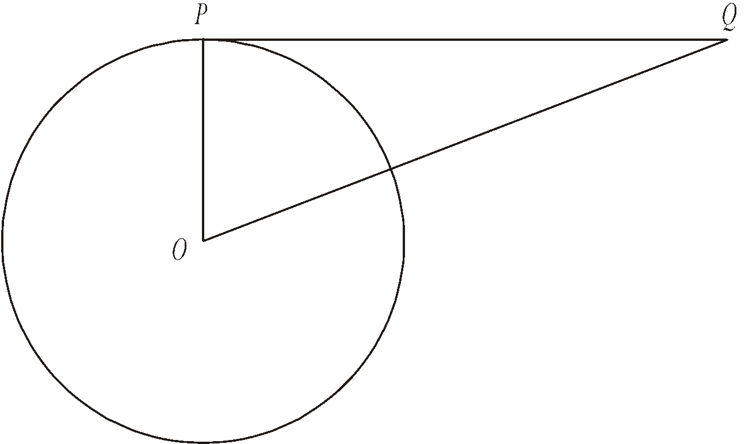
Diagram NOT accurately drawn
P is a point on the circumference of the circle, centre O.
PQ is a tangent to the circle.
(i) Write down the size of angle OPQ.
........................................................... °
(ii) Give a reason for your answer.

………………………......................................................................................................

………………………......................................................................................................
(Total 2 marks)

2.
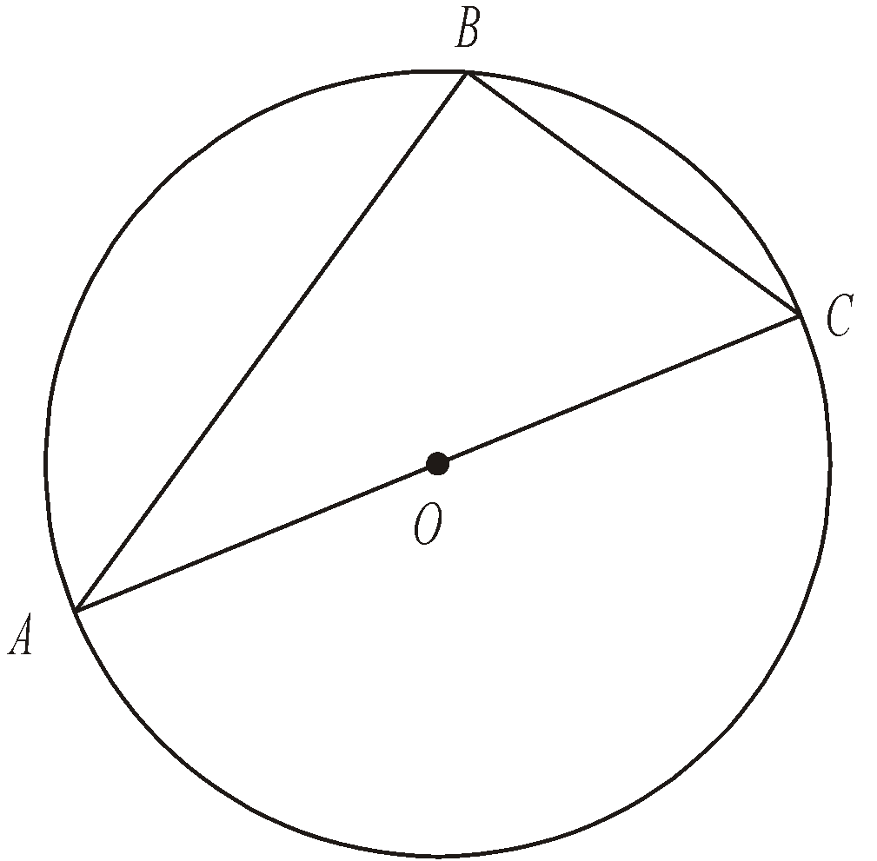
Diagram NOT accurately drawn
A, B and C are points on the circumference of a circle, centre O.
AC is a diameter of the circle.
(a) (i) Write down the size of angle ABC.
........................................................... °
(ii) Give a reason for your answer.

………………………......................................................................................................

………………………......................................................................................................
(2)
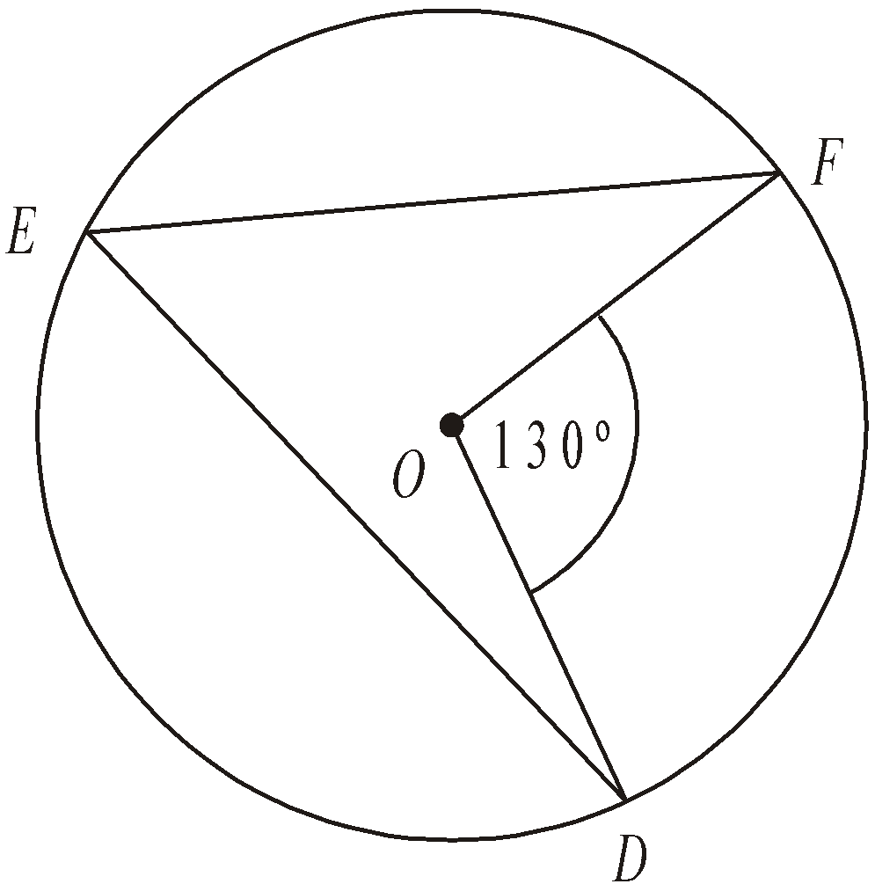
Diagram NOT accurately drawn
D, E and F are points on the circumference of a circle, centre O.
Angle DOF = 130°.
(b) (i) Work out the size of angle DEF.
........................................................... °
(ii) Give a reason for your answer.

………………………......................................................................................................

………………………......................................................................................................
(2)
(Total 4 marks)

3.
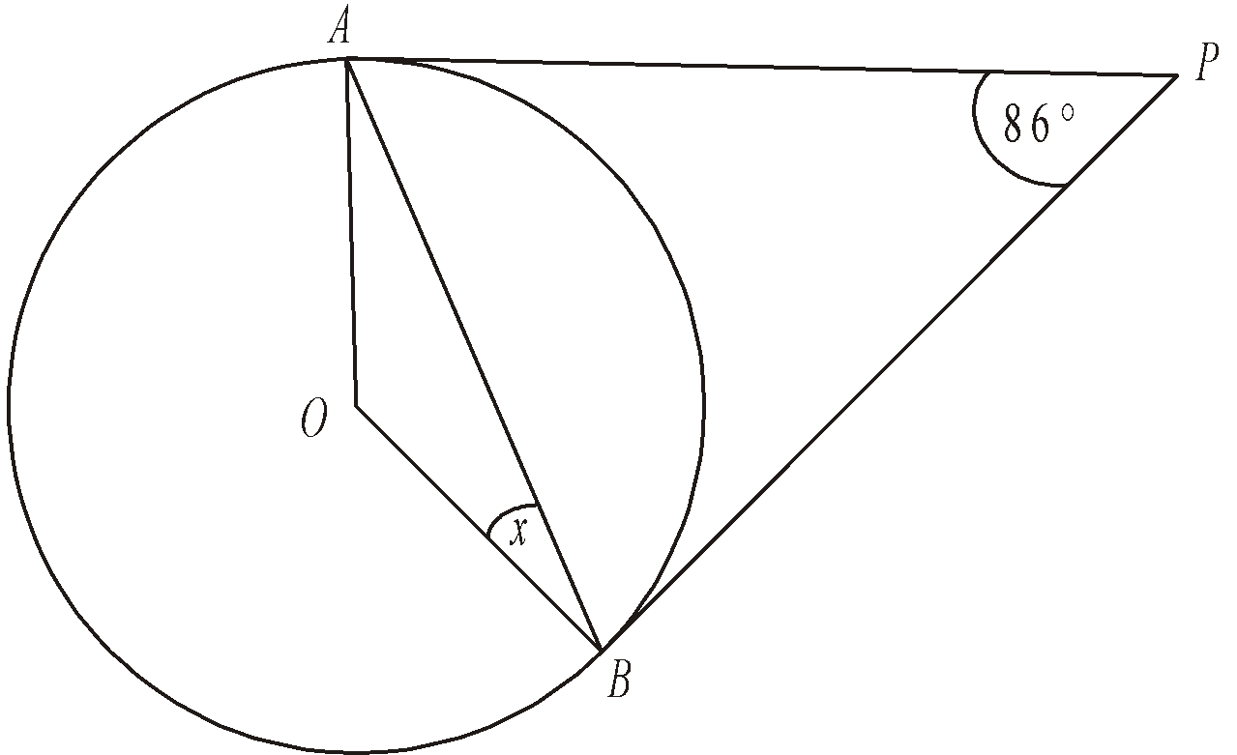
Diagram NOT accurately drawn
A and B are points on the circumference of a circle, centre O.
PA and PB are tangents to the circle.
Angle APB is 86°.
Work out the size of the angle marked x.
........................................................... °
(Total 2 marks)

4.
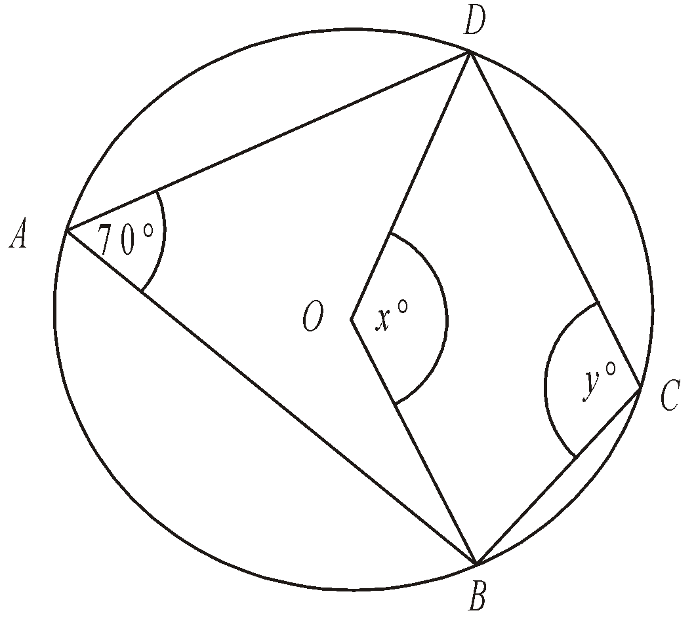
Diagram NOT accurately drawn
In the diagram, A, B, C and D are points on the circumference of a circle, centre O.
Angle BAD = 70°.
Angle BOD = x°.
Angle BCD = y°.
(a) (i) Work out the value of x.
........................................................... °
(ii) Give a reason for your answer.

………………......................................................................................................

………………......................................................................................................
(2)
(b) (i) Work out the value of y.

........................................................... °
(ii) Give a reason for your answer.

………………......................................................................................................
………………......................................................................................................
(2)
(Total 4 marks)

5.
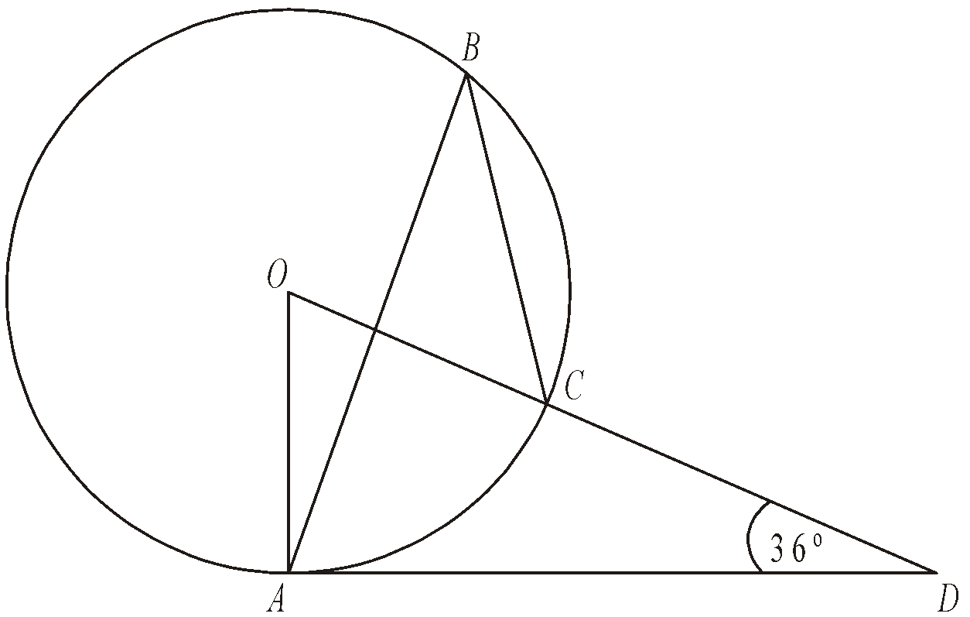
Diagram NOT accurately drawn
The diagram shows a circle centre O.
A, B and C are points on the circumference.
DCO is a straight line.
DA is a tangent to the circle.
Angle ADO = 36°
(a) Work out the size of angle AOD.
........................................................... °
(2)
(b) (i) Work out the size of angle ABC.
........................................................... °
(ii) Give a reason for your answer.

………………......................................................................................................
………………......................................................................................................
(3)
(Total 5 marks)

Vectors

Things to remember:
- Use the letter provided in the question.
- Going against the arrow is a negative.
- Vectors need to be written in bold or underlined.
- They can be manipulated similarly to algebra.

Questions:
1. The diagram shows a regular hexagon ABCDEF with centre O.

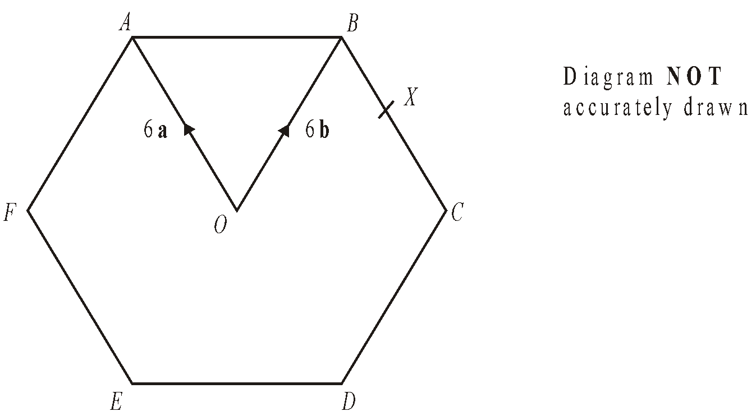
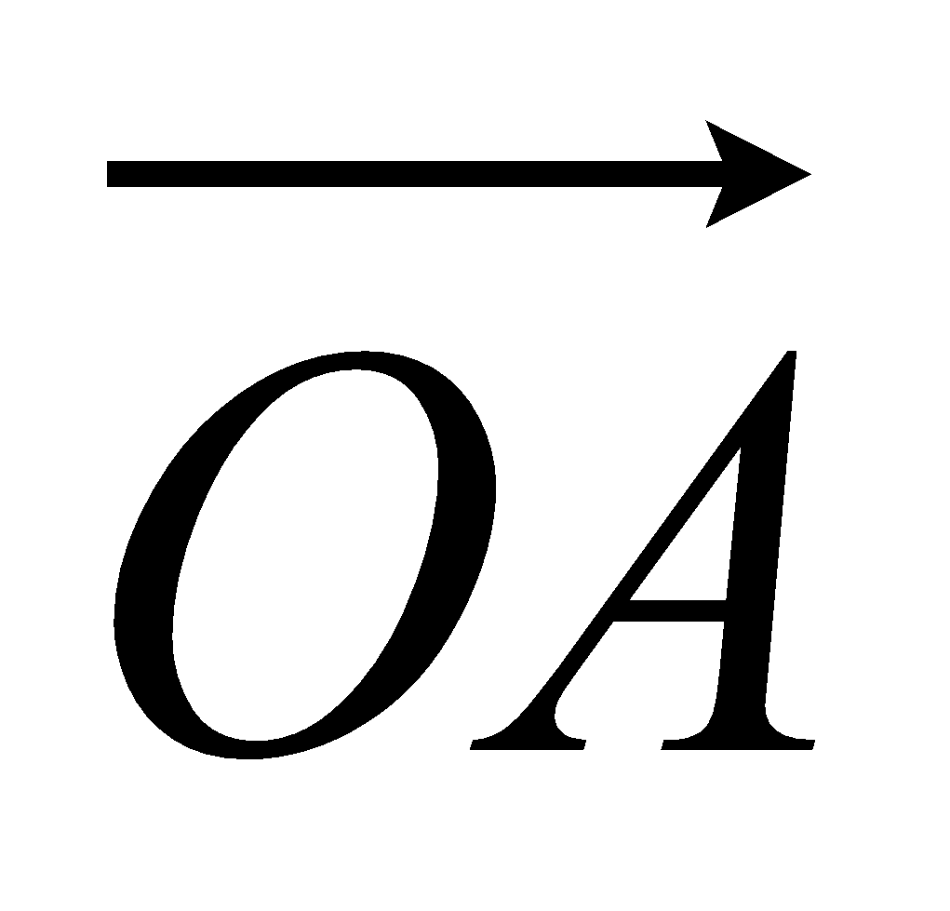 = 6a 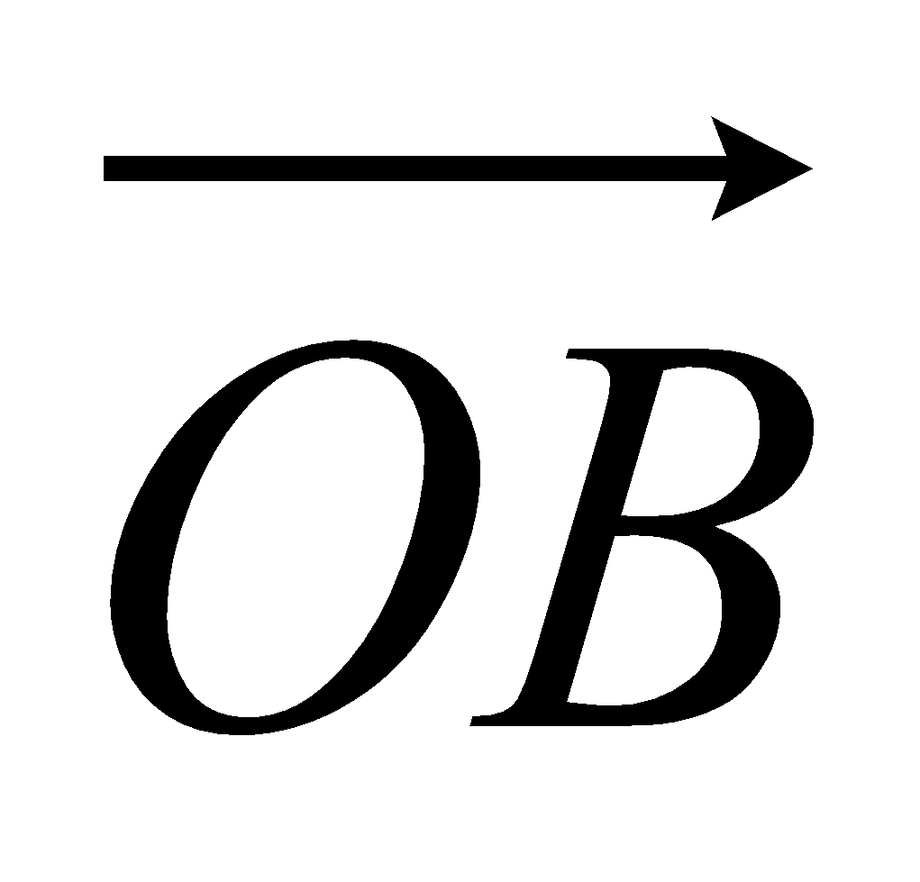 = 6b
(a) Express in terms of a and/or b
(i) 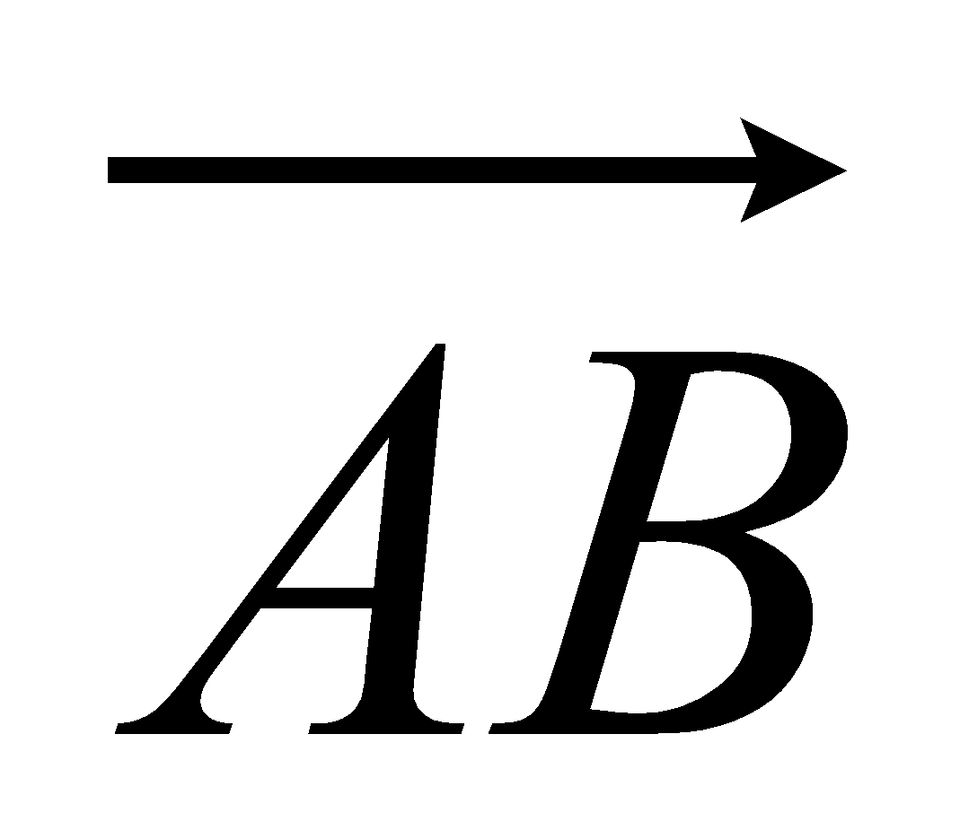,
...........................................................
(ii) 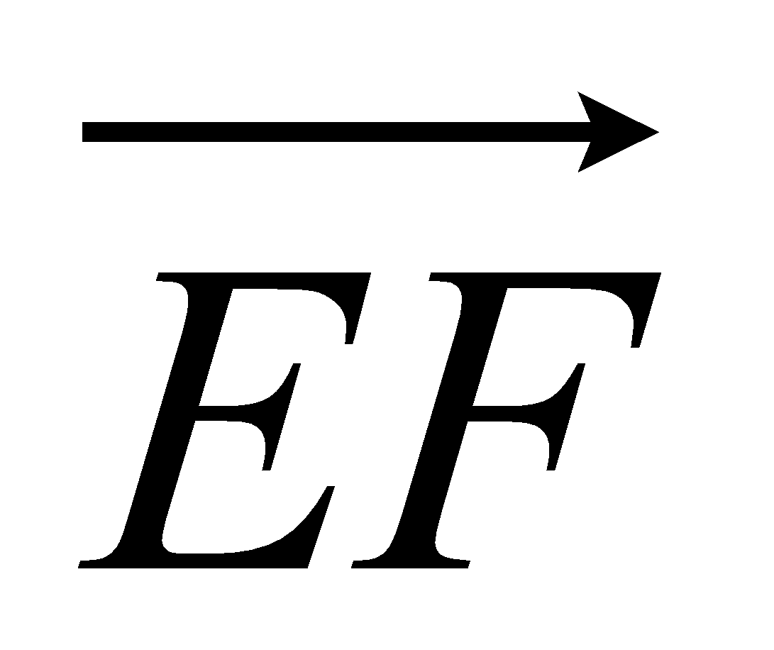.
...........................................................
(2)
X is the midpoint of BC.
(b) Express 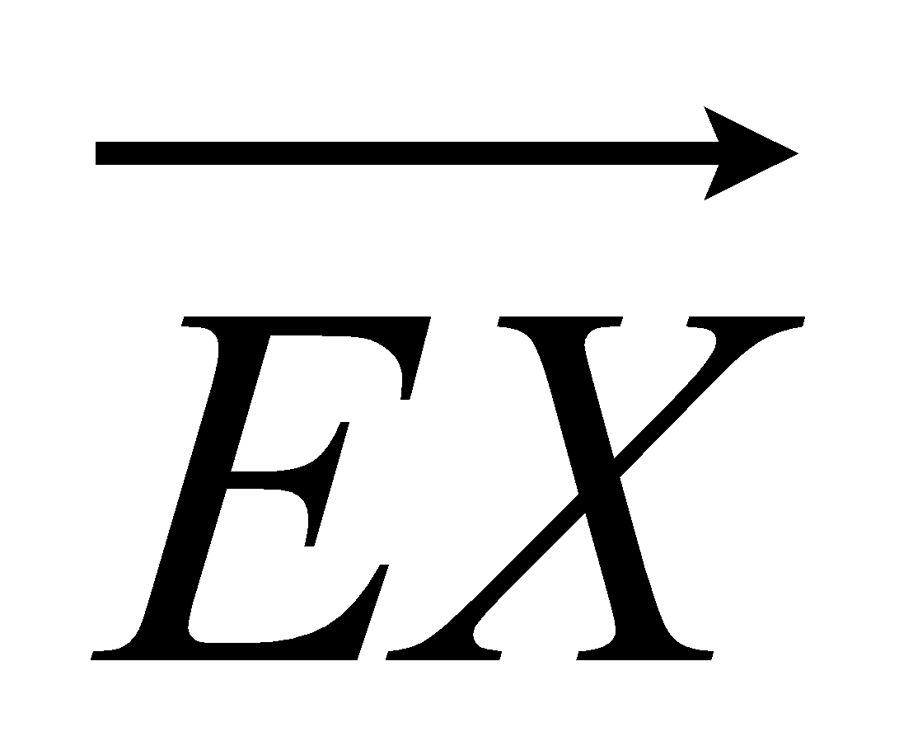 in terms of a and/or b

...........................................................
(2)
Y is the point on AB extended, such that AB : BY = 3:2
(c) Prove that E, X and Y lie on the same straight line.

(3)
(Total 7 marks)

2. T is the point on PQ for which PT : TQ = 2 : 1.
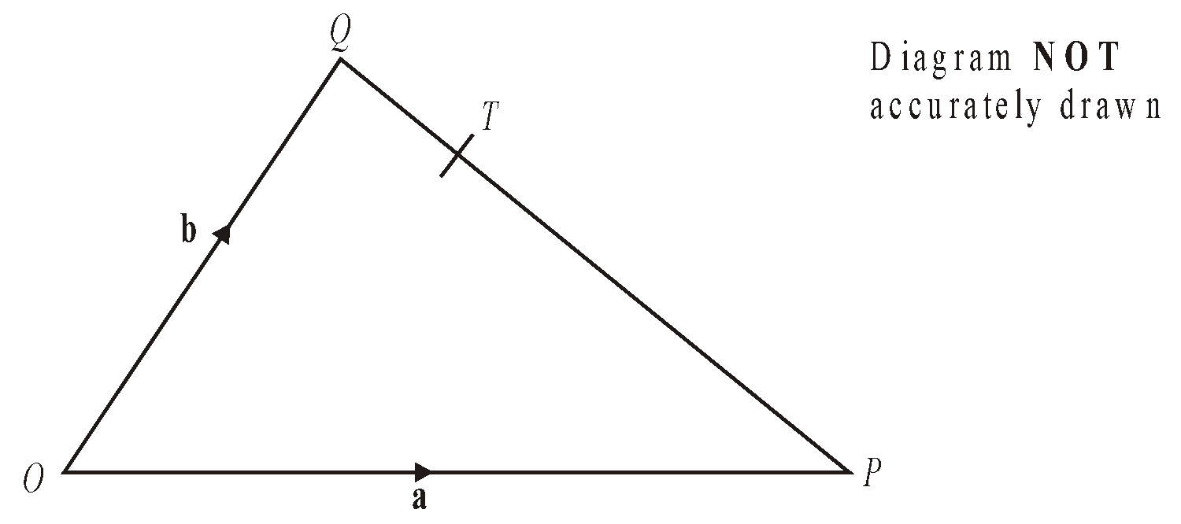
OPQ is a triangle.
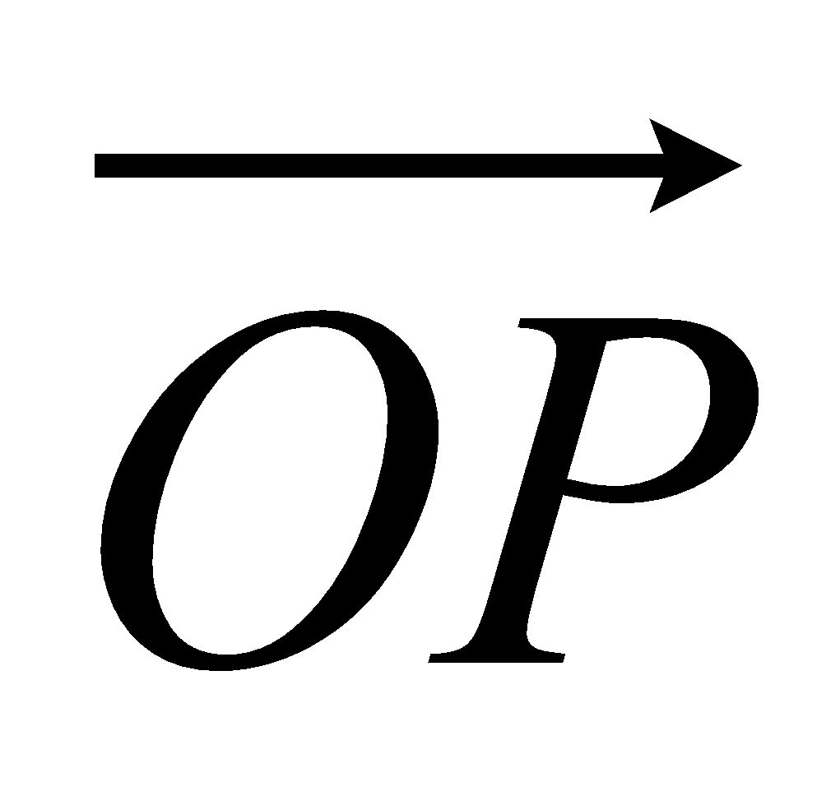 = a and 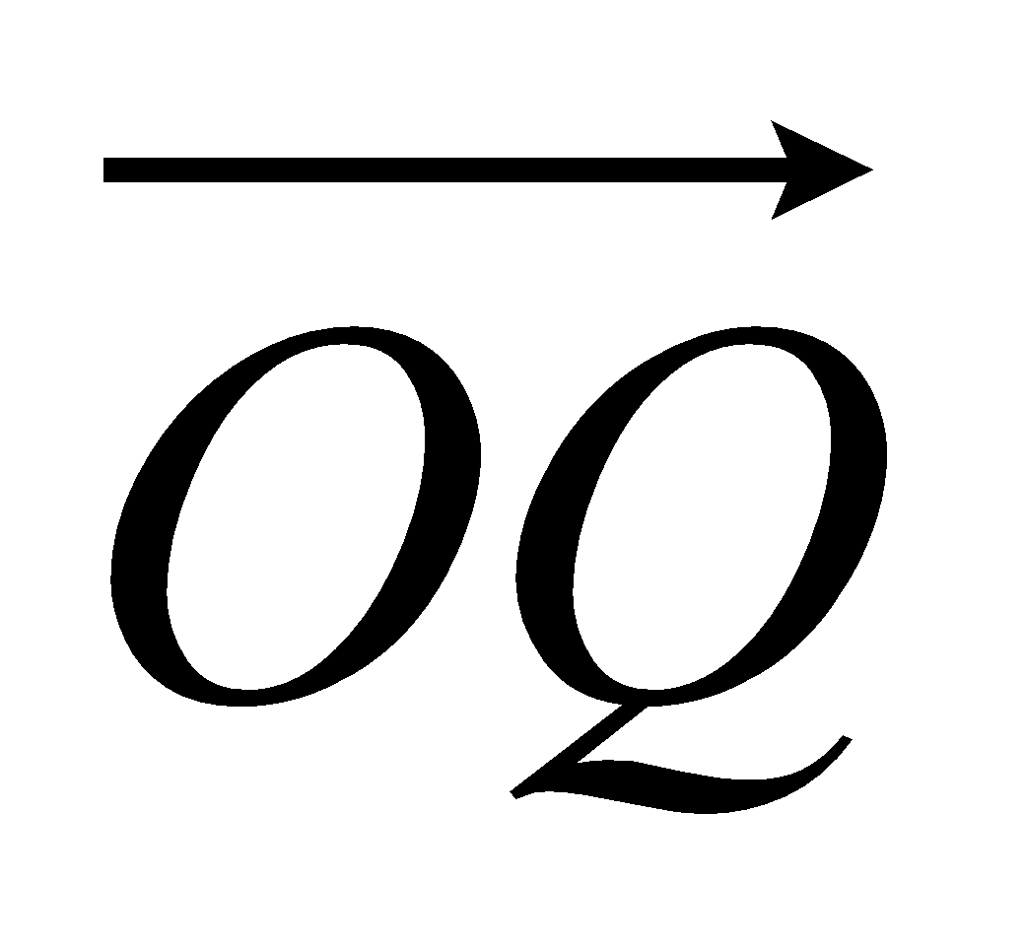 = b.
(a) Write down, in terms of a and b, an expression for 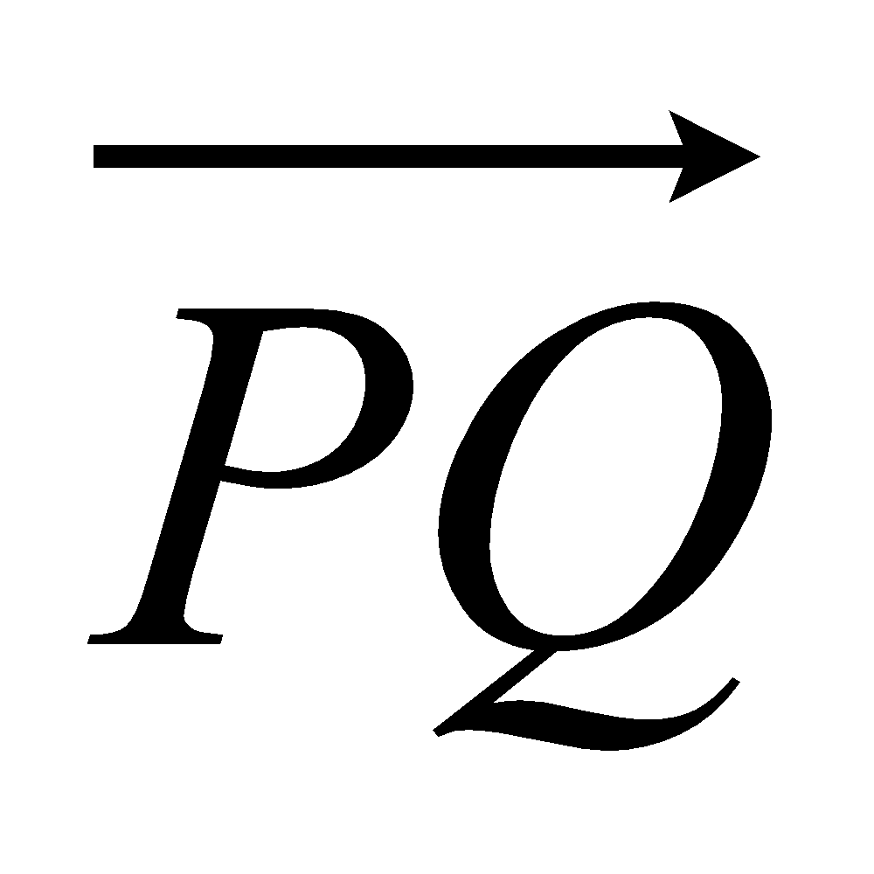.

= ...........................................................
(1)
(b) Express 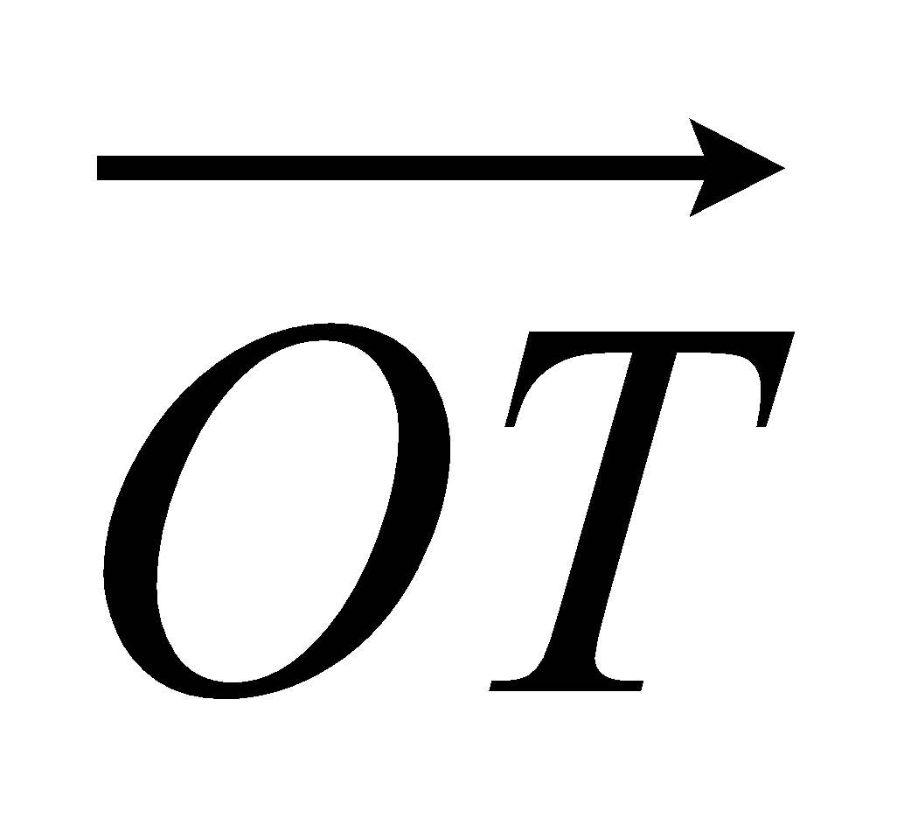 in terms of a and b.
Give your answer in its simplest form.

= ...........................................................
(2)
(Total 3 marks)

3. OABC is a parallelogram.
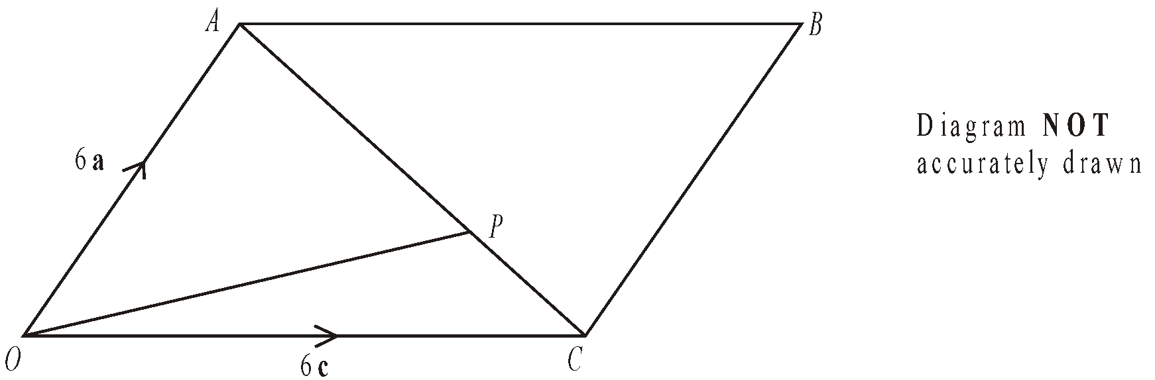
P is the point on AC such that AP = 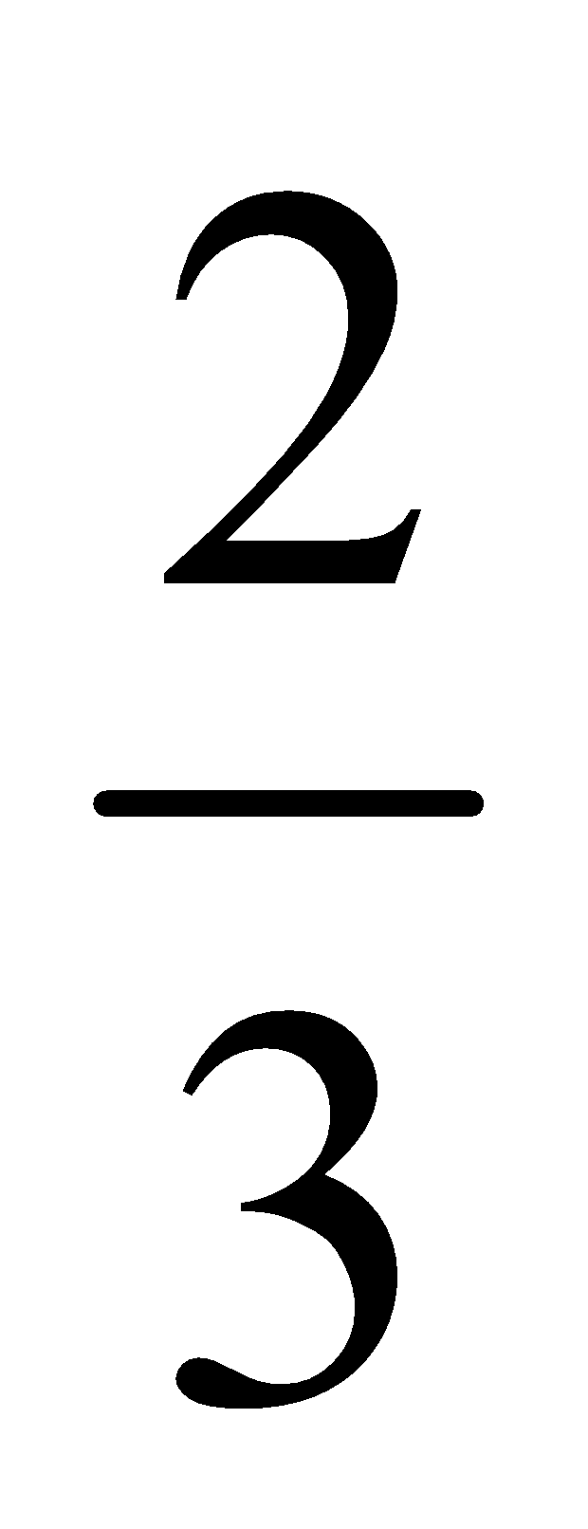AC.
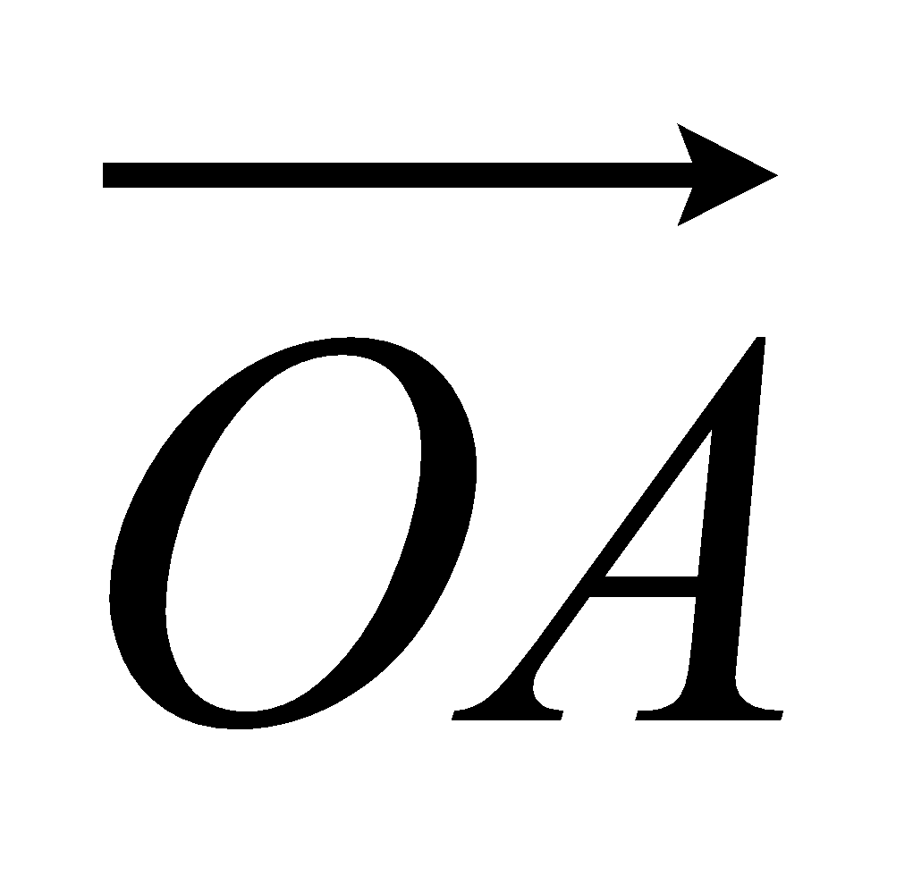 = 6a. 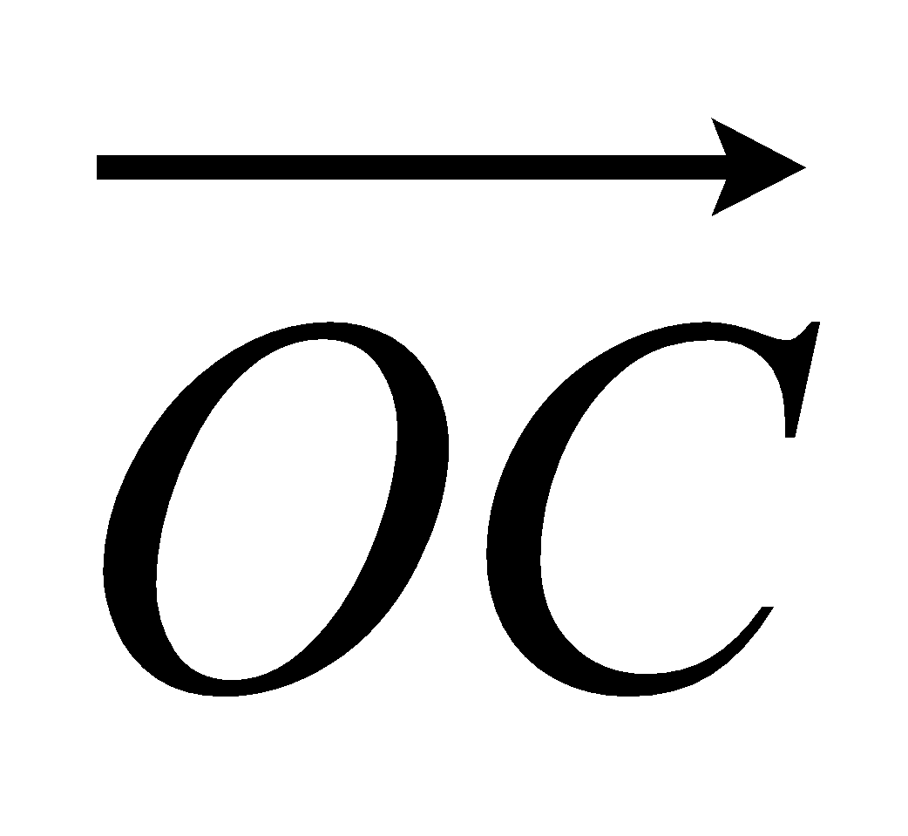 = 6c.
- Find the vector 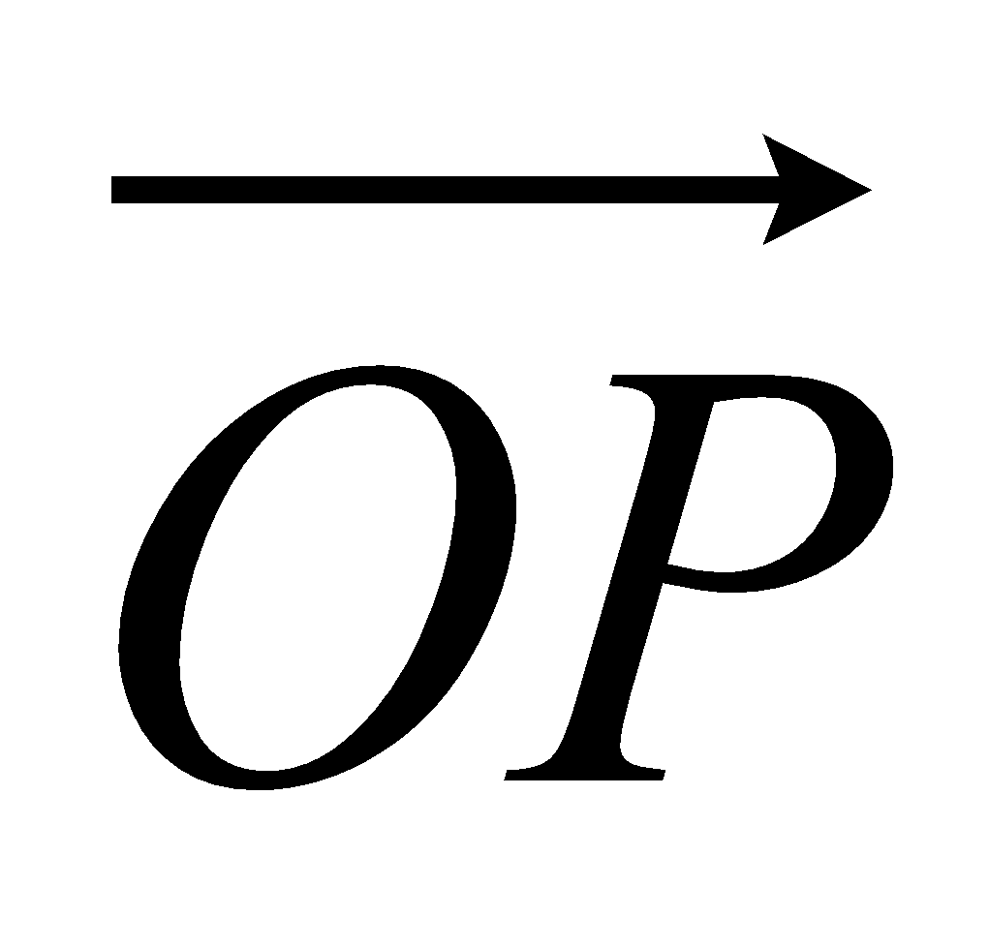.
Give your answer in terms of a and c.

...........................................................
(3)
The midpoint of CB is M.
(b) Prove that OPM is a straight line.

(2)
(Total 5 marks)

4. OPQ is a triangle.
R is the midpoint of OP.
S is the midpoint of PQ.
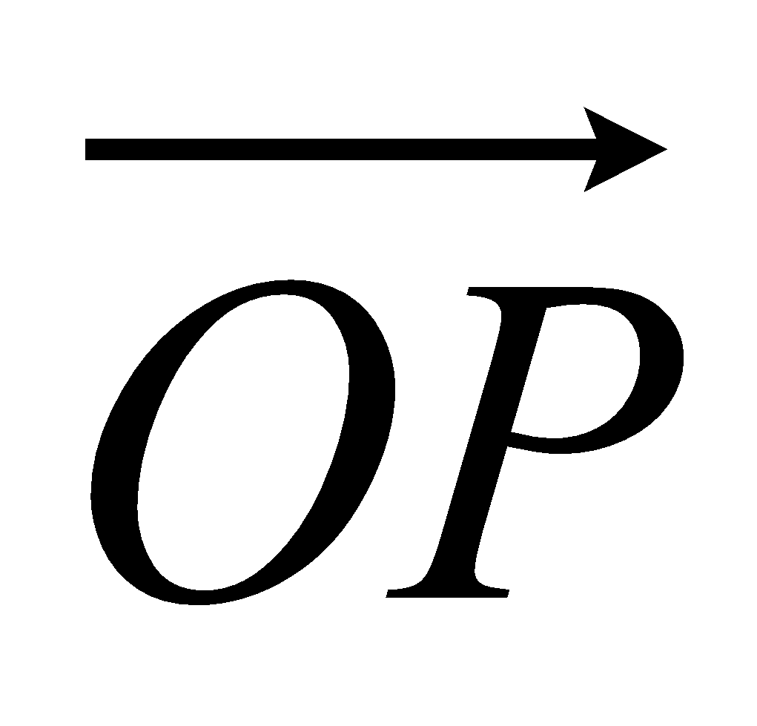 = p and 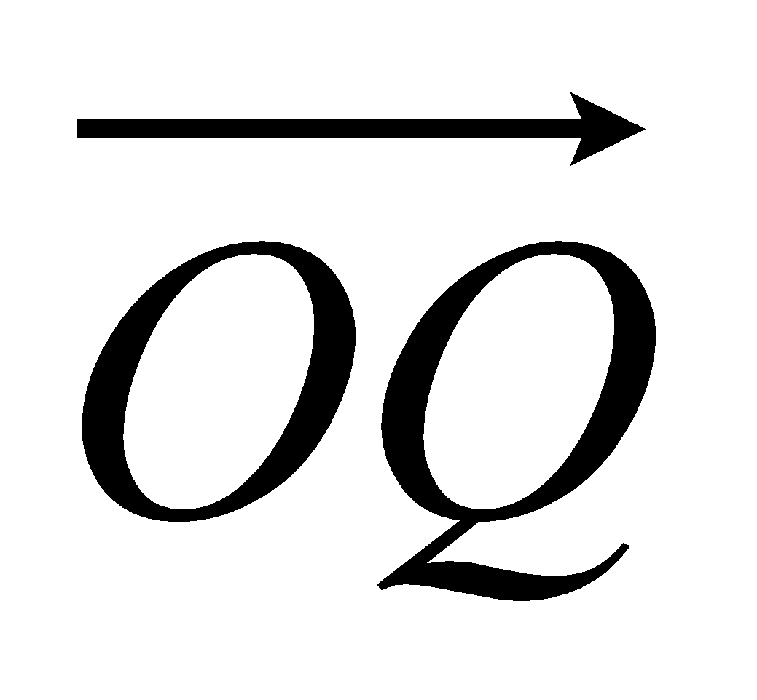 = q

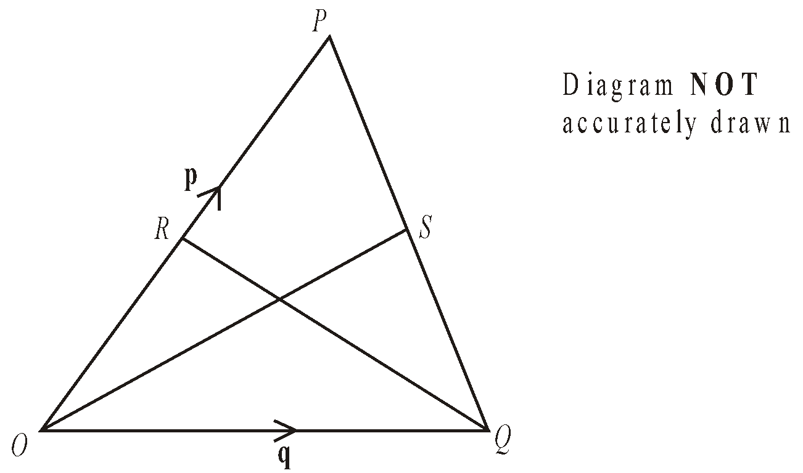
- Find 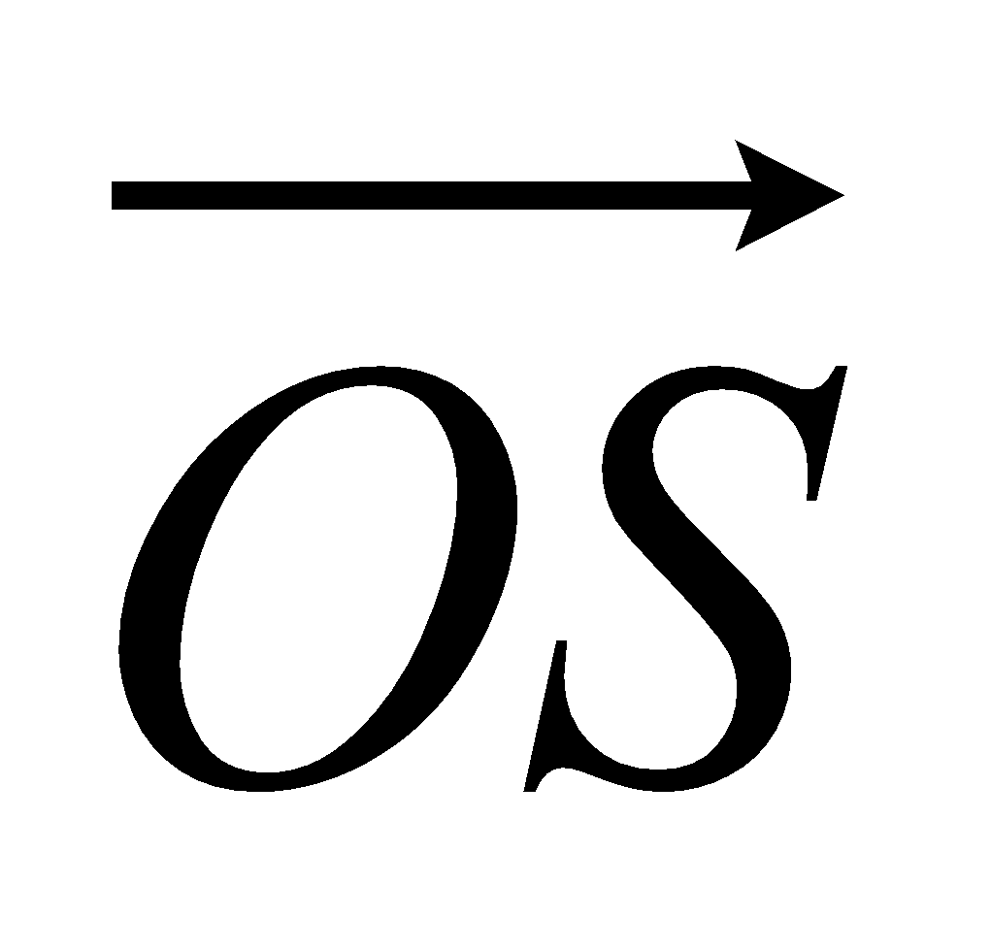 in terms of p and q.

= ...........................................................
(ii) Show that RS is parallel to OQ.

(Total 5 marks)

5. OPQR is a trapezium with PQ parallel to OR.
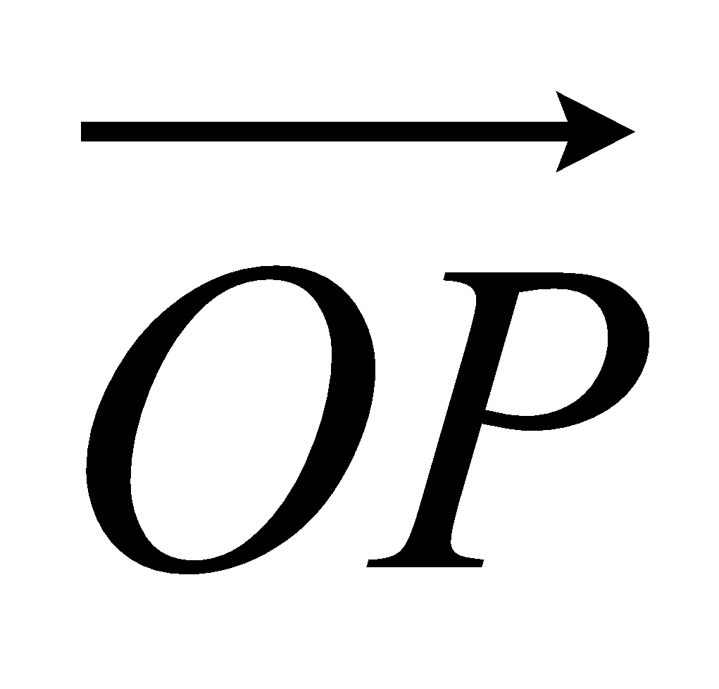 = 2b 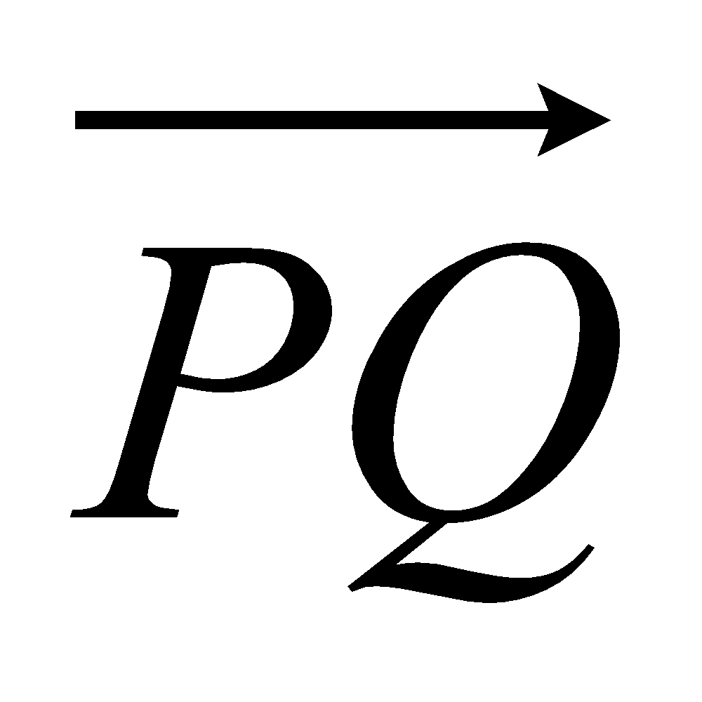 = 2a 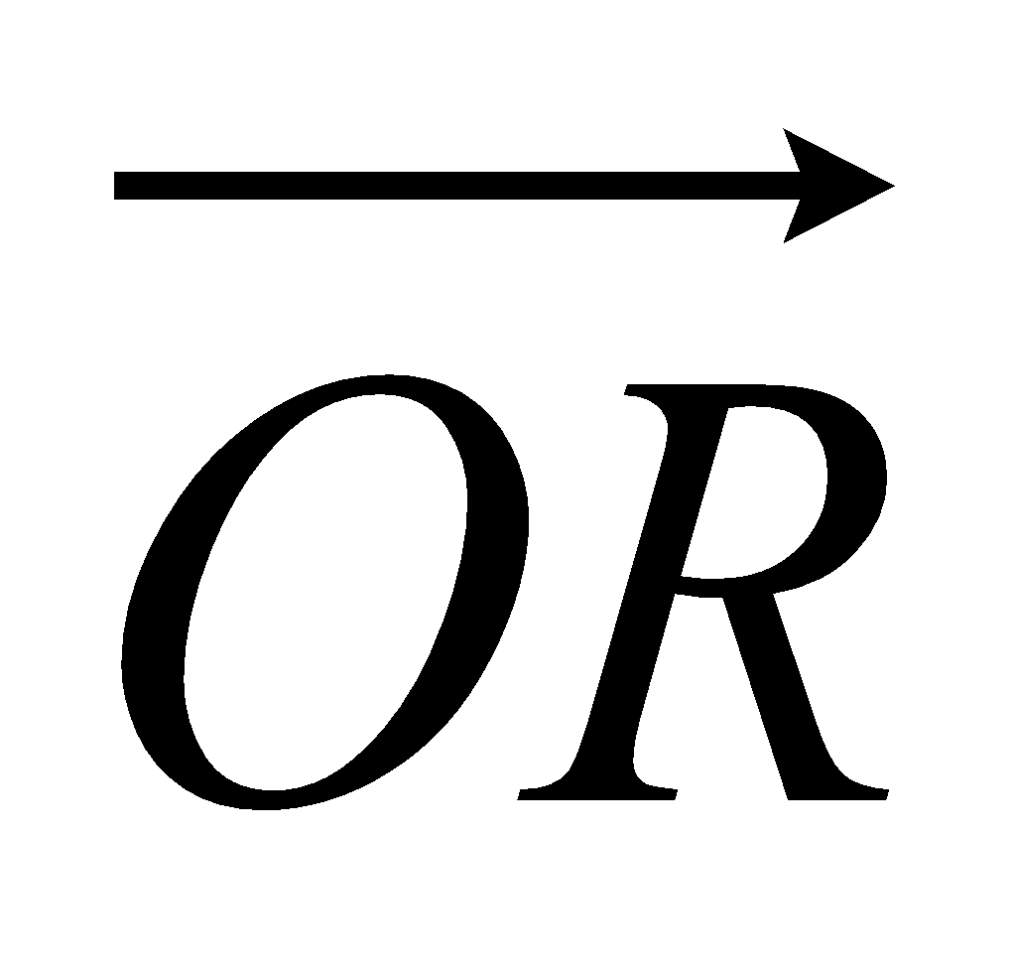 = 6a
M is the midpoint of PQ and N is the midpoint of OR.
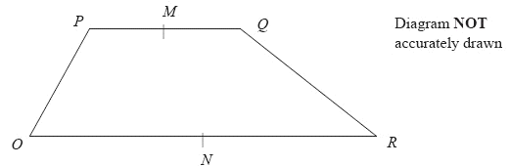
(a) Find the vector 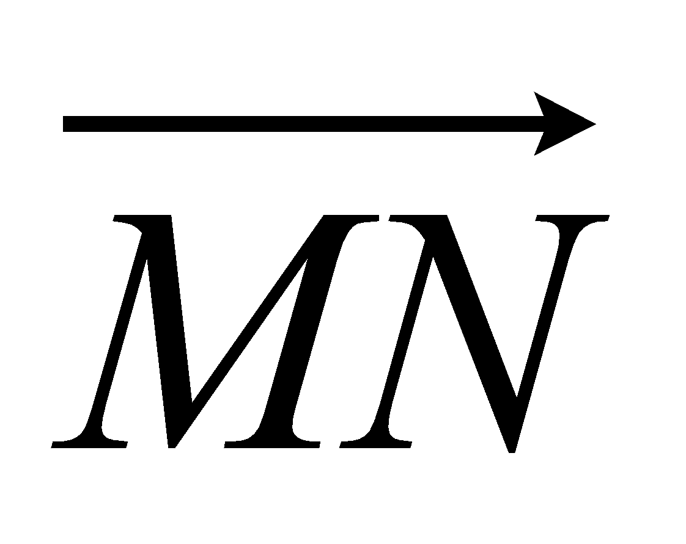 in terms of a and b.

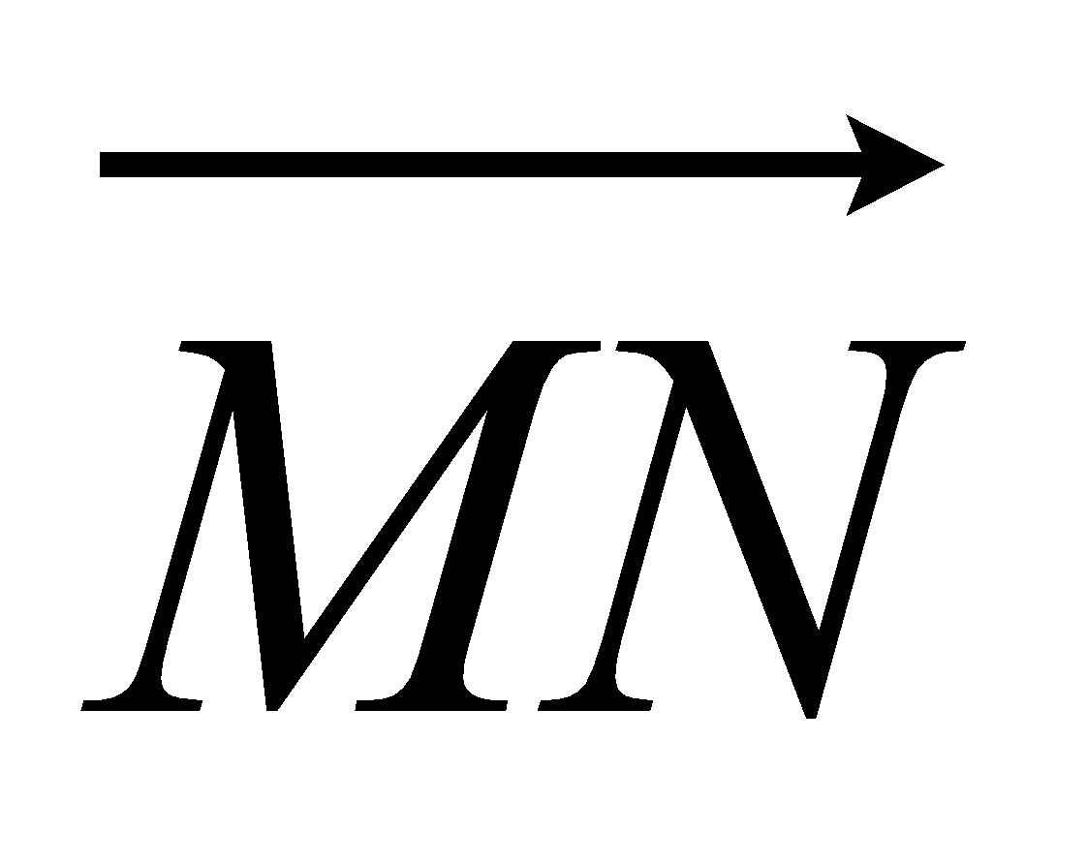 = ...........................................................
(2)
X is the midpoint of MN and Y is the midpoint of QR.
(b) Prove that XY is parallel to OR.

(2)
(Total 4 marks)

6. ABCD is a straight line.
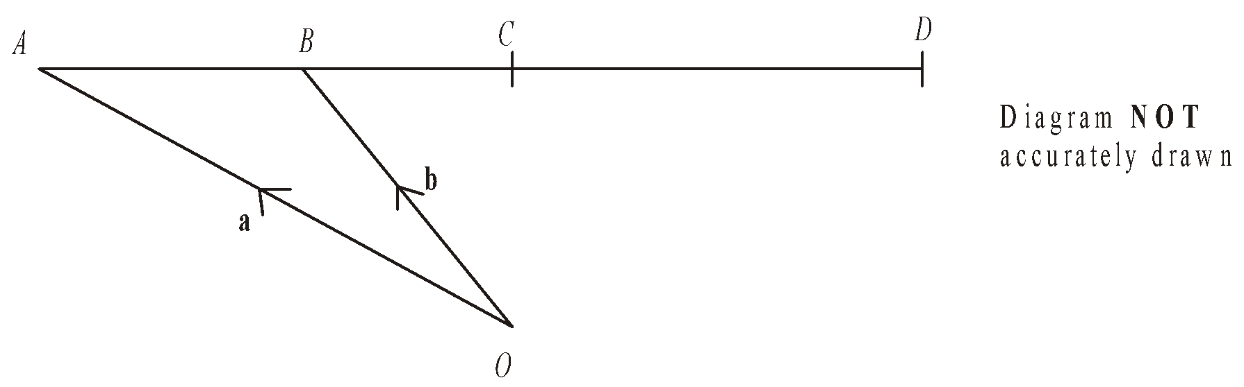
O is a point so that 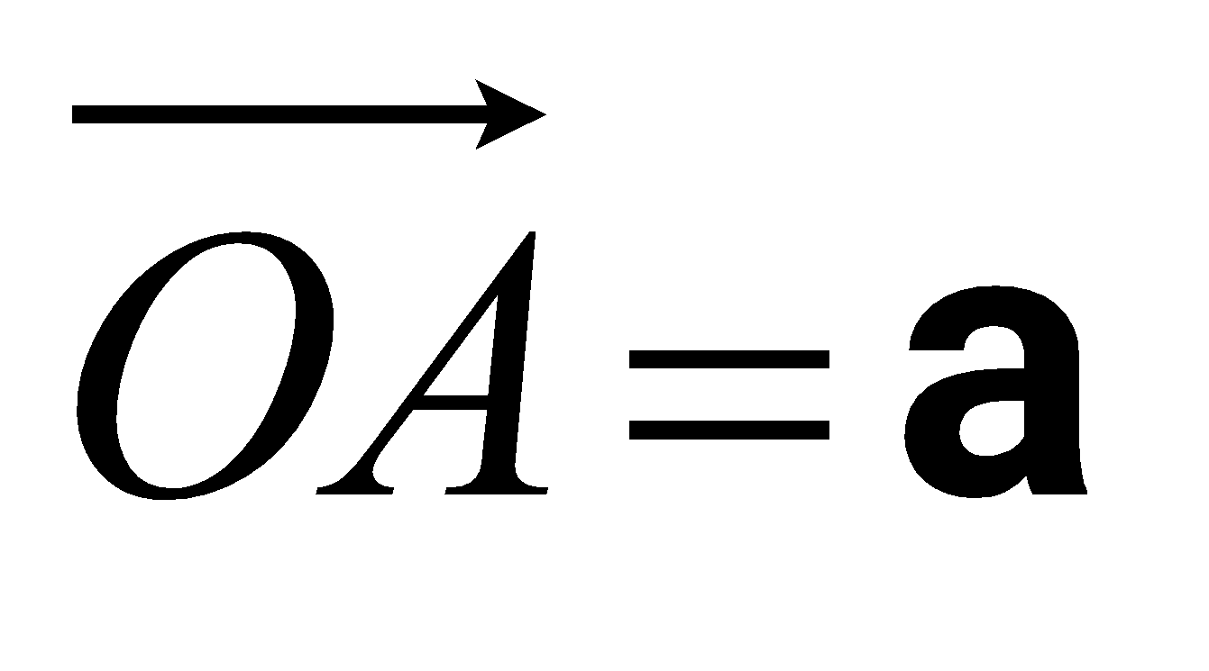 and 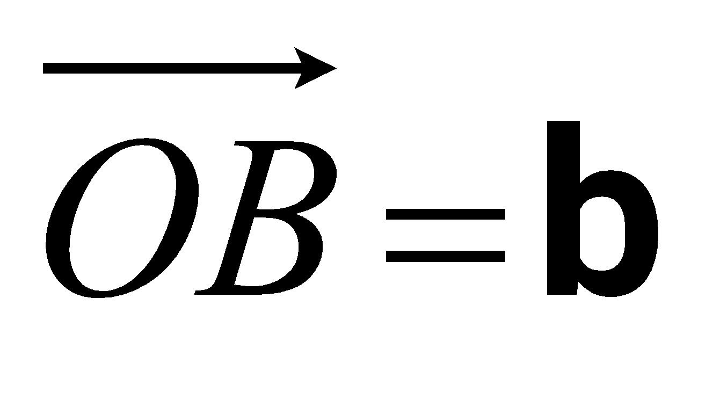.
B is the midpoint of AC.
C is the midpoint of AD.
Express, in terms of a and b, the vectors
(i) 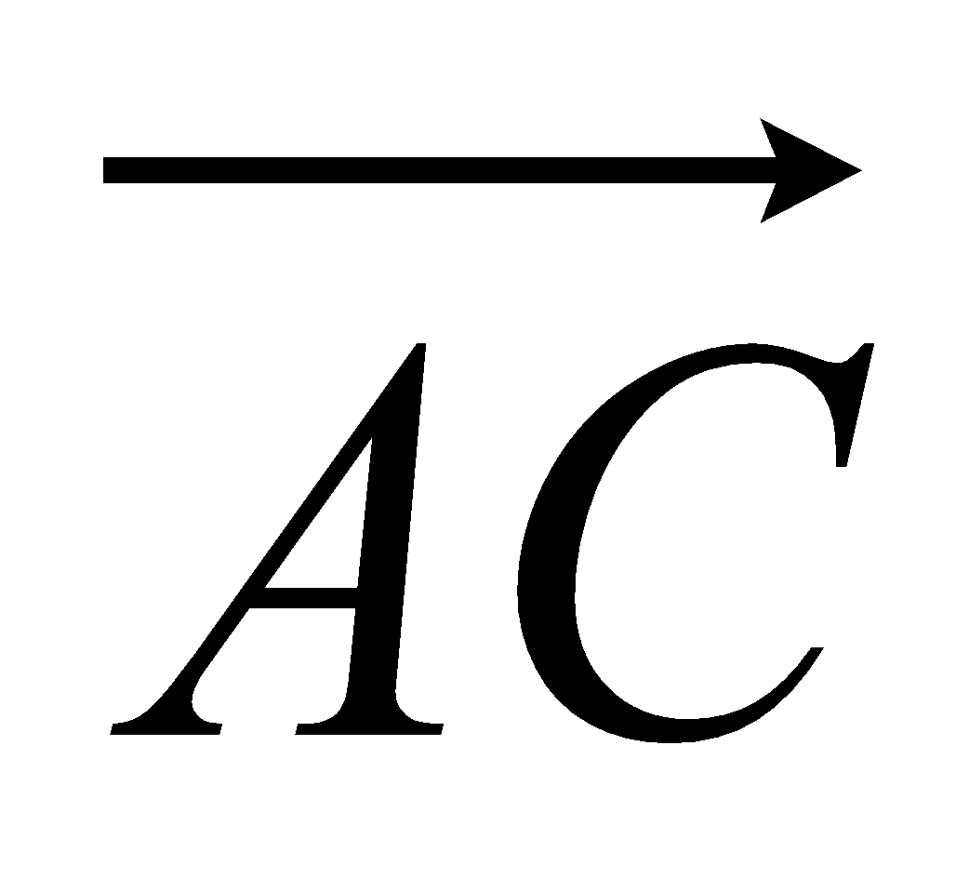

...........................................................
(ii) 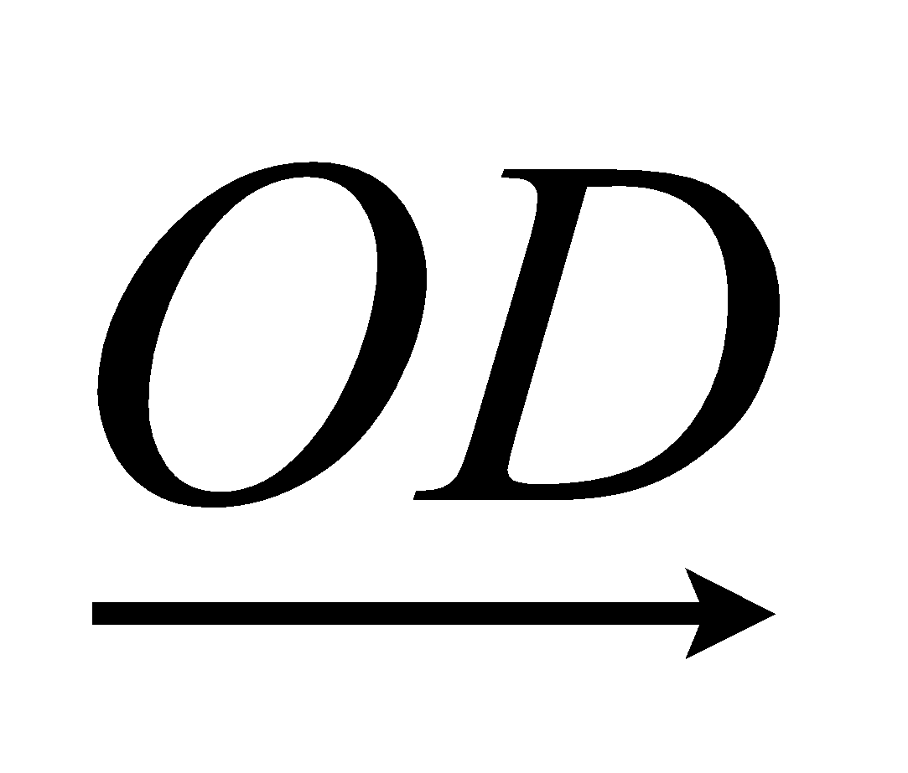

...........................................................
(Total 3 marks)

7. Diagram NOT accurately drawn
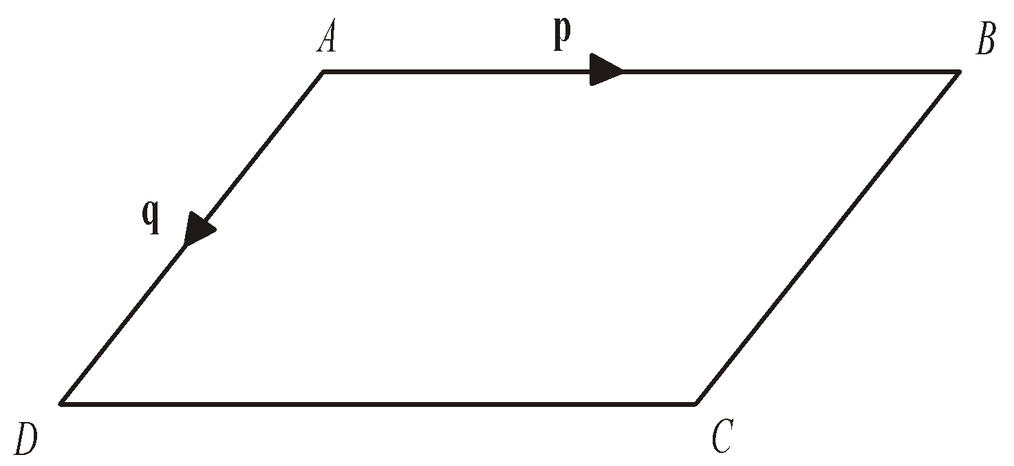
ABCD is a parallelogram.
AB is parallel to DC.
AD is parallel to BC.
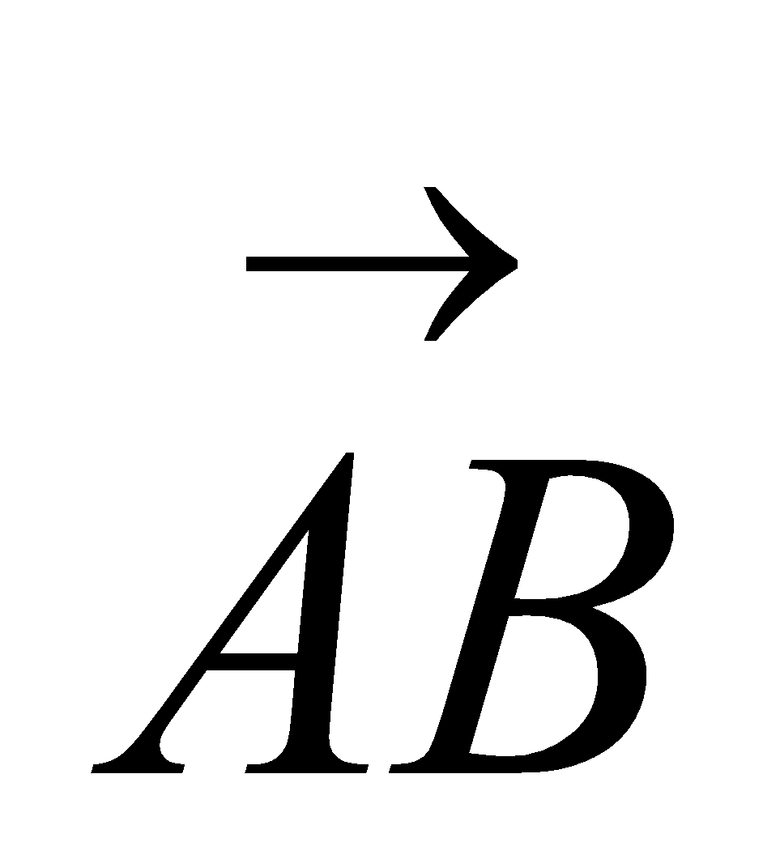 = p
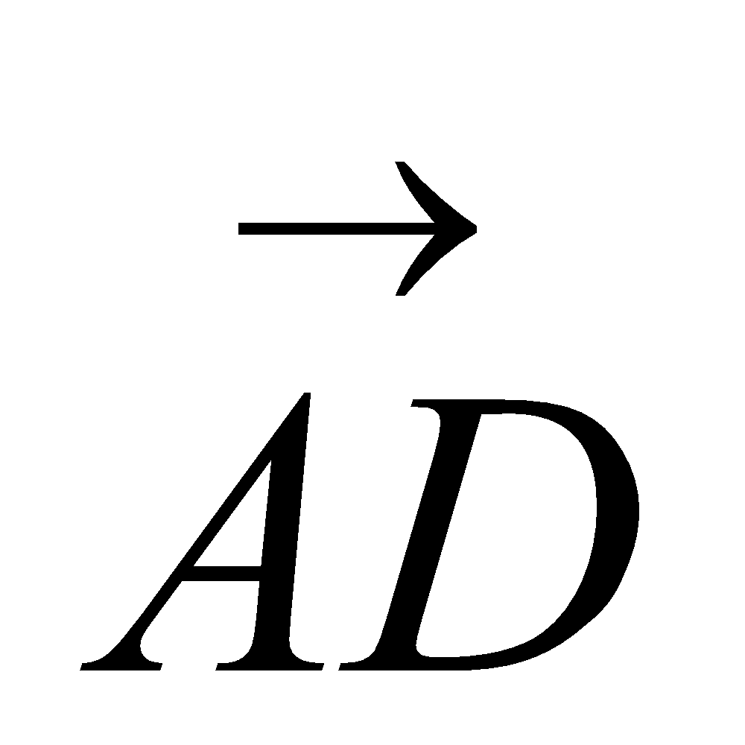 = q
(a) Express, in terms of p and q
(i) 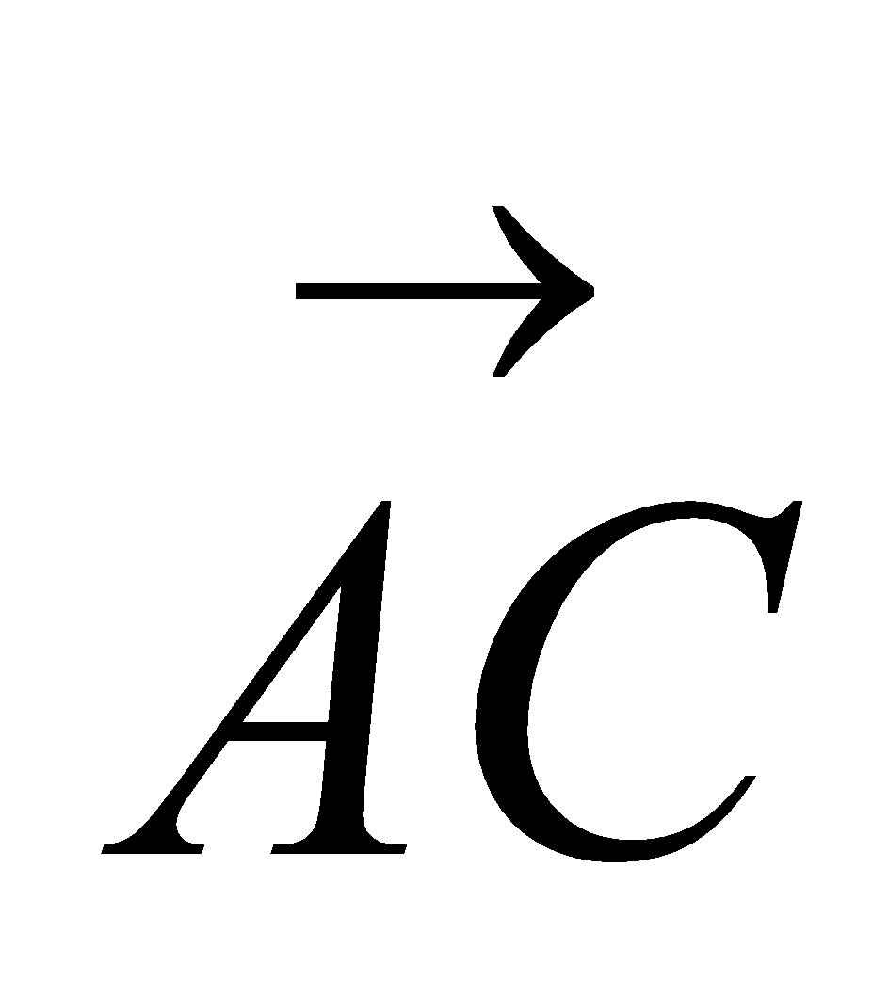

...........................................................
(ii) 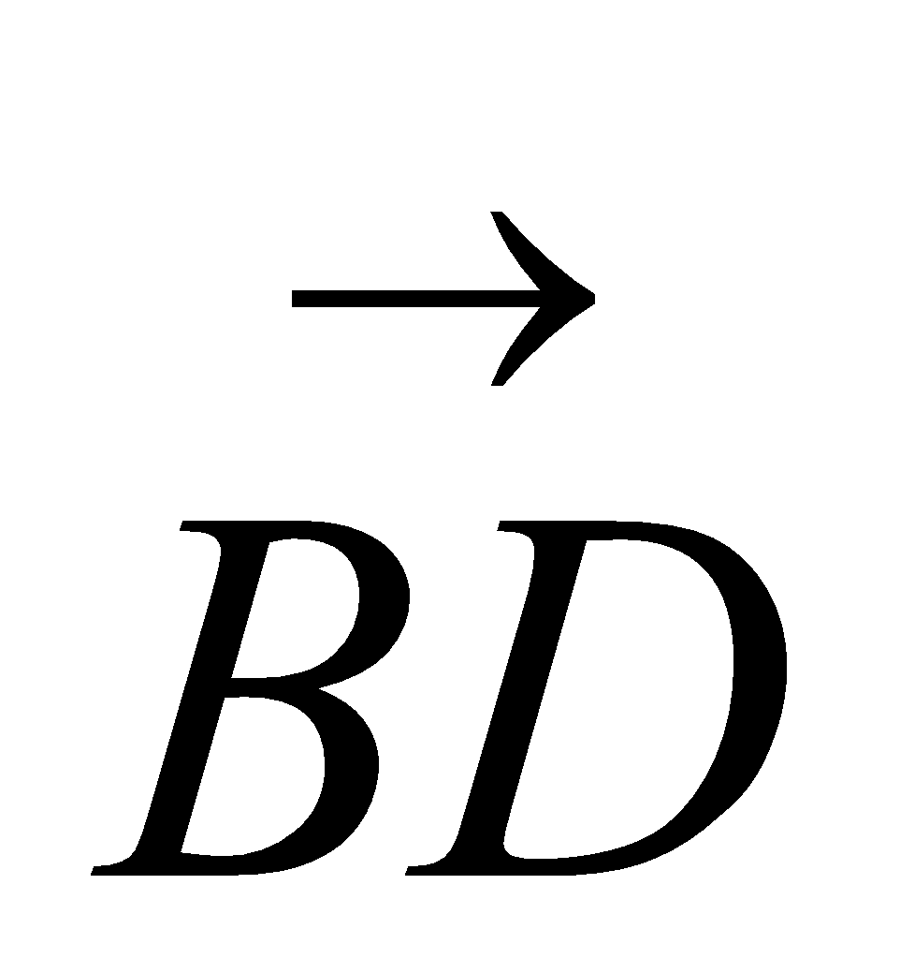

...........................................................
(2)
Diagram NOT accurately drawn
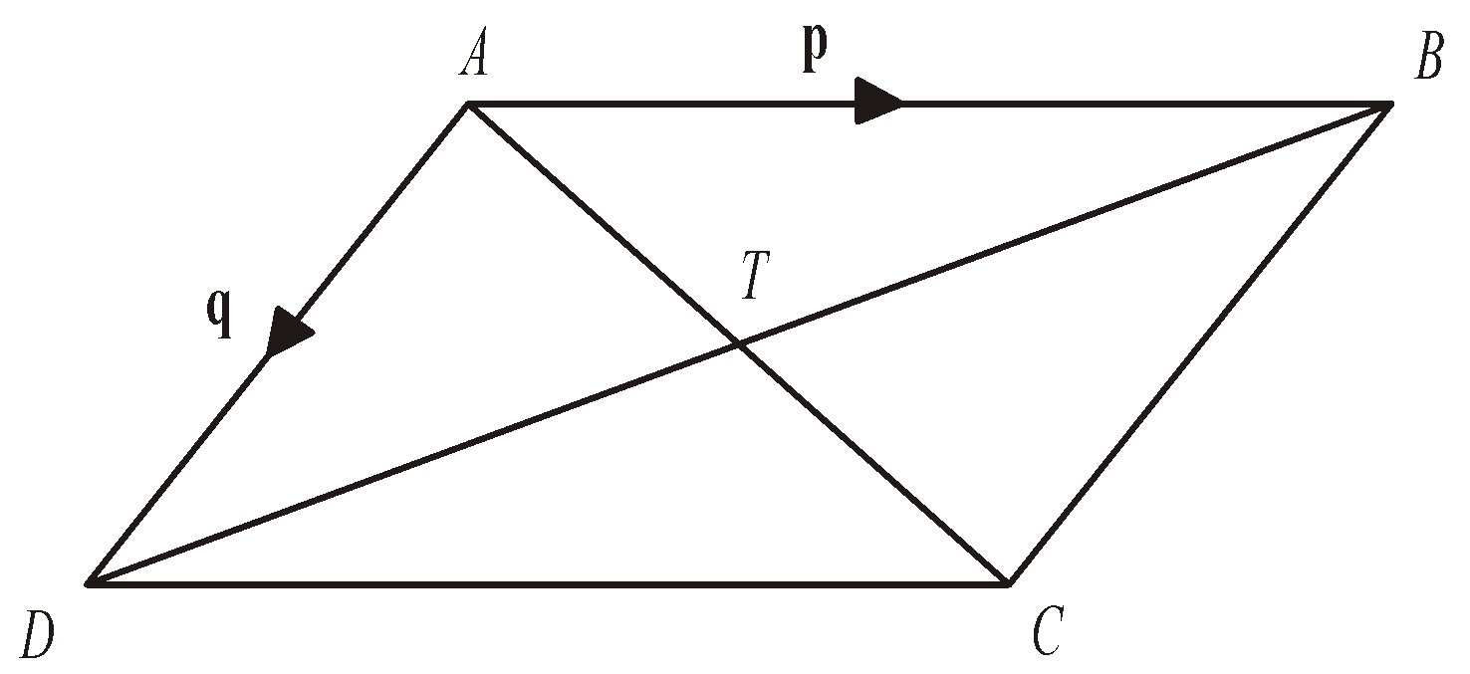
AC and BD are diagonals of parallelogram ABCD.
AC and BD intersect at T.
- Express 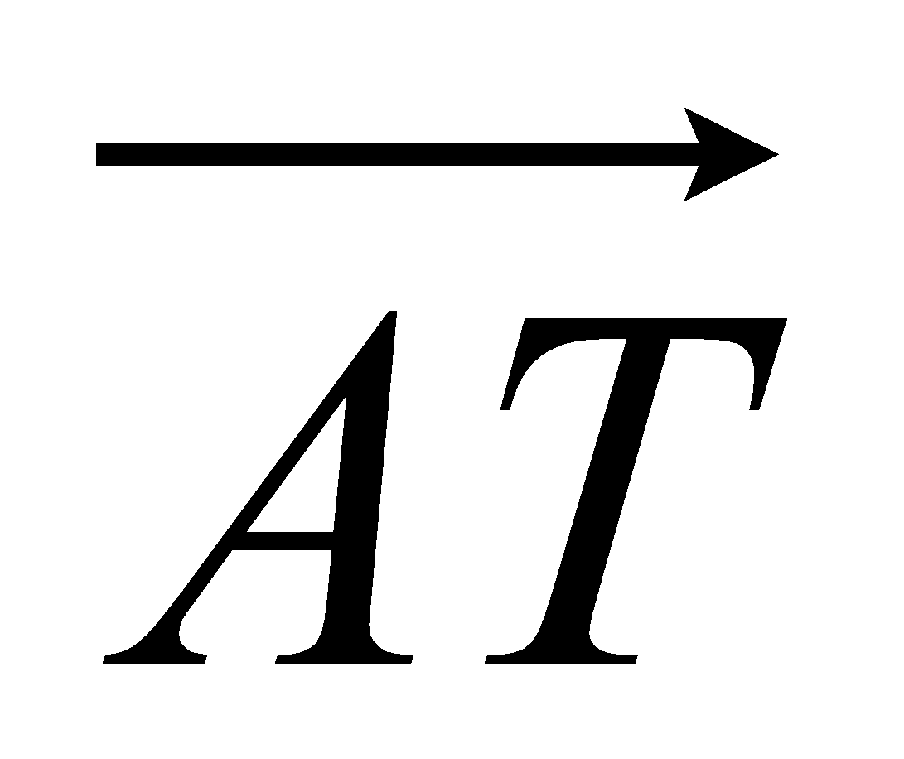 in terms of p and q.

...........................................................
(1)
(Total 3 marks)
8. Diagram NOT accurately drawn
OAB is a triangle.
B is the midpoint of OR.
Q is the midpoint of AB.
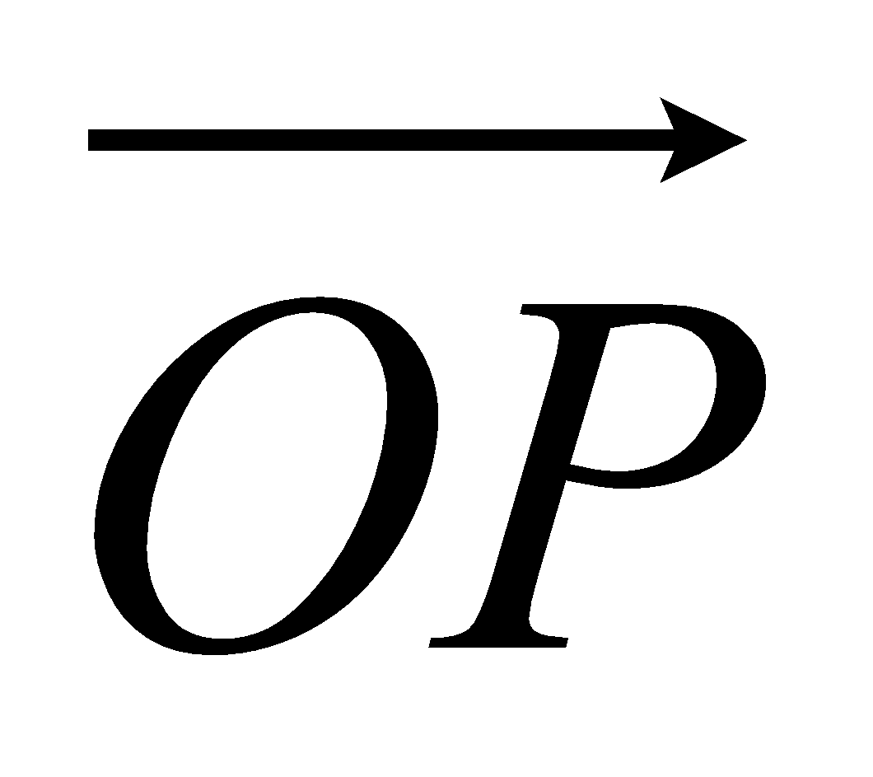 = 2a 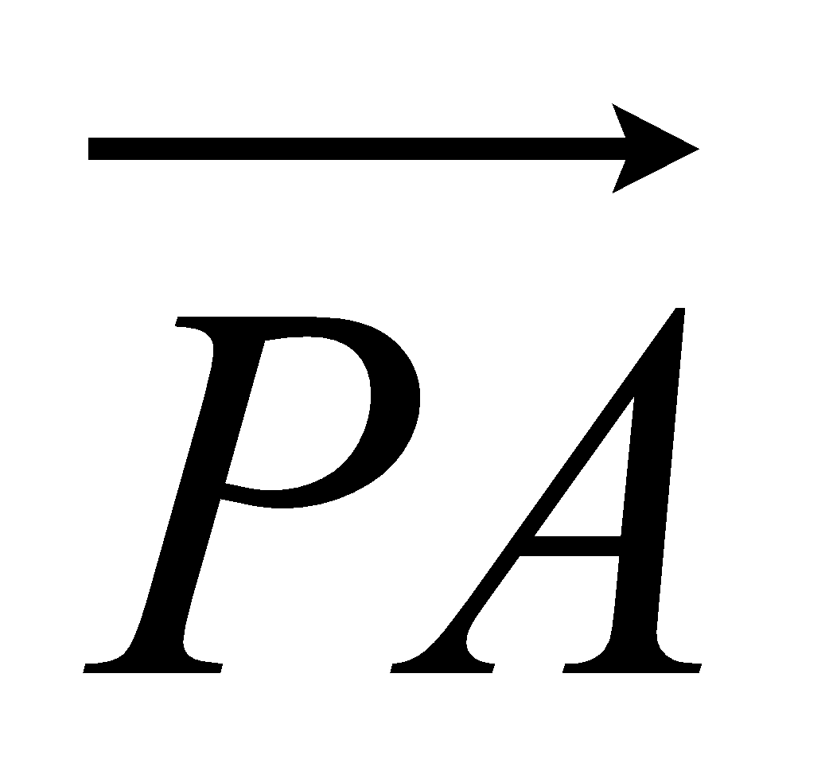 = a 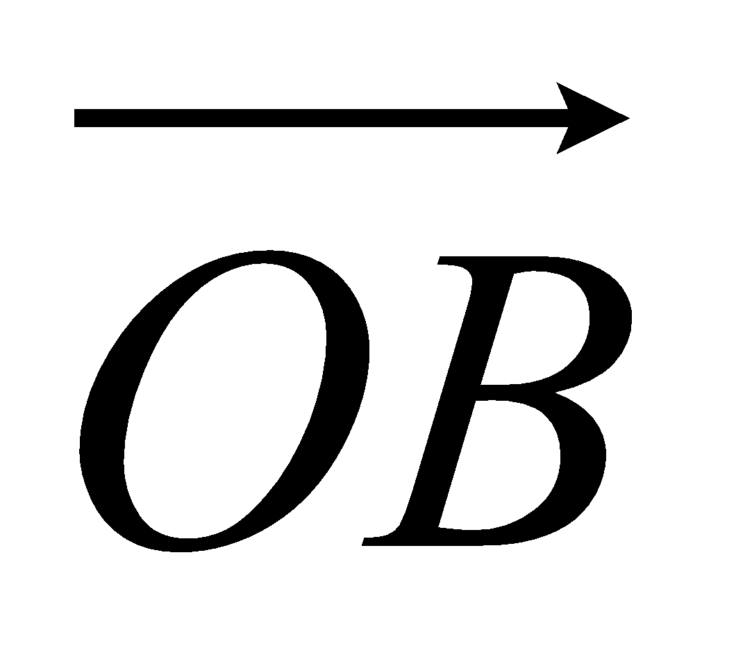 = b

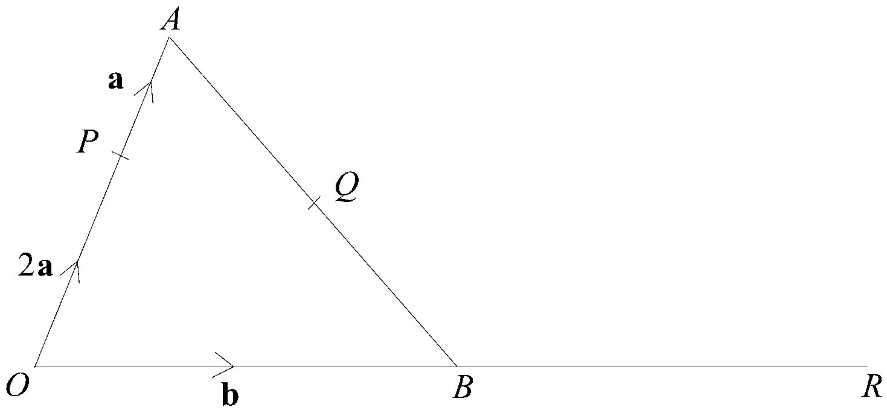
(a) Find, in terms of a and b, the vectors
(i) 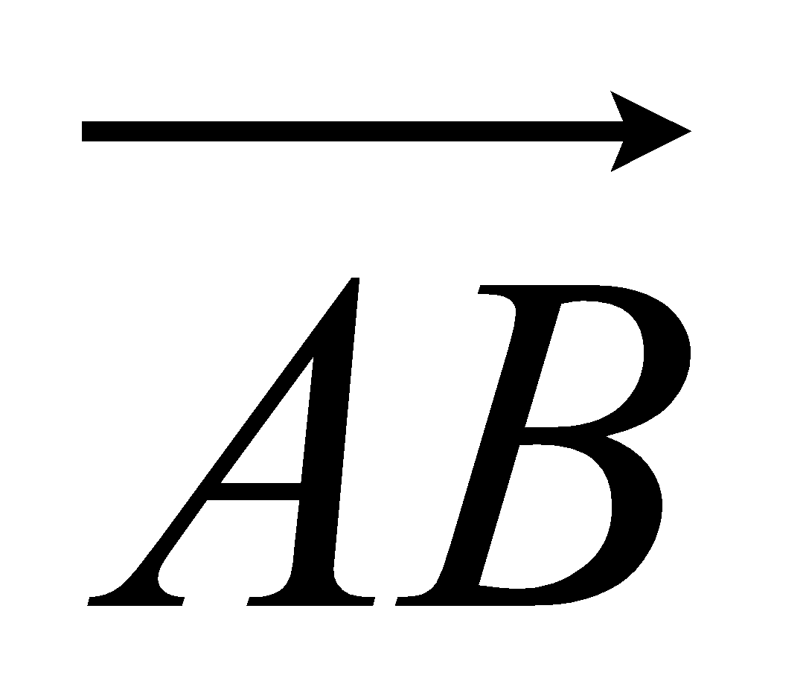,
...........................................................
(ii) ,
...........................................................
(iii) 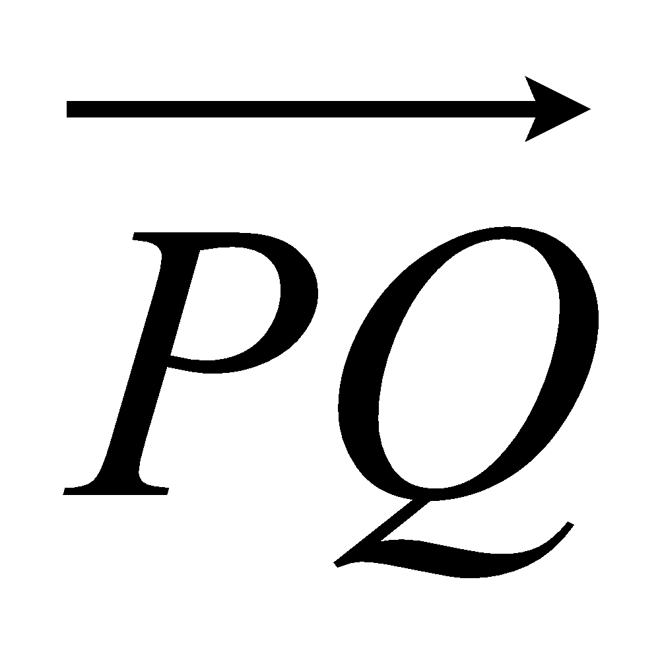.
...........................................................
(4)
(b) Hence explain why PQR is a straight line.

(2)
The length of PQ is 3 cm.
(c) Find the length of PR.

........................................................... cm
(1)
(Total 7 marks)

Sine and Cosine Rules
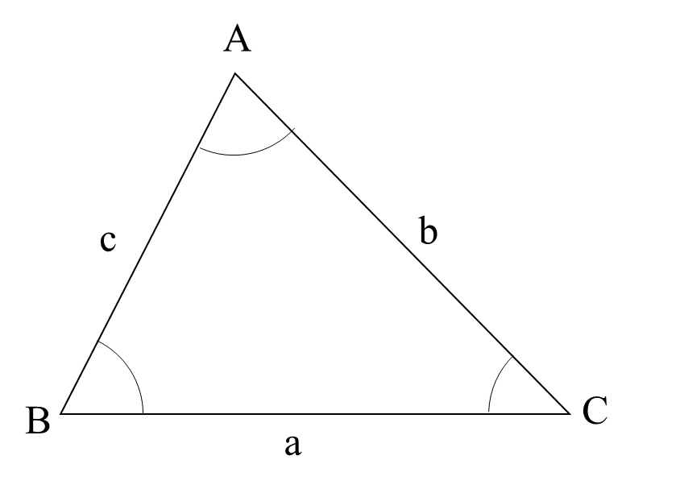
Things to remember:
- For any triangle ABC, a² = b² + c² - 2bc cosA
- For any triangle ABC, $\frac{a}{sinsin A }$ = $\frac{b}{sinsin B }$ = $\frac{c}{sinsin C }$
- For any triangle ABC, area = ½ a b sinC

Questions:
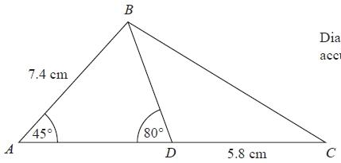
1. Diagram NOT accurately drawn
ABC is a triangle.
D is a point on AC.
Angle BAD = 45°
Angle ADB = 80°
AB = 7.4 cm
DC = 5.8 cm

Work out the length of BC.
Give your answer correct to 3 significant figures.
........................................................... cm
(Total for question = 5 marks)

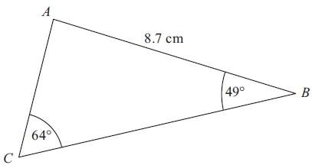
2. Diagram NOT accurately drawn
ABC is a triangle.
AB = 8.7 cm.
Angle ABC = 49°.
Angle ACB = 64°.
Calculate the area of triangle ABC.
Give your answer correct to 3 significant figures.

........................................................... cm²
(Total for Question is 5 marks)
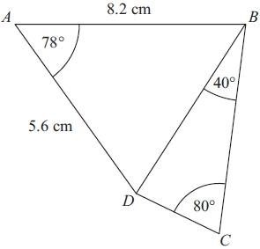
3. ABCD is a quadrilateral.
Diagram NOT accurately drawn
Work out the length of DC.
Give your answer correct to 3 significant figures.

........................................................... cm
(Total for Question is 6 marks)

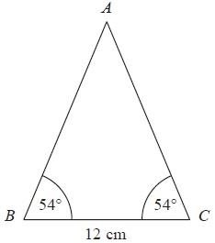
4. Diagram NOT accurately drawn
ABC is an isosceles triangle.
Work out the area of the triangle.
Give your answer correct to 3 significant figures.

........................................................... cm²
(Total for Question is 4 marks)
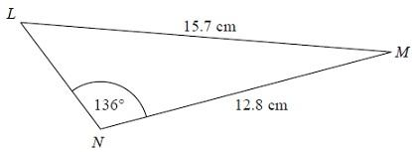
5. Diagram NOT accurately drawn
The diagram shows triangle LMN.
Calculate the length of LN.
Give your answer correct to 3 significant figures.
........................................................... cm
(Total for Question is 5 marks)

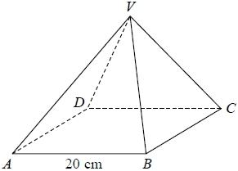
6. VABCD is a solid pyramid.
ABCD is a square of side 20 cm.
The angle between any sloping edge and the plane ABCD is 55°
Calculate the surface area of the pyramid.
Give your answer correct to 2 significant figures.

...........................................................cm²
(Total for question = 5 marks)
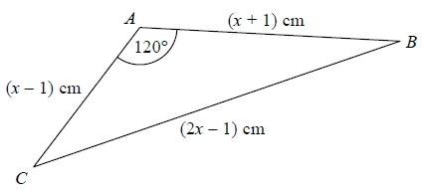
7. The diagram shows triangle ABC.
The area of triangle ABC is k√3 cm².
Find the exact value of k.
k = ...........................................................
(Total for question = 7 marks)

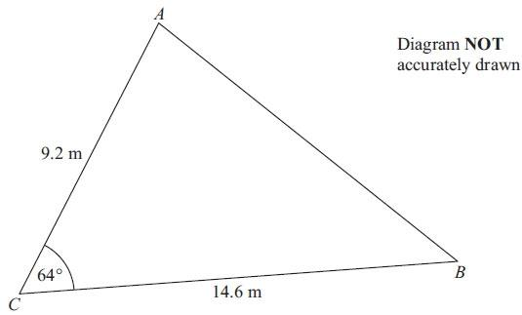
8. Diagram NOT accurately drawn

AC = 9.2 m
BC = 14.6 m
Angle ACB = 64°
(a) Calculate the area of the triangle ABC.
Give your answer correct to 3 significant figures.

.......................................................... m²
(2)
(b) Calculate the length of AB.
Give your answer correct to 3 significant figures.

..........................................................
(3)
(Total for Question is 5 marks)
Area under Graphs

Things to remember:
- Velocity is speed with direction
- Acceleration and deceleration is given by the gradient of the graph $\left(\frac{rise}{run}\right)$
- The distance travelled is given by the area under the graph.

Questions:
1. A car has an initial speed of u m/s.
The car accelerates to a speed of 2u m/s in 12 seconds.
The car then travels at a constant speed of 2u m/s for 10 seconds.
Assuming that the acceleration is constant, show that the total distance, in metres, travelled
by the car is 38u.

(Total for question = 4 marks)

2. Karol runs in a race.
The graph shows her speed, in metres per second, t seconds after the start of the race.
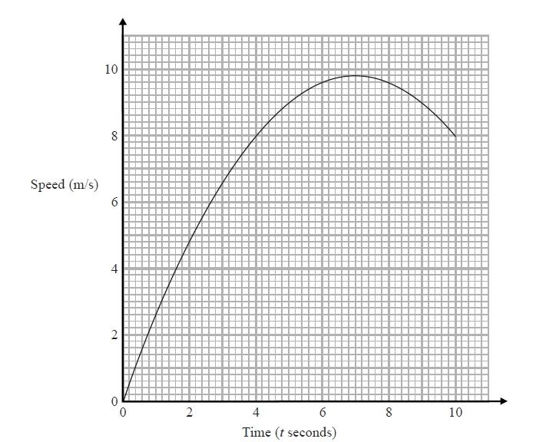
(a) Calculate an estimate for the gradient of the graph when t = 4
You must show how you get your answer.
...........................................................
(3)
(b) Describe fully what your answer to part (a) represents.

.......................................................................................................................................
.......................................................................................................................................
(2)
(c) Explain why your answer to part (a) is only an estimate.

.......................................................................................................................................

.......................................................................................................................................
(1)
(Total for question = 6 marks)

3. Here is a speed-time graph for a car journey.
The journey took 100 seconds.
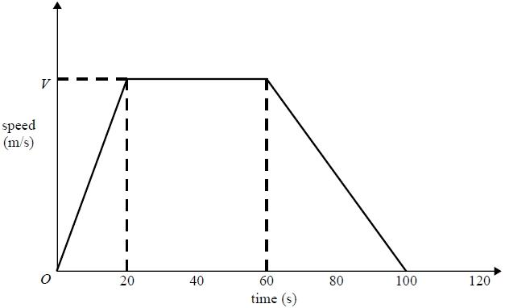
The car travelled 1.75km in the 100 seconds.
(a) Work out the value of V.
...........................................................
(3)
(b) Describe the acceleration of the car for each part of this journey.

.......................................................................................................................................

.......................................................................................................................................

.......................................................................................................................................

.......................................................................................................................................

.......................................................................................................................................

.......................................................................................................................................

.......................................................................................................................................
(2)
(Total for question = 5 marks)

4. The graph shows information about the velocity, v m/s, of a parachutist t seconds after
leaving a plane.
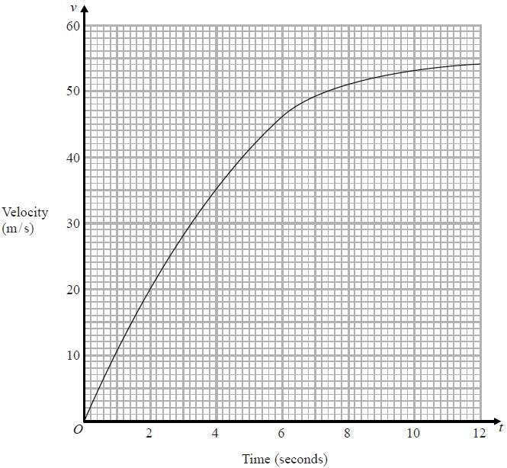
(a) Work out an estimate for the acceleration of the parachutist at t = 6
........................................................... m/s²
(2)
(b) Work out an estimate for the distance fallen by the parachutist in the first
12 seconds after leaving the plane.
Use 3 strips of equal width.

........................................................... m
(3)
(Total for question is 5 marks)

5. Here is a speed-time graph for a car.
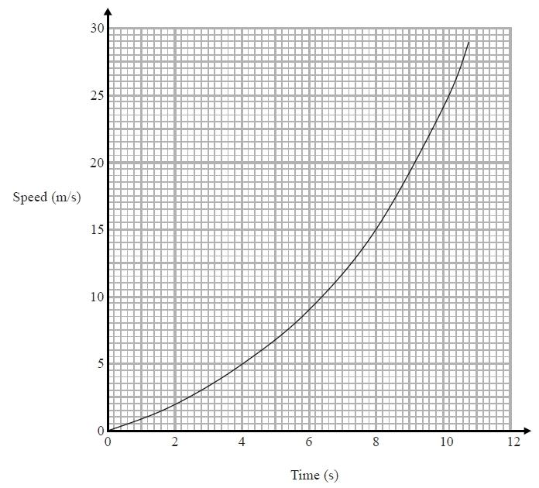
(a) Work out an estimate for the distance the car travelled in the first 10 seconds.
Use 5 strips of equal width.
........................................................... m
(3)
(b) Is your answer to (a) an underestimate or an overestimate of the actual distance?
Give a reason for your answer.

.......................................................................................................................................

.......................................................................................................................................

.......................................................................................................................................
(1)
(Total for question = 4 marks)

Histograms

Things to remember:
- Frequency = Frequency Density x Class Width;
- The y-axis will always be labelled “frequency density”;
- The x-axis will have a continuous scale.

Questions:
1. One Monday, Victoria measured the time, in seconds, that individual birds spent on her bird table. She used this information to complete the frequency table.

Time (t seconds) | Frequency
0 < t ≤ 10 | 8
10 < t ≤ 20 | 16
20 < t ≤ 25 | 15
25 < t ≤ 30 | 12
30 < t ≤ 50 | 6

(a) Use the table to complete the histogram.
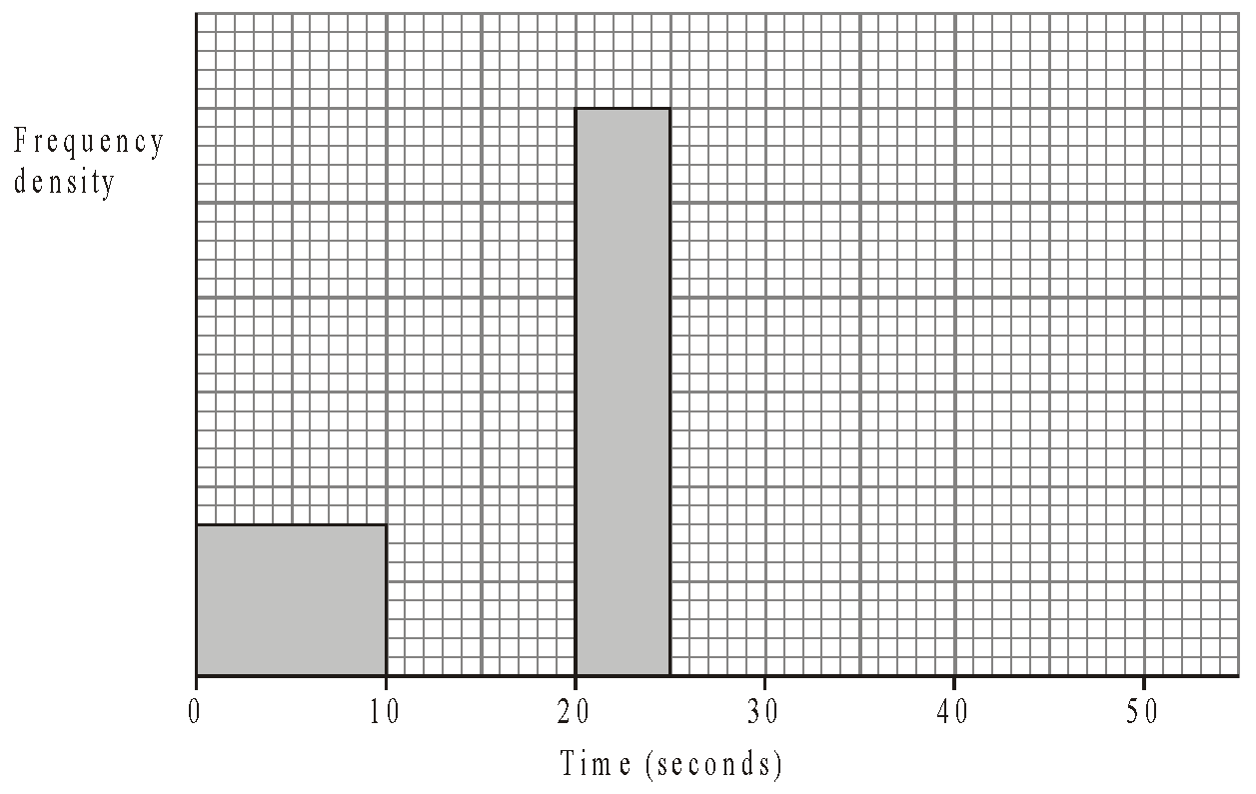
(3)

On Tuesday she conducted a similar survey and drew the following histogram from her results.
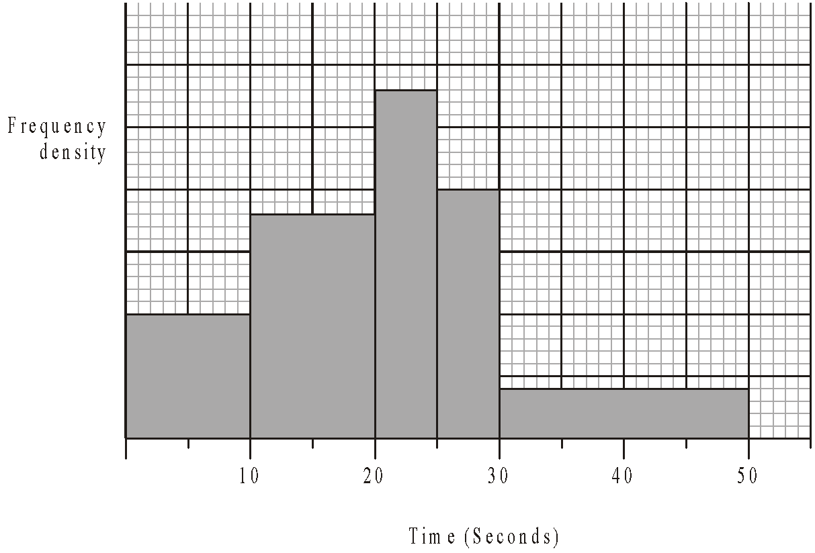

(b) Use the histogram for Tuesday to complete the table.

Time (t seconds) | Frequency
0 < t ≤ 10 | 10
10 < t ≤ 20
20 < t ≤ 25
25 < t ≤ 30
30 < t ≤ 50
(2)
(Total 5 marks)

2. This histogram gives information about the books sold in a bookshop one Saturday.
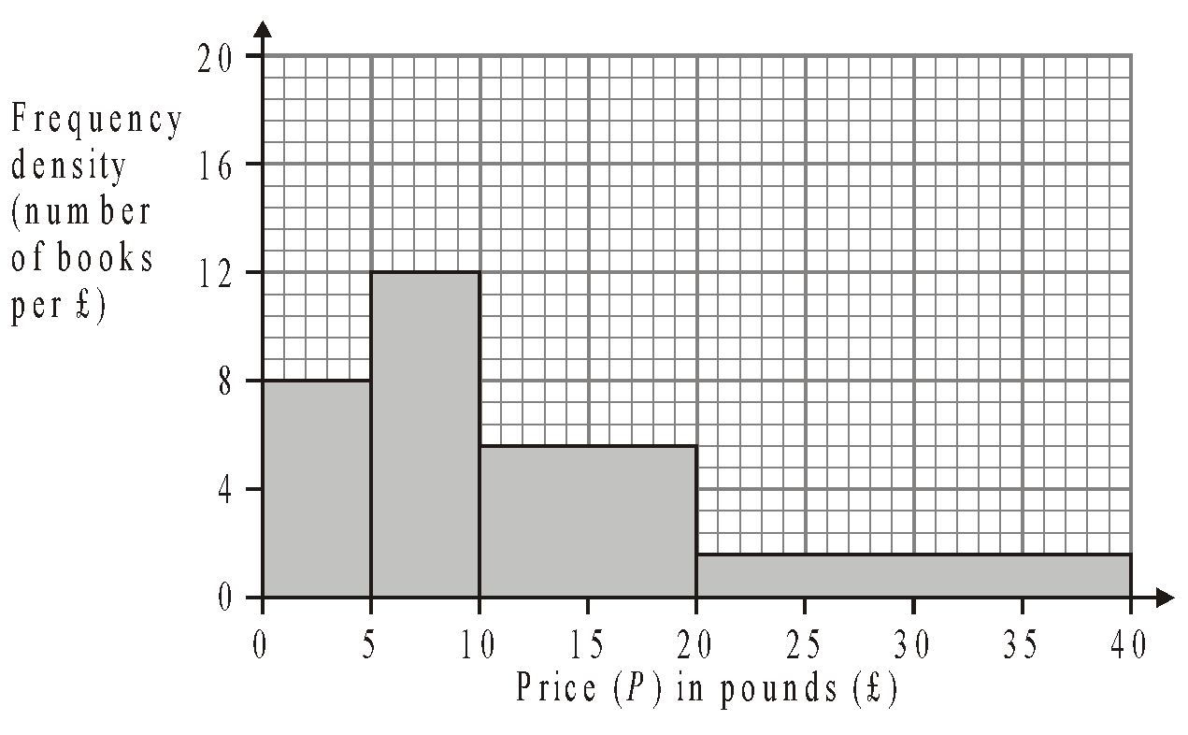
(a) Use the histogram to complete the table.
Price (P) in pounds (£) | Frequency
0 < P ≤ 5
5 < P ≤ 10
10 < P ≤ 20
20 < P ≤ 40
(2)
The frequency table below gives information about the books sold in a second bookshop on the same Saturday.
Price (P) in pounds (£) | Frequency
0 < P ≤ 5 | 80
5 < P ≤ 10 | 20
10 < P ≤ 20 | 24
20 < P ≤ 40 | 96
(b) On the grid below, draw a histogram to represent the information about the books sold in the second bookshop.
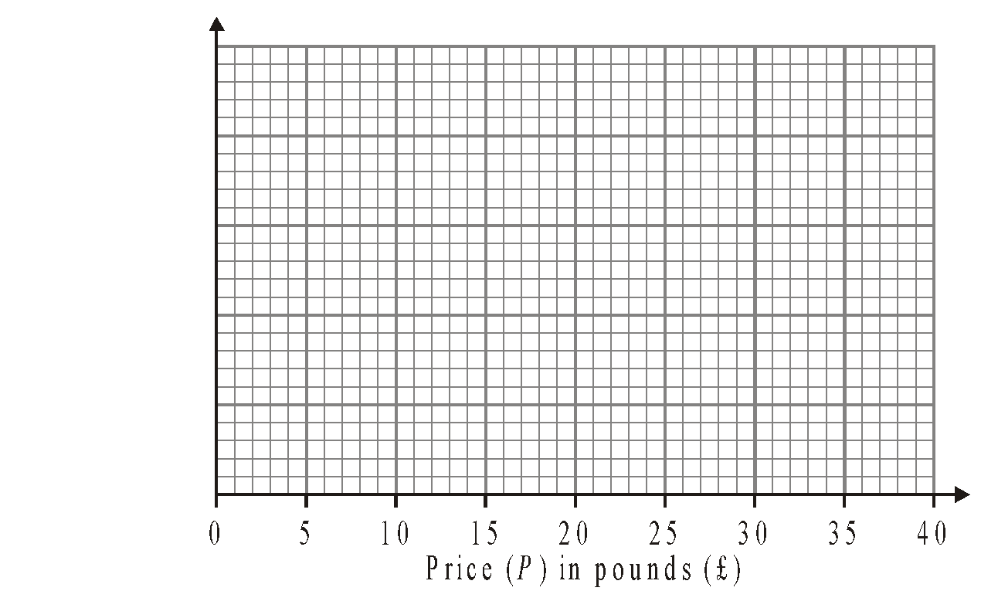
(3)
(Total 5 marks)

3. The incomplete table and histogram give some information about the distances walked by some students in a school in one year.

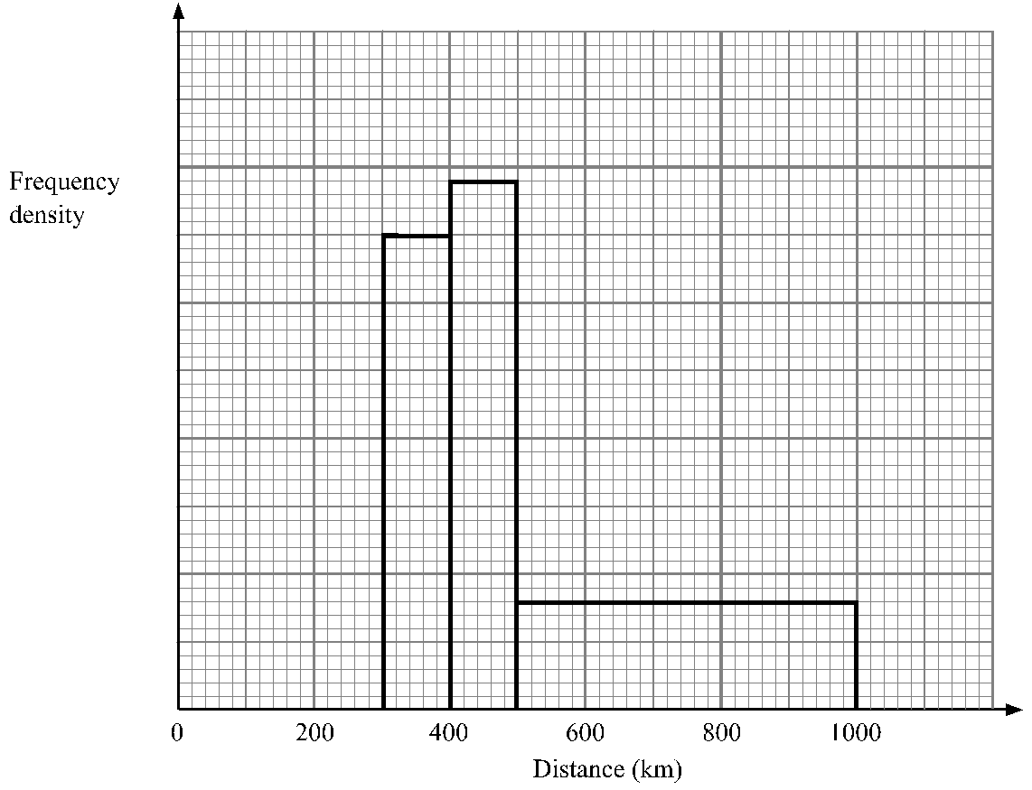

(a) Use the information in the histogram to complete the frequency table.

Distance (d) in km | Frequency
0 < d ≤ 300 | 210
300 < d ≤ 400 | 350
400 < d ≤ 500
500 < d ≤ 1000
(2)
(b) Use the information in the table to complete the histogram.
(1)
(Total 3 marks)

4. The incomplete histogram and table show information about the weights of some containers.

Weight (w) in kg | Frequency
0 < w ≤ 1000 | 16
1000 < w ≤ 2000
2000 < w ≤ 4000
4000 < w ≤ 6000 | 16
6000 < w ≤ 8000
8000 < w ≤ 12000 | 8

(a) Use the information in the histogram to complete the table.
(2)
(b) Use the information in the table to complete the histogram.
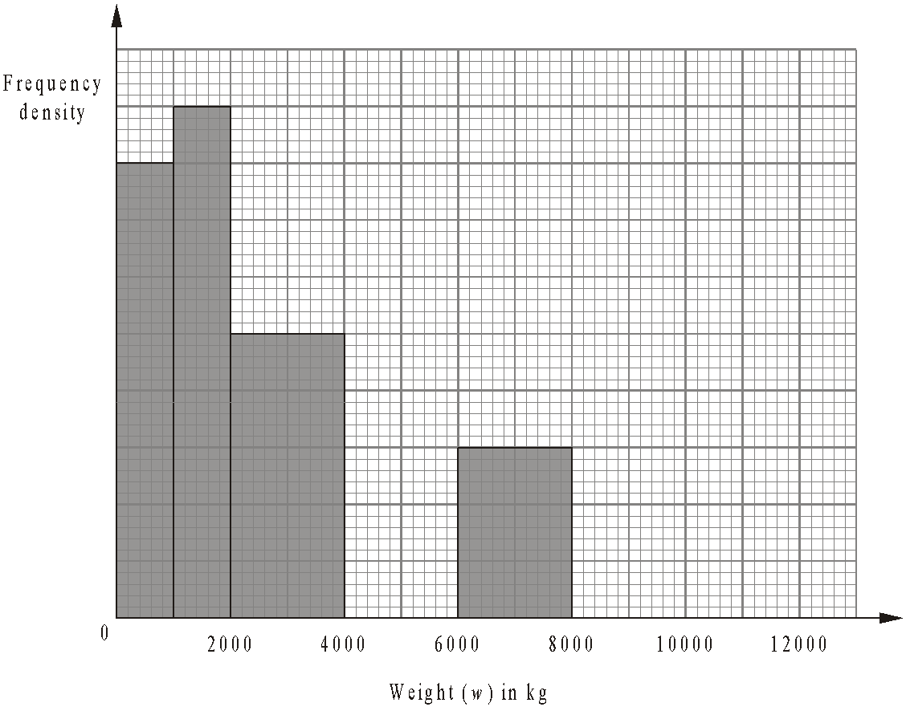
(2)
(Total 4 marks)

5. The incomplete histogram and table give some information about the distances some teachers travel to school.

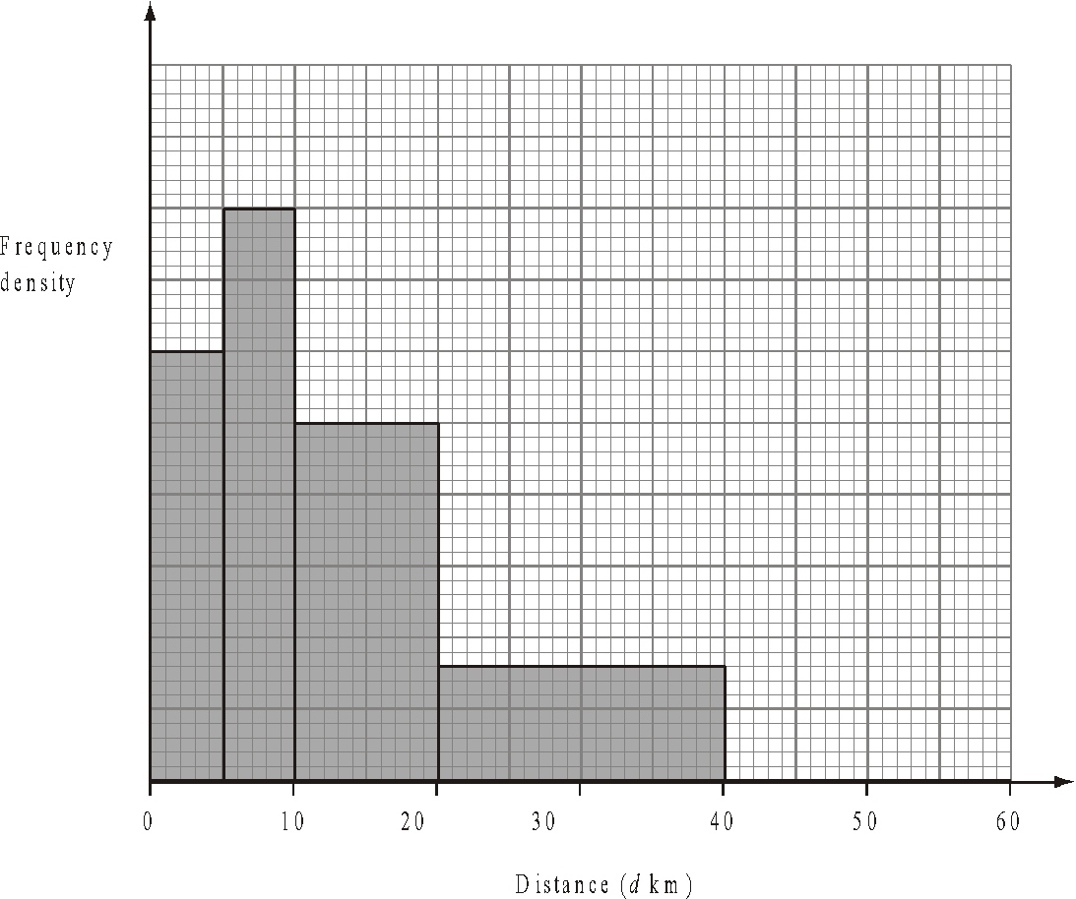
(a) Use the information in the histogram to complete the frequency table.

Distance (dkm) | Frequency
0 < d ≤ 5 | 15
5 < d ≤ 10 | 20
10 < d ≤ 20
20 < d ≤ 40
40 < d ≤ 60 | 10
(2)
(b) Use the information in the table to complete the histogram.
(1)
(Total 3 marks)

6. The table gives information about the heights, in centimetres, of some 15 year old students.

Height (h cm) | 145 < h ≤ 155 | 155 < h ≤ 175 | 175 < h ≤ 190
Frequency | 10 | 80 | 24

Use the table to draw a histogram.

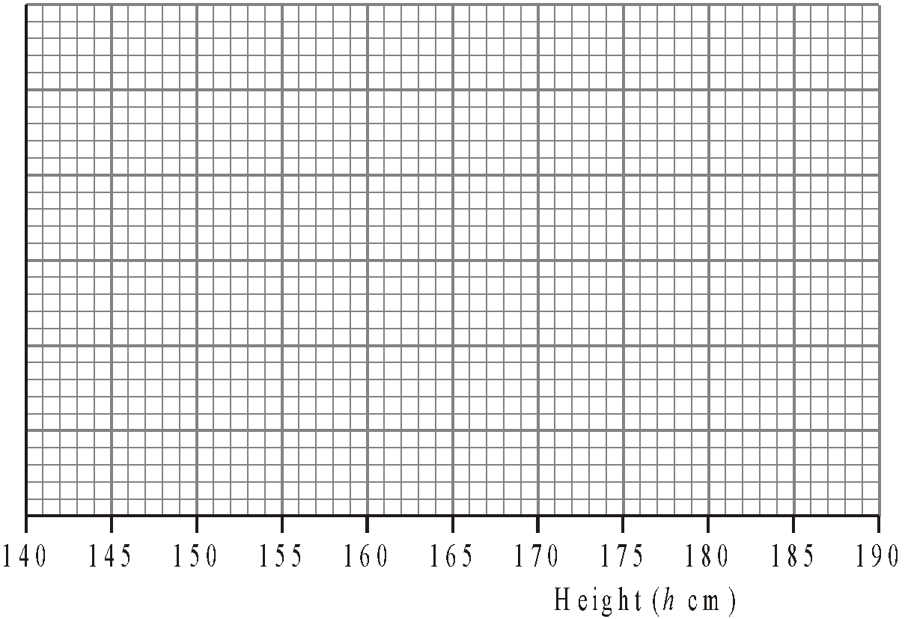
(Total 3 marks)

7. A teacher asked some year 10 students how long they spent doing homework each night.
The histogram was drawn from this information.
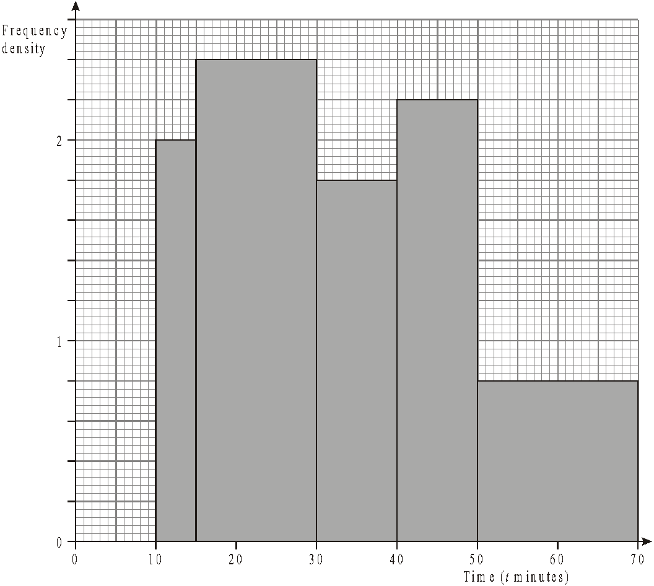
Use the histogram to complete the table.

Time (t minutes) | Frequency
10 ≤ t < 15 | 10
15 ≤ t < 30
30 ≤ t < 40
40 ≤ t < 50
50 ≤ t < 70
(Total 2 marks)

Capture-Recapture

Things to remember:
- Set up a pair of equivalent fractions 🡪 how many out of $x$ were tagged = how many of the second sample are tagged out of how many in the original sample.
- This method assumes that the original sample is thoroughly mixed back in.

Questions:
1. A scientist wants to estimate the number of fish in a lake.
He catches 50 fish from the lake and marks them with a dye.
The fish are then returned to the lake.
The next day the scientist catches another 50 fish.
4 of these fish are marked with the dye.
Work out an estimate for the total number of fish in the lake.

........................................................................................................
(Total 2 marks)

2. A farmer wants to estimate the number of rabbits on his farm.
On Monday he catches 120 rabbits.
He puts a tag on each rabbit.
He then lets the rabbits run away.
On Tuesday the farmer catches 70 rabbits.
15 of these rabbits have a tag on them.
Work out an estimate for the total number of rabbits on the farm.

........................................................................................................
(Total 2 marks)

3. There are N beads in a jar.
40 of these beads are black.
Julie takes at random a sample of 50 beads from the jar.
5 of the beads in her sample are black.
Work out an estimate for the value of N.

..............................................................
(Total 2 marks)
4. Clive wants to estimate the number of bees in a beehive.
Clive catches 50 bees from the beehive.
He marks each bee with a dye.
He then lets the bees go.
The next day, Clive catches 40 bees from the beehive.
8 of these bees have been marked with the dye.
(i) Work out an estimate for the number of bees in the beehive.

............................................ bees

(ii) Write down any assumptions you have made.

.......................................................................................................................................

.......................................................................................................................................

.......................................................................................................................................
(Total 4 marks)

5. Toga wants to estimate the number of termites in a nest.
On Monday Toga catches 80 termites.
He puts a mark on each termite.
He then puts all 80 termites back in the nest.
On Tuesday Toga catches 60 termites.
12 of these termites have a mark on them.
Work out an estimate for the total number of termites in the nest.

..............................................................
(Total 2 marks)

6. There are a large number of white beads in a bag.
There are only white beads in the bag.
Felicity wants to find an estimate for the number of beads in the bag.
Felicity replaces 30 of the white beads in the bag with 30 black beads.
She then takes 50 beads from the bag.
2 of the 50 beads are black.
Felicity then puts the 50 beads back in the bag.
(a) Work out an estimate for the number of beads in the bag.

......................................................
(2)
(b) Write down one assumption you have made.

.......................................................................................................................................

.......................................................................................................................................
(1)
(Total 3 marks)

7. Alex wants to find out how many ducks there are in a park.
One day he puts a tag on each of 30 of the ducks.
The next day he catches 40 ducks.
8 of these ducks have tags on them.
(i) Work out an estimate for the number of ducks in the park.

.......................................................

Alex assumed that none of the tags fell off during the night.
(ii) If Alex’s assumption is wrong, explain how this could affect your answer to part (i).

.......................................................................................................................................

.......................................................................................................................................
(Total 4 marks)

Set Theory

Things to remember:
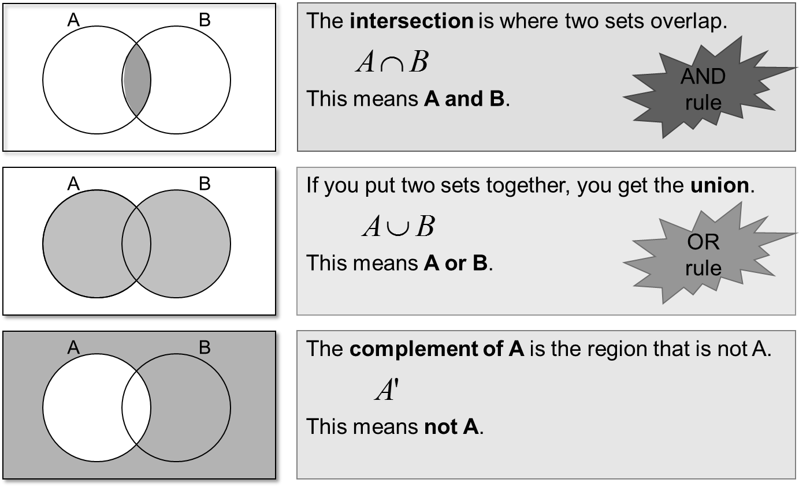

Questions:
1.
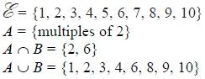
Draw a Venn diagram for this information.

(Total for question is 4 marks)

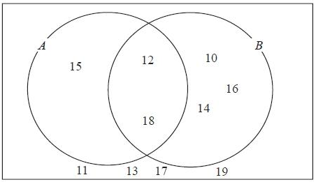
2. Here is a Venn diagram.

(a) Write down the numbers
that are in set
(i) A ∪ B

.............................................

(ii) A ∩ B
.............................................
(2)

One of the numbers in the diagram is chosen at random.
(b) Find the probability that the number is in set A'

...........................................................
(2)
(Total for question = 4 marks)

4. Sami asked 50 people which drinks they liked from tea, coffee and milk.
All 50 people like at least one of the drinks
19 people like all three drinks.
16 people like tea and coffee but do not like milk.
21 people like coffee and milk.
24 people like tea and milk.
40 people like coffee.
1 person likes only milk.
Sami selects at random one of the 50 people.
(a) Work out the probability that this person likes tea.

...........................................................
(4)
(b) Given that the person selected at random from the 50 people likes tea, find the probability that this person also likes exactly one other drink.

...........................................................
(2)
(Total for question = 6 marks)

Proportion

Things to remember:
- Start by checking the question for squares, cubes and roots;
- “x is directly proportional to y” looks like x α y or x = ky
- “x is inversely proportional to y” looks like x α $\frac{1}{y}$or x = $\frac{k}{y}$

Questions:
1. The shutter speed, S, of a camera varies inversely as the square of the aperture setting, f.
When f = 8, S = 125
(a) Find a formula for S in terms of f.

...........................................................
(3)
(b) Hence, or otherwise, calculate the value of S when f = 4

S = ...........................................................
(1)
(Total 4 marks)
2. In a factory, chemical reactions are carried out in spherical containers.
The time, T minutes, the chemical reaction takes is directly proportional to the square of the radius, R cm, of the spherical container.
When R = 120, T = 32
Find the value of T when R = 150

T = ...........................................................
(Total 4 marks)

3. d is directly proportional to the square of t.
d = 80 when t = 4
(a) Express d in terms of t.

...........................................................
(3)
(b) Work out the value of d when t = 7

d = ...........................................................
(1)
(c) Work out the positive value of t when d = 45

t = ...........................................................
(2)
(Total 6 marks)

4. The distance, D, travelled by a particle is directly proportional to the square of the time, t, taken. When t = 40, D = 30
(a) Find a formula for D in terms of t.

D = ...........................................................
(3)
(b) Calculate the value of D when t = 64

...........................................................
(1)
(c) Calculate the value of t when D = 12
Give your answer correct to 3 significant figures.

...........................................................
(2)
(Total 6 marks)
5. The time, T seconds, it takes a water heater to boil some water is directly proportional
to the mass of water, m kg, in the water heater. When m = 250, T = 600
(a) Find T when m = 400

T = ...........................................................
(3)
The time, T seconds, it takes a water heater to boil a constant mass of water is inversely proportional to the power, P watts, of the water heater.
When P = 1400, T = 360
(b) Find the value of T when P = 900

T = ...........................................................
(3)
(Total 6 marks)

6. A ball falls vertically after being dropped.
The ball falls a distance d metres in a time of t seconds.
d is directly proportional to the square of t.
The ball falls 20 metres in a time of 2 seconds.
(a) Find a formula for d in terms of t.

d = ...........................................................
(3)
(b) Calculate the distance the ball falls in 3 seconds.

........................................................... m
(1)
(c) Calculate the time the ball takes to fall 605 m.

........................................................... seconds
(3)
(Total 7 marks)
7. In a spring, the tension (T newtons) is directly proportional to its extension (x cm). When the tension is 150 newtons, the extension is 6 cm.
(a) Find a formula for T in terms of x.

T = ...........................................................
(3)
(b) Calculate the tension, in newtons, when the extension is 15 cm.

...........................................................newtons
(1)
(c) Calculate the extension, in cm, when the tension is 600 newtons.

...........................................................cm
(1)
(Total 5 marks)

8. f is inversely proportional to d.
When d = 50, f = 256
Find the value of f when d = 80

f = ...........................................................
(Total 3 marks)

Percentages – reverse

Things to remember:
- Work out what the multiplier would have been;
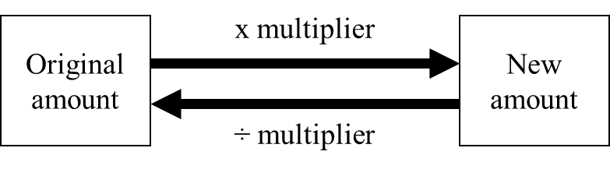

Questions:
1. Loft insulation reduces annual heating costs by 20%.
After he insulated his loft, Curtley’s annual heating cost was £520.
Work out Curtley’s annual heating cost would have been, if he had not insulated his loft.

£ ...........................................................
(Total 3 marks)

2. In a sale, normal prices are reduced by 20%.
SALE - 20% OFF
Andrew bought a saddle for his horse in the sale.
The sale price of the saddle was £220.
Calculate the normal price of the saddle.

£ ...........................................................
(Total 3 marks)

3. Hajra’s weekly pay this year is £240
This is 20% more than her weekly pay last year.
Bill says ‘This means Hajra’s weekly pay last year was £192’.
Bill is wrong,
(a) Explain why.

.......................................................................................................................................

.......................................................................................................................................
(1)
(b) Work out Hajra’s weekly pay last year.

£ ...........................................................
(2)
(Total 3 marks)

4. The price of all rail season tickets to London increased by 4%.
(a) The price of a rail season ticket from Cambridge to London increased by £121.60
Work out the price before this increase.

£ ...........................................................
(2)
(b) After the increase, the price of a rail season ticket from Brighton to London was £2828.80
Work out the price before this increase.

£ ...........................................................
(3)
(Total 5 marks)

5. In a sale, normal prices are reduced by 25%.
The sale price of a saw is £12.75
Calculate the normal price of the saw.

£ ...........................................................
(Total 3 marks)

6. In a sale, normal prices are reduced by 12%.
The sale price of a DVD player is £242.
Work out the normal price of the DVD player.

£ ...........................................................
(Total 3 marks)

7. A garage sells cars.
It offers a discount of 20% off the normal price for cash.
Dave pays £5200 cash for a car.
Calculate the normal price of the car.

£ ...........................................................
(Total 3 marks)

Useful websites:

www.mathswatchvle.com

www.methodmaths.com

www.hegartymaths.com

www.mymaths.co.uk

www.drfrost.com

www.bbc.co.uk/schools/gcsebitesize
/maths

Remember: Do your best;
it is all you can do ☺

