GCSE MATHEMATICS

Aiming for Grade 7

REVISION BOOKLET

Exam Dates:
________________
________________
________________

Name: ______________________________
Contents
Page:
Number:
Surds 3
Bounds calculations 7

Algebra:
Parallel and perpendicular graphs 11
Transformations of graphs 16
Algebraic fractions - simplifying 20
Algebraic fractions – solving 23
Solving quadratic inequalities 26

Shape, Space and Measure:
Circle theorems 28
Vectors 32
Sine and cosine rules 40

Data Handling:
Cumulative frequency and box plots 44
Histograms 51

Probability:
Set theory 59

Ratio and Proportion:
Proportion 62
Percentages – compound interest 66
Percentages – reverse 68

Surds

Things to remember:
- √ means square root;
- To simplify surds, find all its factors;
- To rationalise the denominator, find an equivalent fraction where the denominator is rational.

Questions:
1. Work out
$\frac{(5 + \sqrt{3})(5- \sqrt{3})}{\sqrt{22}}$
Give your answer in its simplest form.

……………………………………
(Total 3 marks)

2. (a) Rationalise the denominator of $\frac{1}{\sqrt{3}}$

……………………………………
(1)
(b) Expand $(2+ \sqrt{3})(1+ \sqrt{3})$
Give your answer in the form $a+b\sqrt{3}$ where a and b are integers.

……………………………………
(2)
(Total 3 marks)
3. (a) Rationalise the denominator of $\frac{1}{\sqrt{7}}$

……………………………………
(2)
(b) (i) Expand and simplify ${(\sqrt{3}+ \sqrt{15})}^{2}$
Give your answer in the form $a+b\sqrt{3}$ where a and b are integers.

……………………………………

(ii) All measurements on the triangle are in centimetres.
ABC is a right-angled triangle.
k is a positive integer.
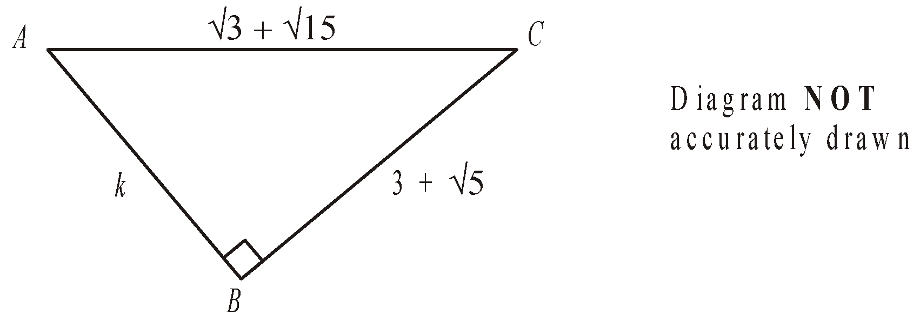

Find the value of k.

k = ……………………………………
(5)
(Total 7 marks)

4. Expand and simplify $(\sqrt{3}- \sqrt{2})(\sqrt{3}- \sqrt{2})$

……………………………………
(Total 2 marks)

5. (a) Write down the value of ${49}^{\frac{1}{2}}$
……………………………………
(1)
(b) Write $\sqrt{45}$ in the form $k\sqrt{5}$, where k is an integer.

……………………………………
(1)
(Total 2 marks)

6. Write $\frac{\sqrt{18} + 10}{\sqrt{2}}$ in the form $a+b\sqrt{3}$ where a and b are integers.

a = ……………………………………

b = ……………………………………
(Total 2 marks)

7. Expand and simplify $(2+ \sqrt{3})(7- \sqrt{3})$
Give your answer in the form $a+b\sqrt{3}$ where a and b are integers.

……………………………………
(Total 3 marks)

8. Rationalise the denominator of $\frac{(4 + \sqrt{2})(4 - \sqrt{2)}}{\sqrt{7}}$
Give your answer in its simplest form.

……………………………………
(Total for question = 3 marks)

9. Show that $\frac{(4 - \sqrt{3})(4 + \sqrt{3})}{\sqrt{13}}$ simplifies to $\sqrt{13}$

(Total for question = 2 marks)
Bounds Calculations

Things to remember:
- Calculating bounds is the opposite of rounding – they are the limits at which you would round up instead of down, and vice versa.
- When dividing bounds, UB = UB ÷ LB and LB = LB ÷ UB

Questions:
1. A piece of wood has a length of 65 centimetres to the nearest centimetre.
(a) What is the least possible length of the piece of wood?
……………………………………
(1)
(b) What is the greatest possible length of the piece of wood?
……………………………………
(1)
(Total for Question is 2 marks)

2. Chelsea's height is 168 cm to the nearest cm.
(a) What is Chelsea's minimum possible height?
........................................................... cm
(1)
(b) What is Chelsea's maximum possible height?
........................................................... cm
(1)
(Total for Question is 2 marks)

3. 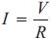
V = 250 correct to the nearest 5
R = 3900 correct to the nearest 100
Work out the lower bound for the value of I.
Give your answer correct to 3 decimal places.
You must show your working.

...........................................................
(Total for question = 3 marks)

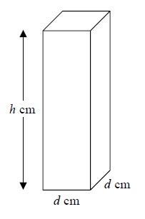
4. Here is a solid bar made of metal.
The bar is in the shape of a cuboid.
The height of the bar is h cm.
The base of the bar is a square of side d cm.
The mass of the bar is M kg.

d = 8.3 correct to 1 decimal place.
M = 13.91 correct to 2 decimal places.
h = 84 correct to the nearest whole number.

Find the value of the density of the metal to an appropriate degree of accuracy.
Give your answer in g/cm³.
You must explain why your answer is to an appropriate degree of accuracy.

(Total for question = 5 marks)

5. Steve travelled from Ashton to Barnfield.
He travelled 235 miles, correct to the nearest 5 miles.
The journey took him 200 minutes, correct to the nearest 5 minutes.
Calculate the lower bound for the average speed of the journey.
Give your answer in miles per hour, correct to 3 significant figures.
You must show all your working.
........................................................... mph
(Total for question = 4 marks)
6. The value of p is 4.3
The value of q is 0.4
Both p and q are given correct to the nearest 0.1
(a) Write down the lower bound for p.
...........................................................
(1)
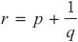
(b) Work out the upper bound for r.
You must show all your working.
...........................................................
(3)
(Total for question = 4 marks)

7. 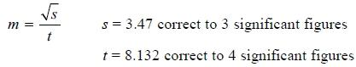
By considering bounds, work out the value of m to a suitable degree of accuracy.
Give a reason for your answer.

(Total for question = 5 marks)
8. a is 8.3 cm correct to the nearest mm
b is 6.1 cm correct to the nearest mm
Calculate the upper bound for c.
You must show your working.
........................................................... cm
(Total for question = 4 marks)

Parallel and Perpendicular Graphs

Things to remember:
- The general equation of a linear graph is given by y = mx + c, where m is the gradient and c is the y-intercept.
- Parallel graphs have the same gradient.
- Gradients of perpendicular graphs have a product of -1.

Questions:
1. The diagram shows a straight line, L₁, drawn on a grid.
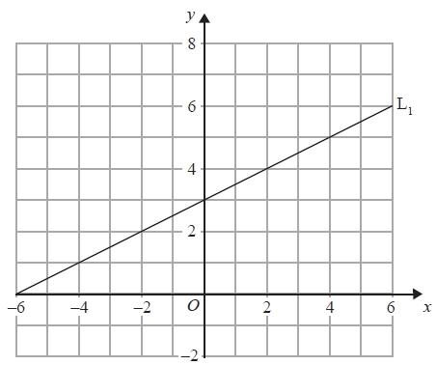
A straight line, L₂, is parallel to the straight line L₁ and passes through the point (0, −5).
Find an equation of the straight line L₂.

...........................................................
(Total for Question is 3 marks)

2. The straight line L has equation y = 2x − 5
Find an equation of the straight line perpendicular to L which passes through (−2, 3).

...........................................................
(Total for Question is 3 marks)

3. In the diagram, ABC is the line with equation $y=-\frac{1}{2}x+5$
AB = BC
D is the point with coordinates (−13, 0)

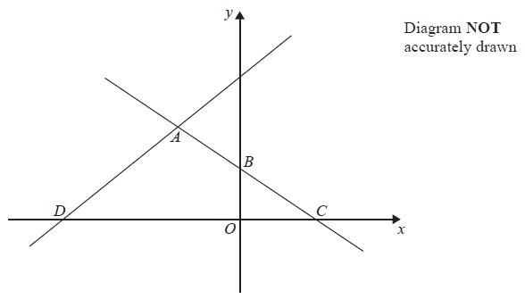
Find an equation of the line through A and D.
...........................................................
(Total for question = 5 marks)

4. Here are the graphs of 6 straight lines.

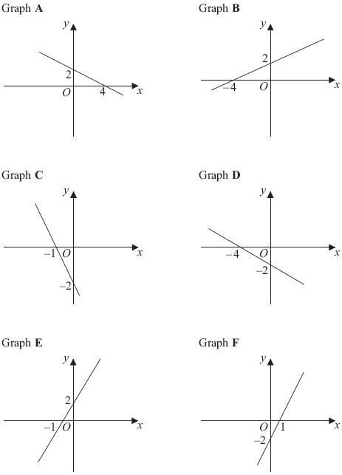

Match each of the graphs A, B, C, D, E and F to the equations in the table.

Equation | $y=\frac{1}{2}x+2$ | $y=2x-2$ | $y=-\frac{1}{2}x+2$ | $y=-2x-2$ | $y=2x+2$ | $y=-\frac{1}{2}x-2$
Graph

(Total for Question is 3 marks)

5. In the diagram, A is the point (-2, 0)
B is the point (0, 4)
C is the point (5, -1)

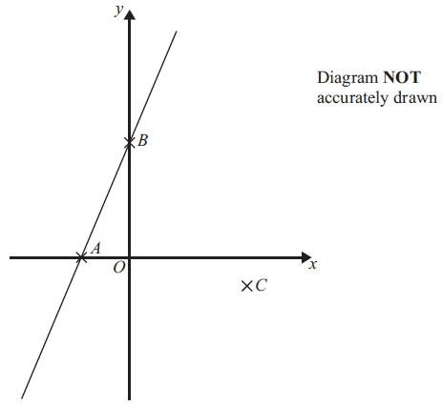

Find an equation of the line that passes through C and is perpendicular to AB.

...........................................................
(Total for Question is 4 marks)

6. Find an equation of the straight line that is perpendicular to the straight line x + 2y = 5 and that passes through the point (3, 7).

...........................................................
(Total for Question is 4 marks)
*7. A and B are straight lines.
Line A has equation 2y = 3x + 8
Line B goes through the points (−1, 2) and (2, 8)
Do lines A and B intersect?
You must show all your working.

(Total for Question is 3 marks)

8. A straight line, L, is perpendicular to the line with equation y = 1 – 3x.
The point with coordinates (6, 3) is on the line L.
Find an equation of the line L.

...........................................................
(Total for Question is 3 marks)
Transformations of graphs

Things to remember:
- f(x) means the function of x.
- -f(x) is a reflection in the x-axis.
- f(-x) is a reflection in the y-axis.
- f(x – a) is a translation in the x-axis, a units.
- f(x) + b is a translation in the y-axis, b units.
- cf(x) is an enlargement in the y-axis, scale factor c.
- f(dx) is an enlargement in the x-axis, scale factor $\frac{1}{d}$.

Questions:
1. y = f(x)
The graph of y = f(x) is shown on the grid.
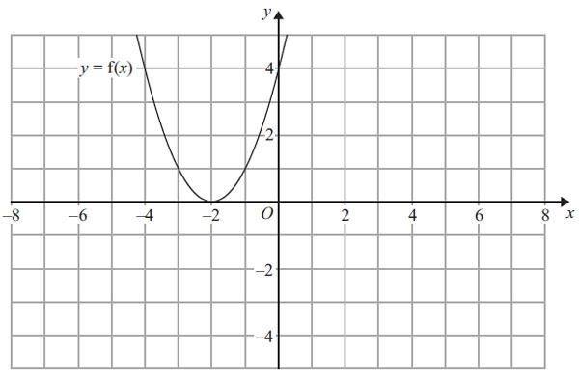
(a) On the grid above, sketch the graph of y = – f(x).
(2)
The graph of y = f(x) is shown on the grid.
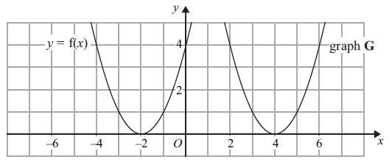
The graph G is a translation of the graph of y = f(x).
(b) Write down the equation of graph G.

...........................................................
(2)
(Total for Question is 3 marks)

2. The graph of y = f(x) is shown on both grids below.
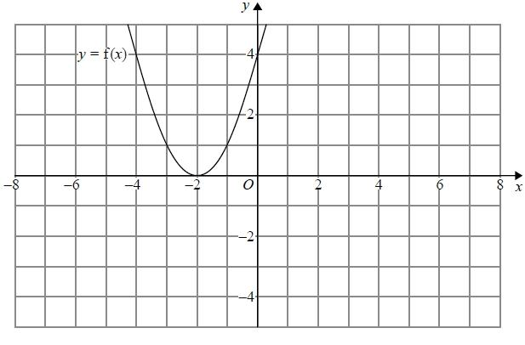
(a) On the grid above, sketch the graph of y = f(−x)
(1)
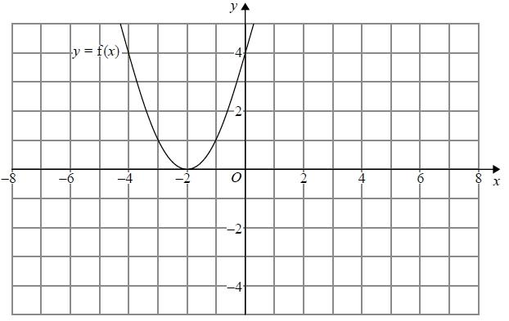
(b) On this grid, sketch the graph of y = −f(x) + 3
(1)
(Total for question = 2 marks)

3. The graph of y = f(x) is shown on each of the grids.
(a) On this grid, sketch the graph of y = f(x – 3)
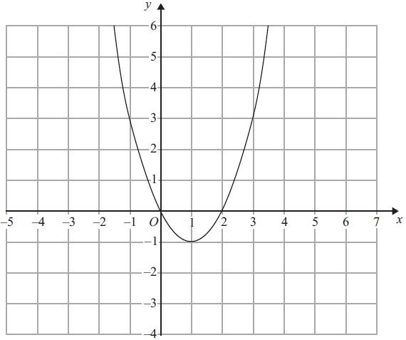
(2)
(b) On this grid, sketch the graph of y = 2f(x)
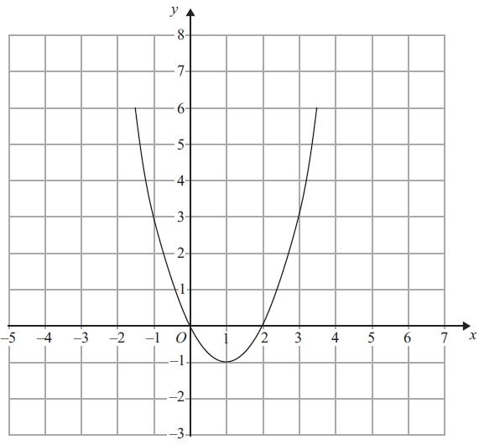
(2)
(Total for Question is 4 marks)

4. The graph of y = f(x) is shown on the grid.
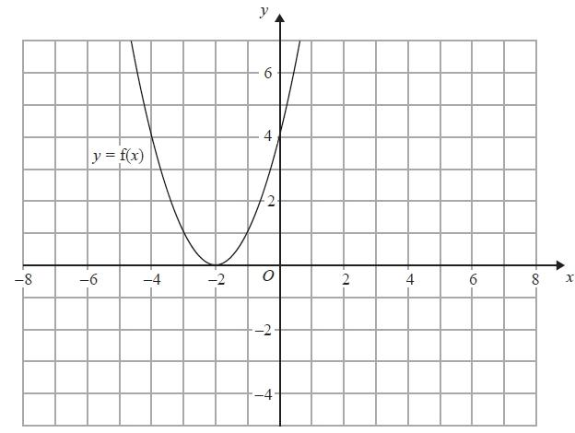
(a) On the grid above, sketch the graph of y = f(x + 3)
(2)
The graph of y = g(x) is shown below.
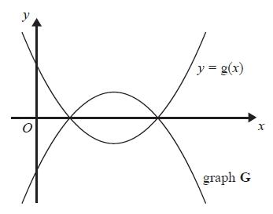
The graph G is the reflection of y = g(x) in the x-axis.
(b) Write down an equation of graph G.
...........................................................
(1)
(Total for question = 3 marks)

Algebraic Fractions – Simplifying

Things to remember:
- Factorise the numerator and denominator;
- Cancel common factors;
- Then add/subtract/multiply divide if necessary.

Questions:
1. Simplify $\frac{p^{2}-9}{2p+6}$

...........................................................
(Total 3 marks)
2. Simplify fully $\frac{{6x}^{2}+3x}{{4x}^{2}-1}$

...........................................................
(Total 3 marks)
3. Simplify $\frac{x^{2}+2x+1}{x^{2}+3x+2}$

...........................................................
(Total 3 marks)
4. Simplify fully $\frac{x^{2}+x-6}{x^{2}-7x+10}$

...........................................................
(Total 3 marks)
5. Simplify fully $\frac{x^{2}-8x+15}{{2x}^{2}-7x-15}$

...........................................................
(Total 3 marks)

6. Simplify fully $\frac{2x^{2}+3x+1}{x^{2}-3x-4}$

...........................................................
(Total 3 marks)
7. (a) Simplify $\frac{2x+4}{x^{2}+4x+4}$

...........................................................
(3)
(b) Write $\frac{1}{x+4}+\frac{2}{x-4}$ as a single fraction in its simplest form.

...........................................................
(3)
(Total 6 marks)
8. Simplify fully $\frac{x+3}{4}+\frac{x-5}{3}$

...........................................................
(Total 3 marks)

Algebraic fractions – solving

Things to remember:
- Multiply every term by the product of the denominators;
- Solve to find x.

Questions:
1. Solve $\frac{5(2x+1)}{3}=4x+7$

x = ...........................................................
(Total 3 marks)

2. (a) Show that the equation $\frac{5}{x+2}=\frac{4-3x}{x-1}$

can be rearranged to give ${3x}^{2}+7x-13=0$

(3)
(b) Solve ${3x}^{2}+7x-13=0$
Give your solutions correct to 2 decimal places.

x = ........................................................... or x = ...........................................................
(3)
(Total 6 marks)
3. Solve the equation $\frac{x}{2x-3}+\frac{4}{x+1}=1$

x = ...........................................................
(Total 5 marks)

4. Solve the equation $\frac{3}{x+3}-\frac{4}{x-3}=\frac{5x}{x^{2}-9}$

x = ...........................................................
(Total 4 marks)

5. (a) Solve $\frac{3}{x}+\frac{3}{2x}=2$

x=...........................................................
(2)

(b) Using your answer to part (a), or otherwise, solve $\frac{3}{{(y-1)}^{2}}+\frac{3}{2{(y-1)}^{2}}=2$

y = .................................................................................................................
(3)
(Total 5 marks)
Solving Quadratic Inequalities

Things to remember:
- Start by solving the quadratic to find the values of x, then sketch the graph to determine the inequality.

Questions:
1. Solve x² > 3x + 4
...........................................................
(Total for question = 3 marks)

2. Solve the inequality x² > 3(x + 6)
...........................................................
(Total for question = 4 marks)

3. Solve the inequality x² + 5x > 6

...........................................................
(Total for question = 3 marks)

4. Solve the inequality x² - 2x - 8 < 0

...........................................................
(Total for question = 3 marks)

5. Solve the inequality x² - x ≥ 12

...........................................................
(Total for question = 3 marks)

6. Solve the inequality x² ≤ 4(2x + 5)

...........................................................
(Total for question = 4 marks)

Circle theorems

Things to remember:
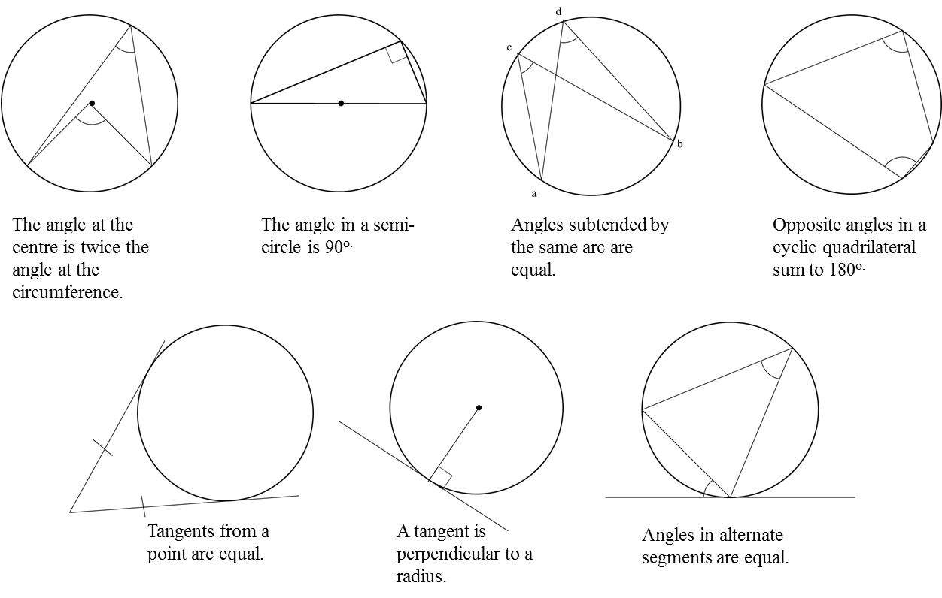
Questions:
1.
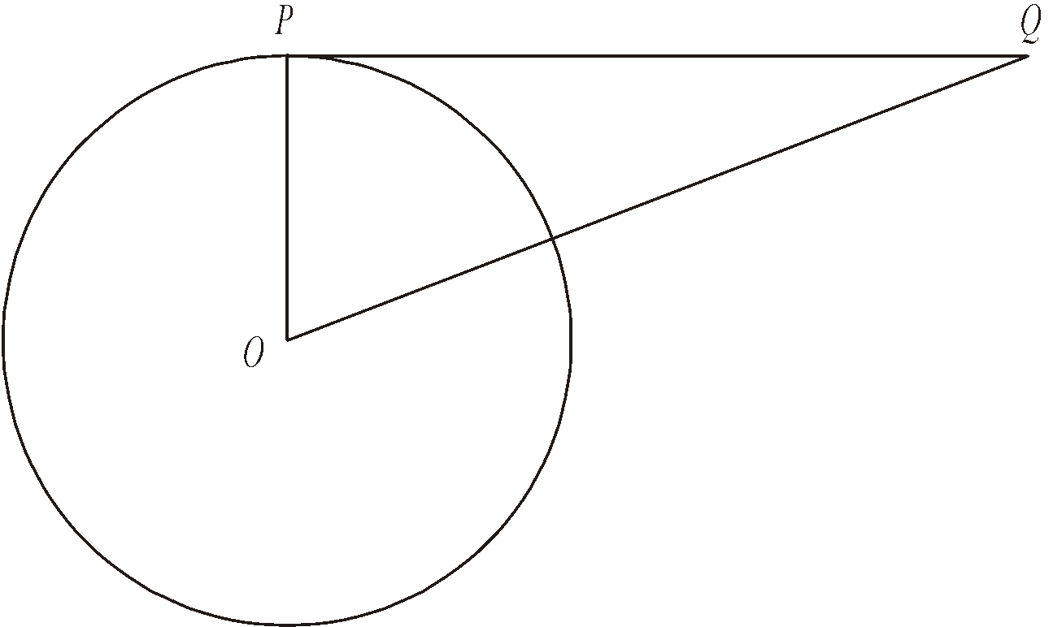
Diagram NOT accurately drawn
P is a point on the circumference of the circle, centre O.
PQ is a tangent to the circle.
(i) Write down the size of angle OPQ.
........................................................... °
(ii) Give a reason for your answer.

………………………......................................................................................................

………………………......................................................................................................
(Total 2 marks)

2.
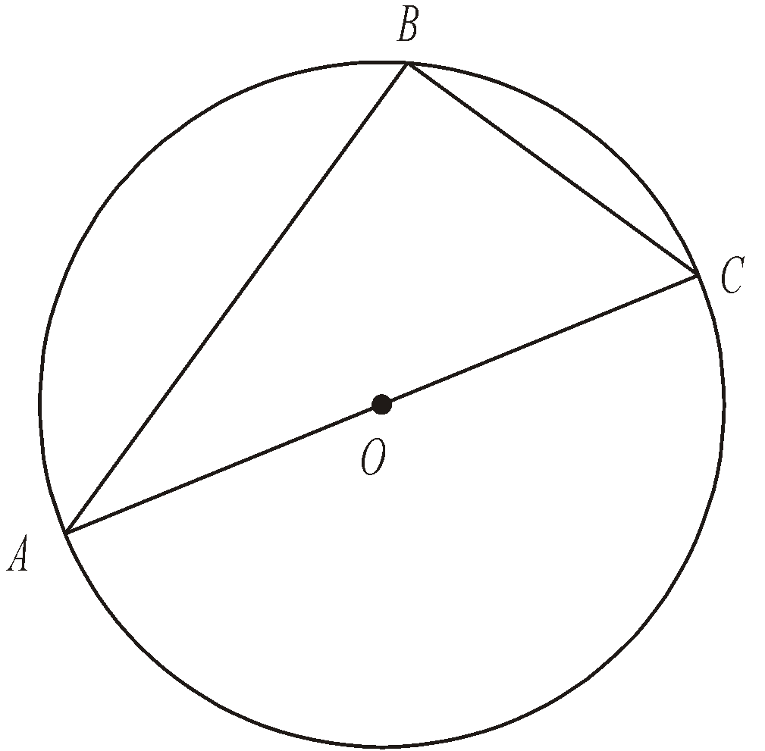
Diagram NOT accurately drawn
A, B and C are points on the circumference of a circle, centre O.
AC is a diameter of the circle.
(a) (i) Write down the size of angle ABC.
........................................................... °
(ii) Give a reason for your answer.

………………………......................................................................................................

………………………......................................................................................................
(2)
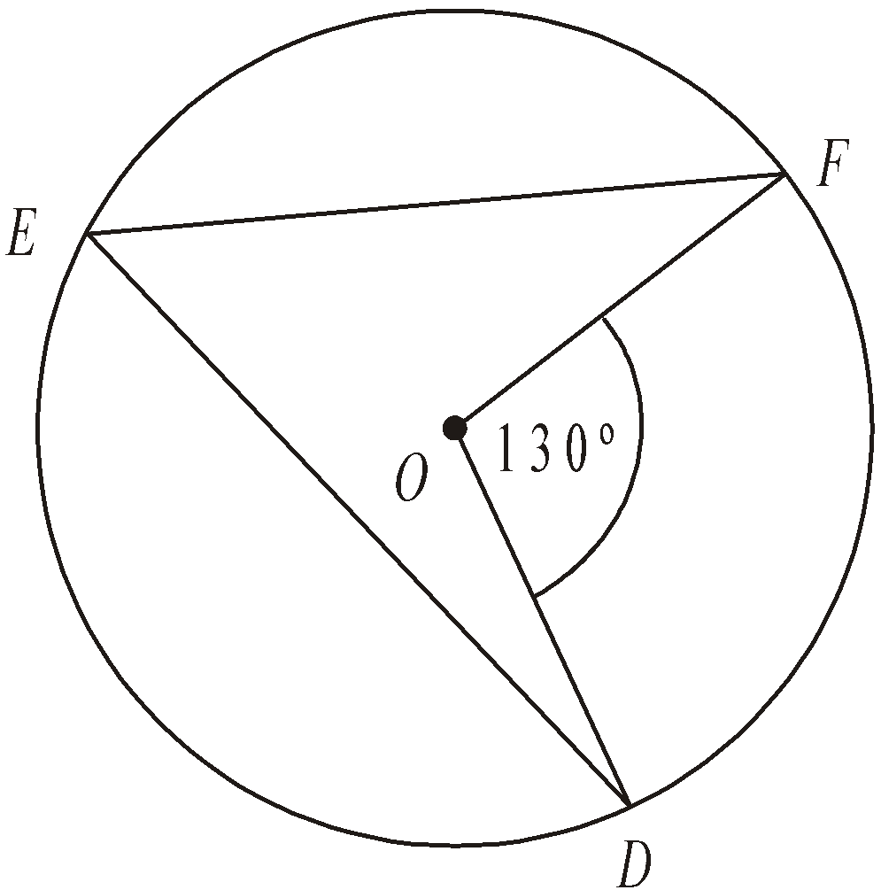
Diagram NOT accurately drawn
D, E and F are points on the circumference of a circle, centre O.
Angle DOF = 130°.
(b) (i) Work out the size of angle DEF.
........................................................... °
(ii) Give a reason for your answer.

………………………......................................................................................................

………………………......................................................................................................
(2)
(Total 4 marks)

3.
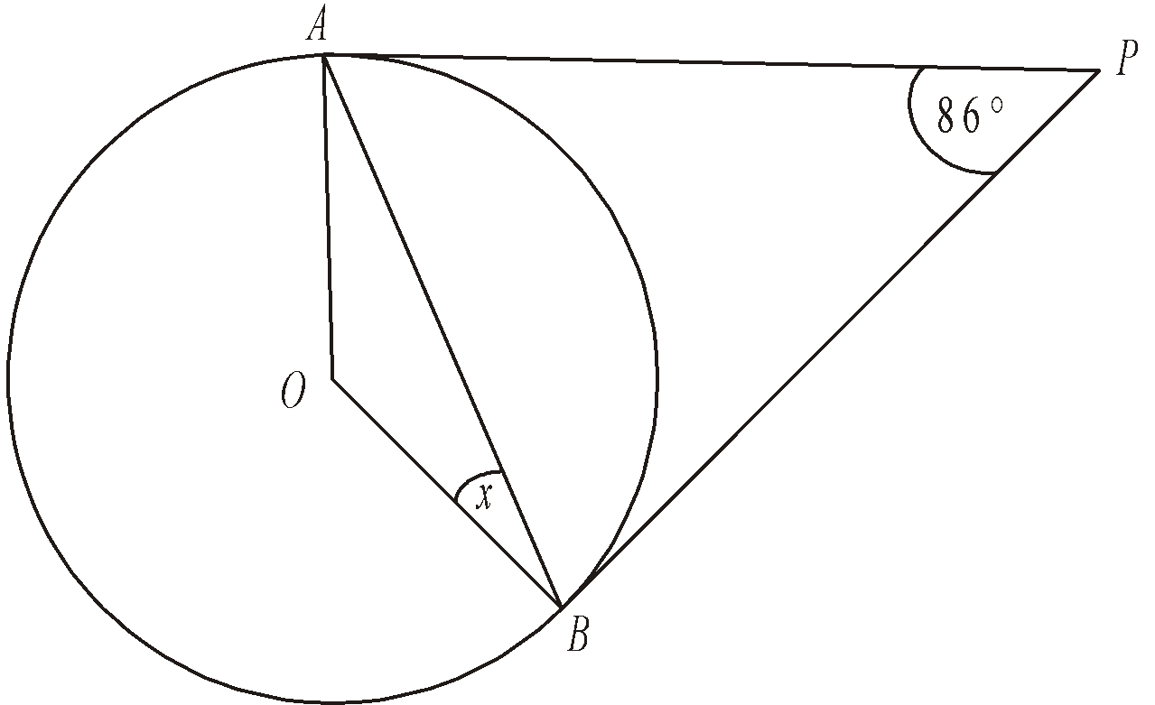
Diagram NOT accurately drawn
A and B are points on the circumference of a circle, centre O.
PA and PB are tangents to the circle.
Angle APB is 86°.
Work out the size of the angle marked x.
........................................................... °
(Total 2 marks)

4.
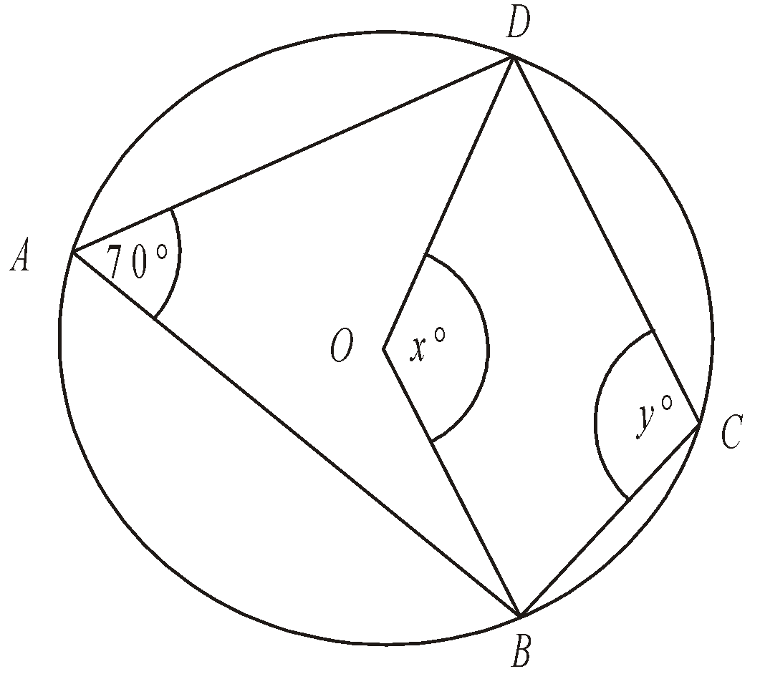
Diagram NOT accurately drawn
In the diagram, A, B, C and D are points on the circumference of a circle, centre O.
Angle BAD = 70°.
Angle BOD = x°.
Angle BCD = y°.
(a) (i) Work out the value of x.
........................................................... °
(ii) Give a reason for your answer.

………………......................................................................................................

………………......................................................................................................
(2)
(b) (i) Work out the value of y.

........................................................... °
(ii) Give a reason for your answer.

………………......................................................................................................
………………......................................................................................................
(2)
(Total 4 marks)

5.
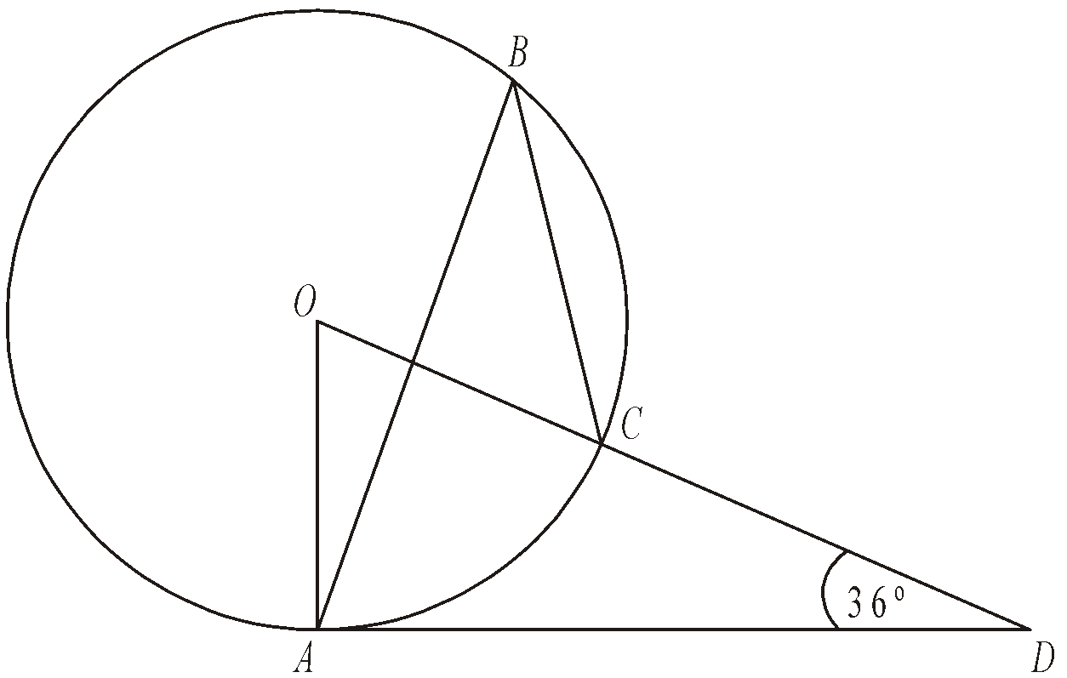
Diagram NOT accurately drawn
The diagram shows a circle centre O.
A, B and C are points on the circumference.
DCO is a straight line.
DA is a tangent to the circle.
Angle ADO = 36°
(a) Work out the size of angle AOD.
........................................................... °
(2)
(b) (i) Work out the size of angle ABC.
........................................................... °
(ii) Give a reason for your answer.

………………......................................................................................................
………………......................................................................................................
(3)
(Total 5 marks)

Vectors

Things to remember:
- Use the letter provided in the question.
- Going against the arrow is a negative.
- Vectors need to be written in bold or underlined.
- They can be manipulated similarly to algebra.

Questions:
1. The diagram shows a regular hexagon ABCDEF with centre O.

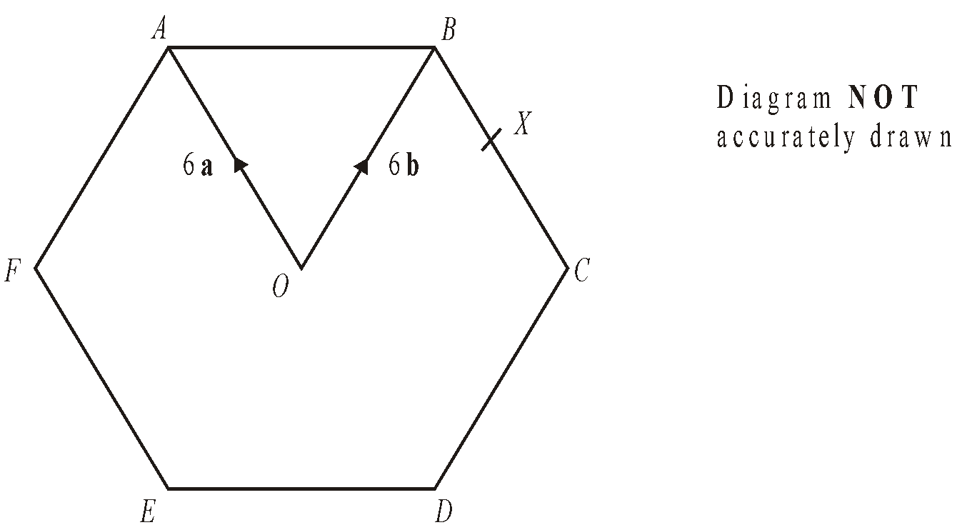
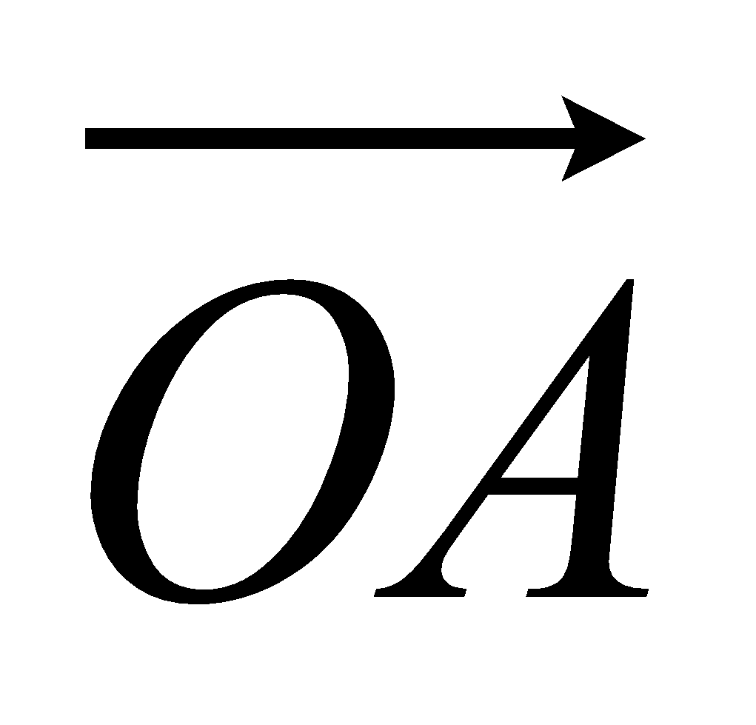 = 6a 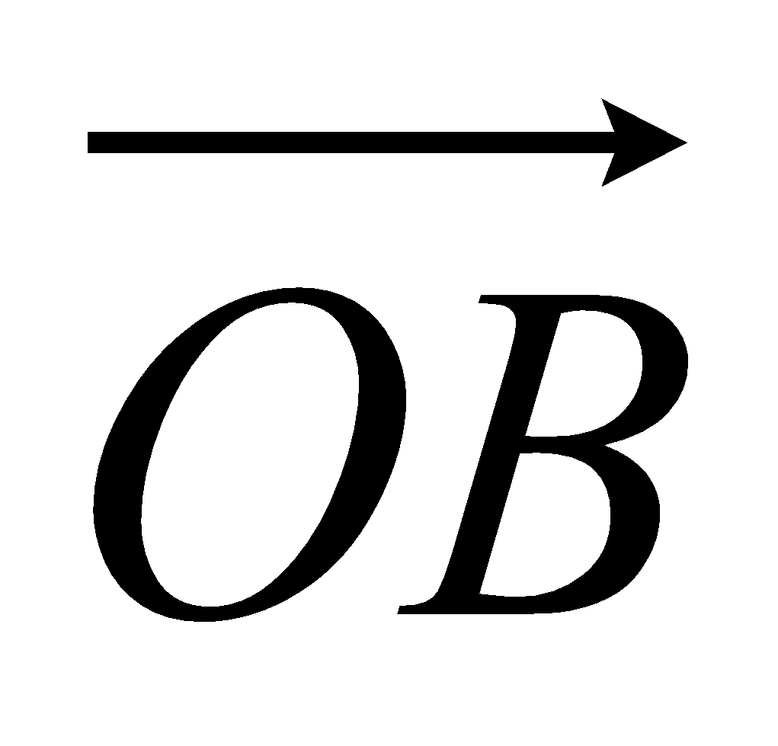 = 6b
(a) Express in terms of a and/or b
(i) 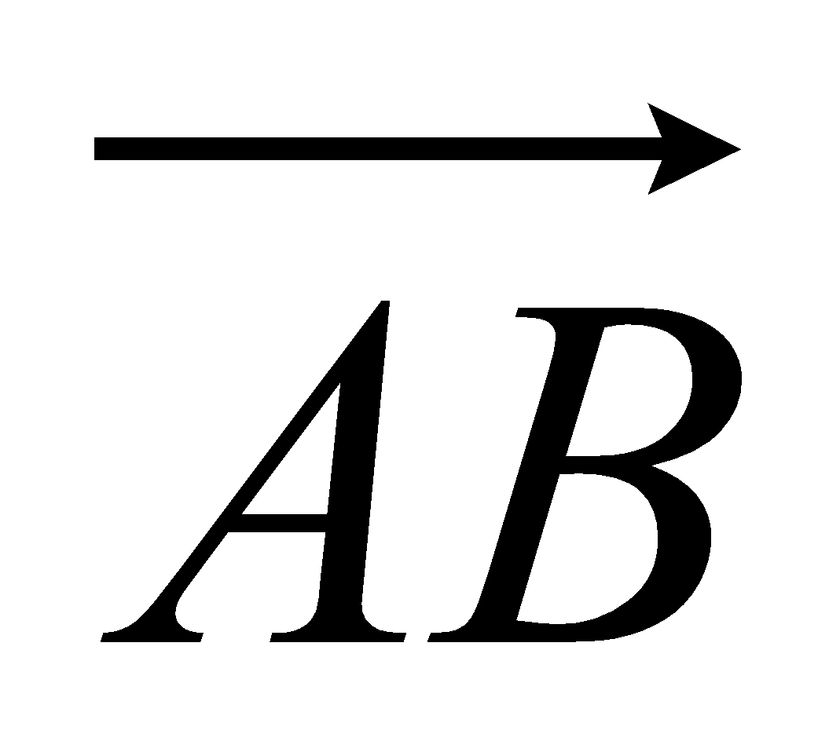,
...........................................................
(ii) 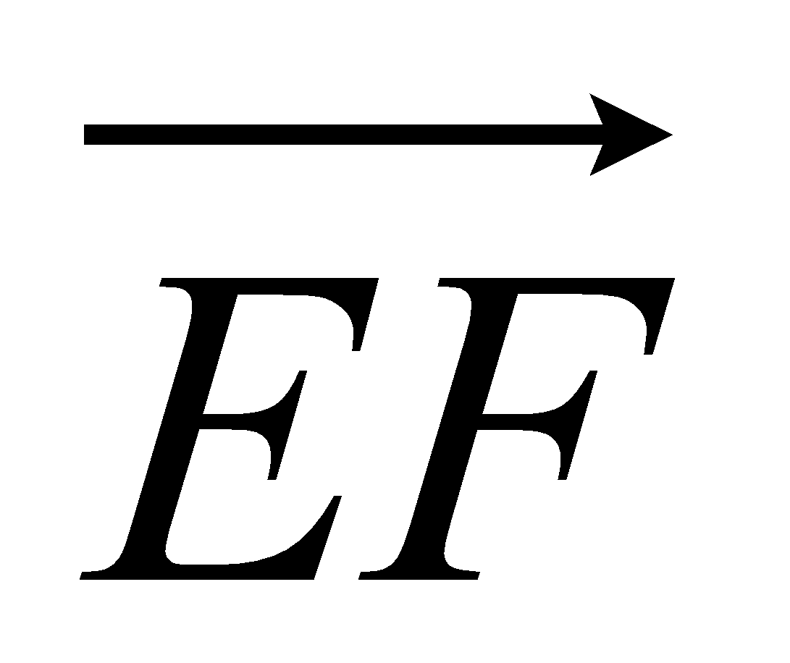.
...........................................................
(2)
X is the midpoint of BC.
(b) Express 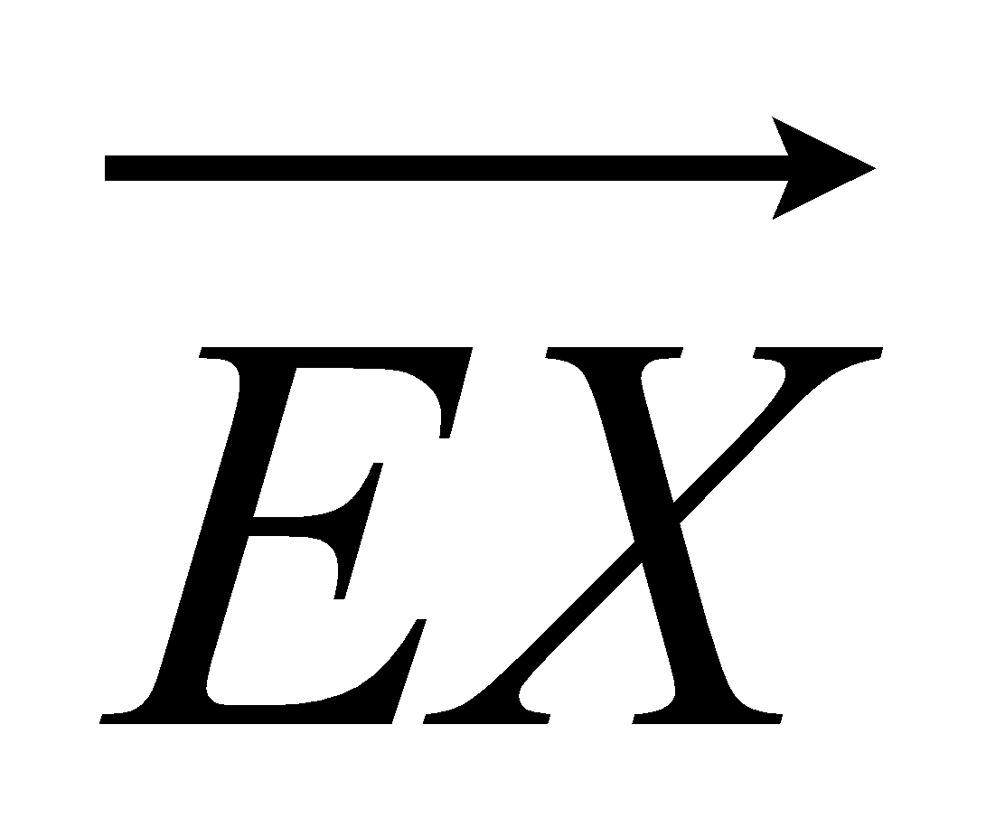 in terms of a and/or b

...........................................................
(2)
Y is the point on AB extended, such that AB : BY = 3:2
(c) Prove that E, X and Y lie on the same straight line.

(3)
(Total 7 marks)

2. T is the point on PQ for which PT : TQ = 2 : 1.
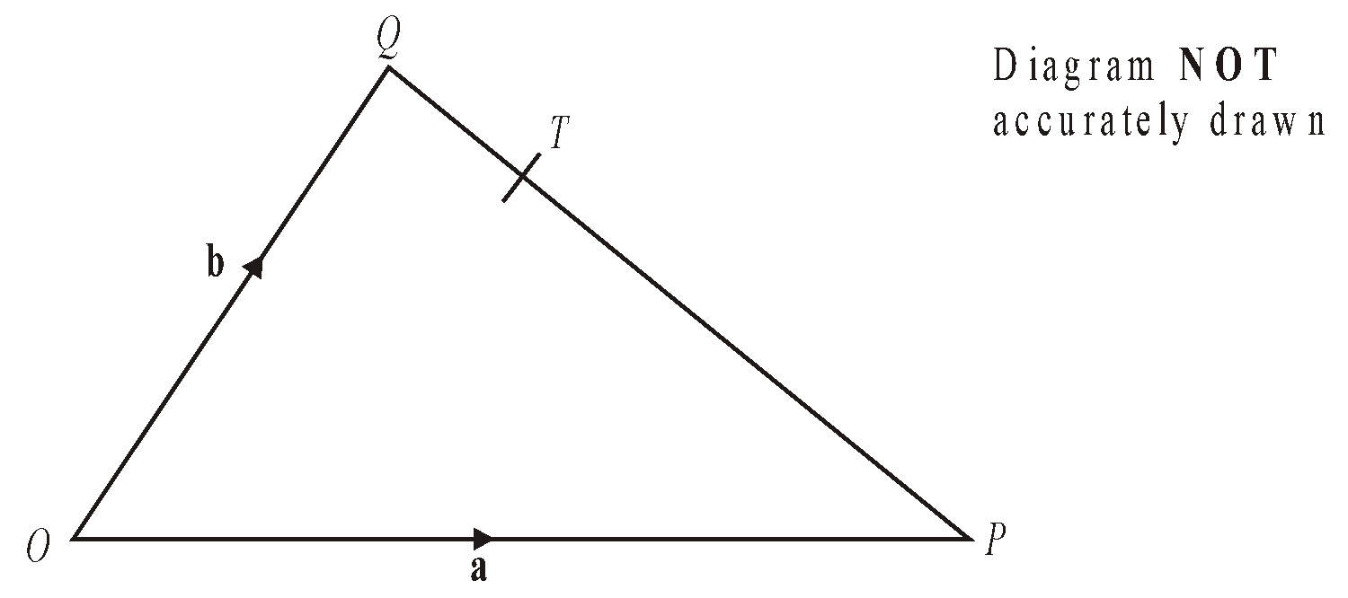
OPQ is a triangle.
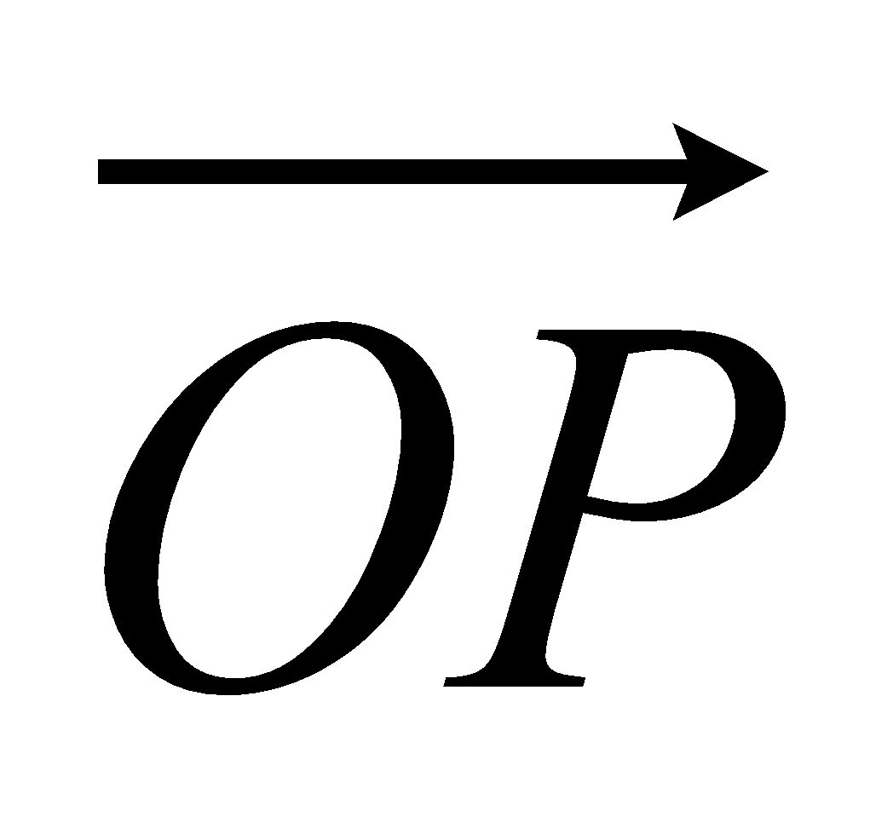 = a and 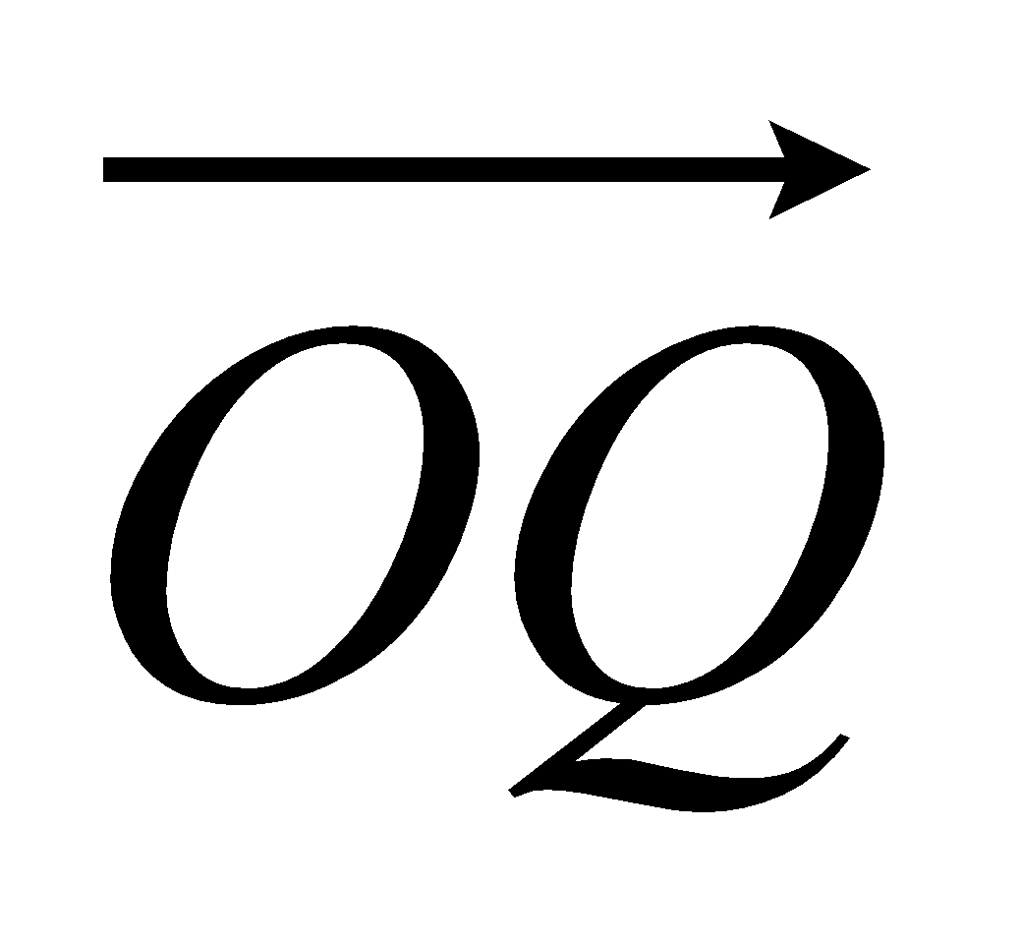 = b.
(a) Write down, in terms of a and b, an expression for 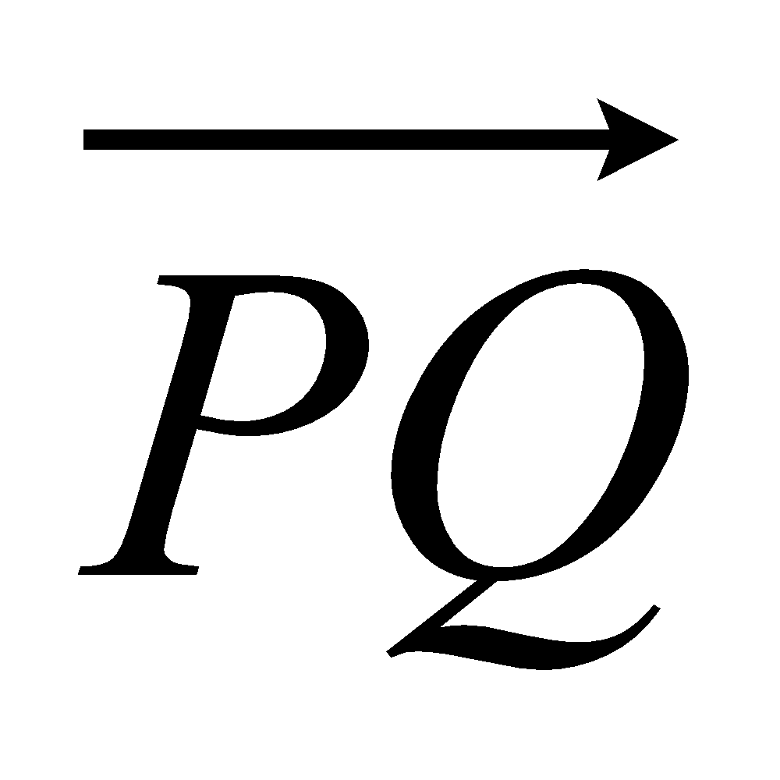.

= ...........................................................
(1)
(b) Express 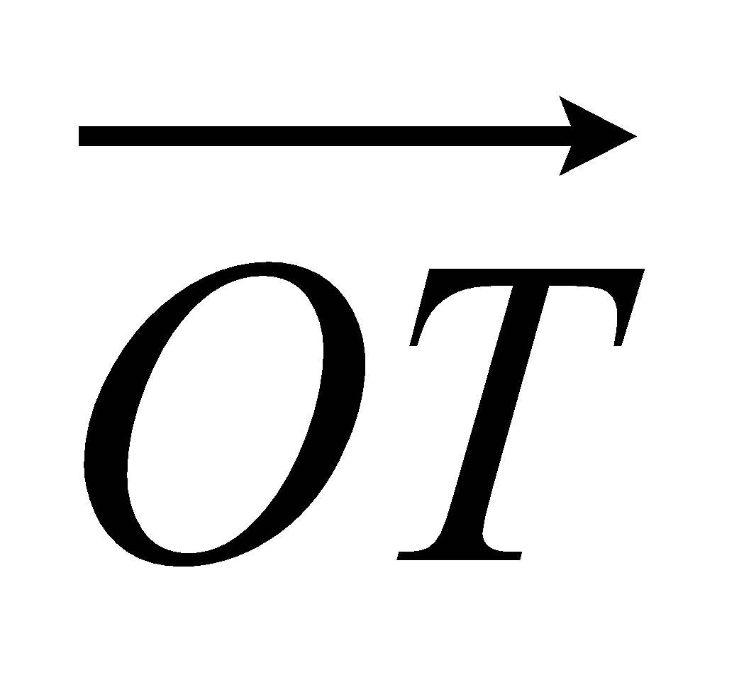 in terms of a and b.
Give your answer in its simplest form.

= ...........................................................
(2)
(Total 3 marks)

3. OABC is a parallelogram.
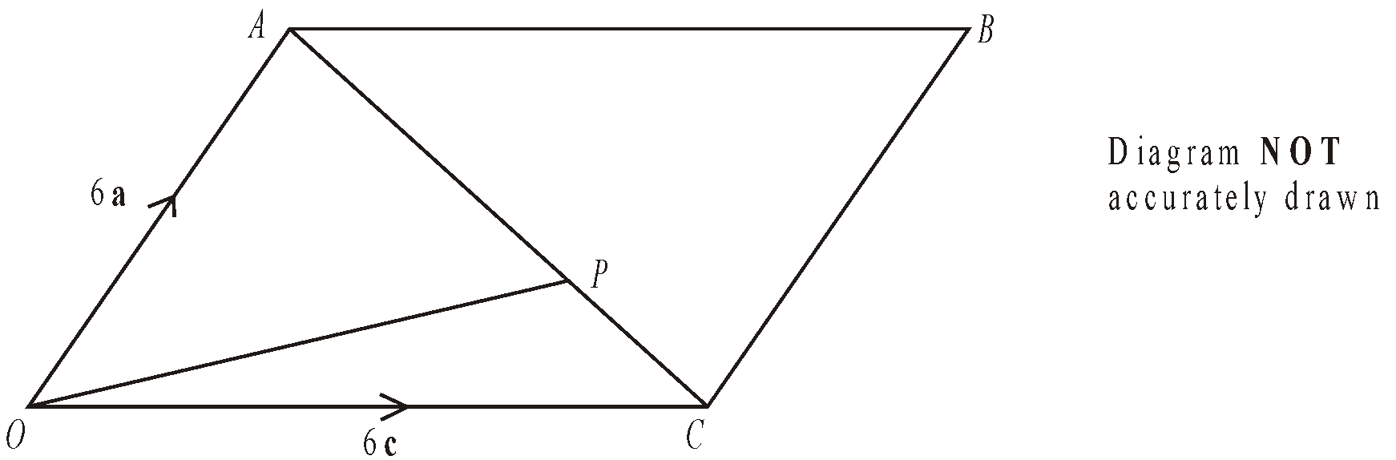
P is the point on AC such that AP = 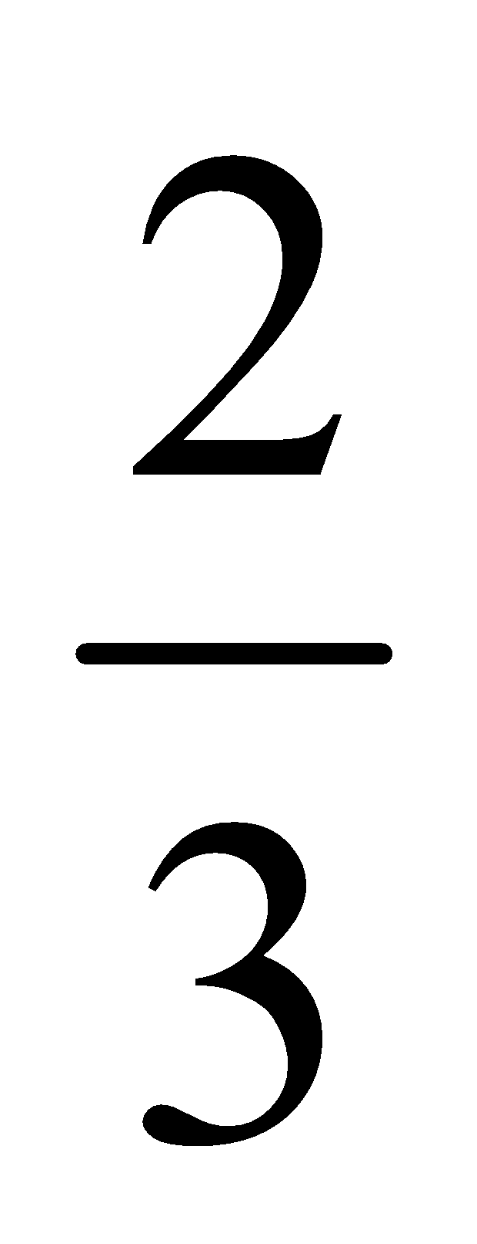AC.
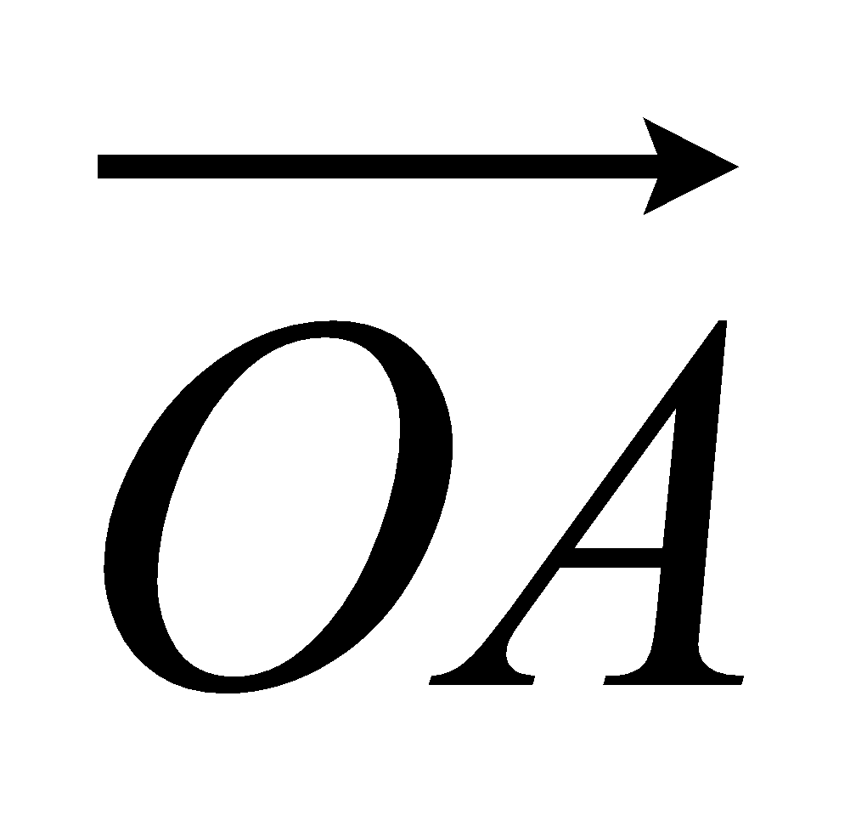 = 6a. 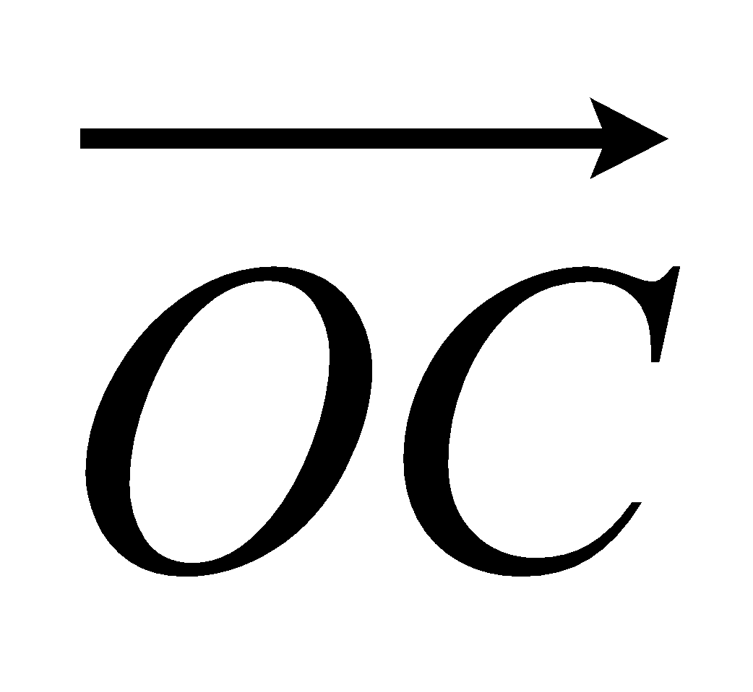 = 6c.
- Find the vector 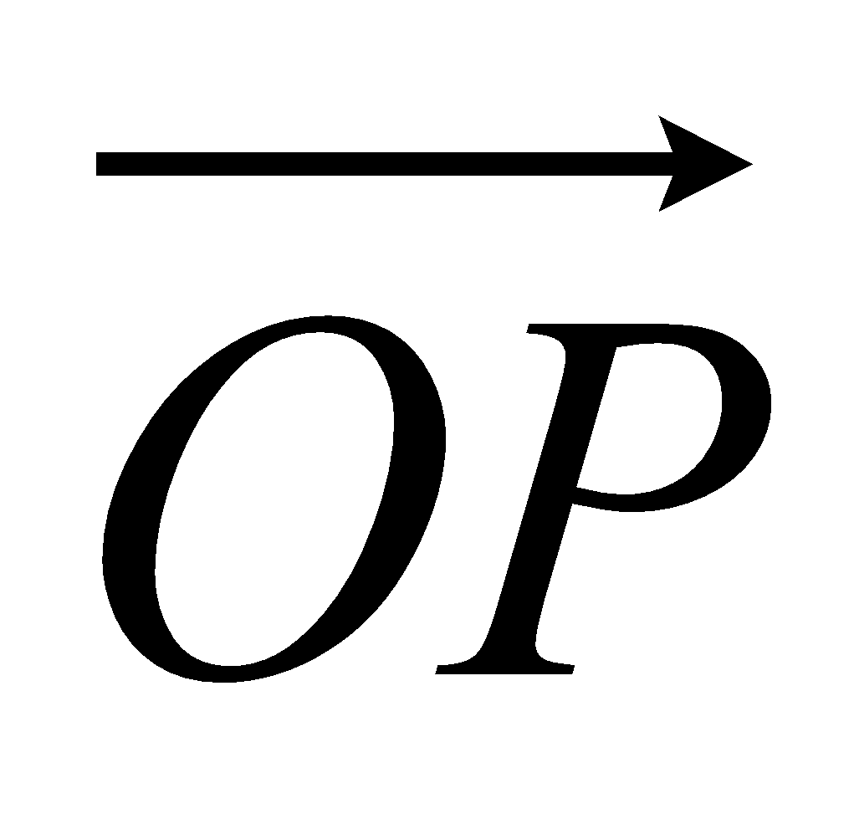.
Give your answer in terms of a and c.

...........................................................
(3)
The midpoint of CB is M.
(b) Prove that OPM is a straight line.

(2)
(Total 5 marks)

4. OPQ is a triangle.
R is the midpoint of OP.
S is the midpoint of PQ.
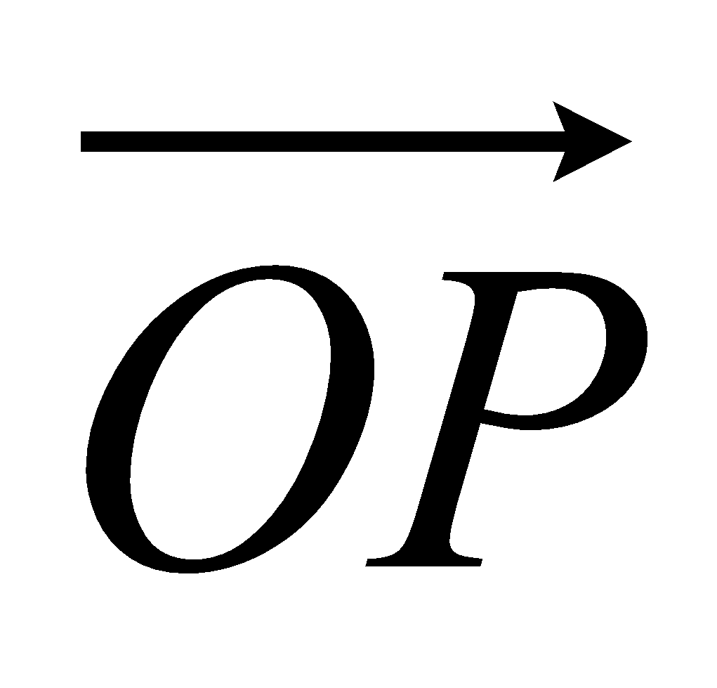 = p and 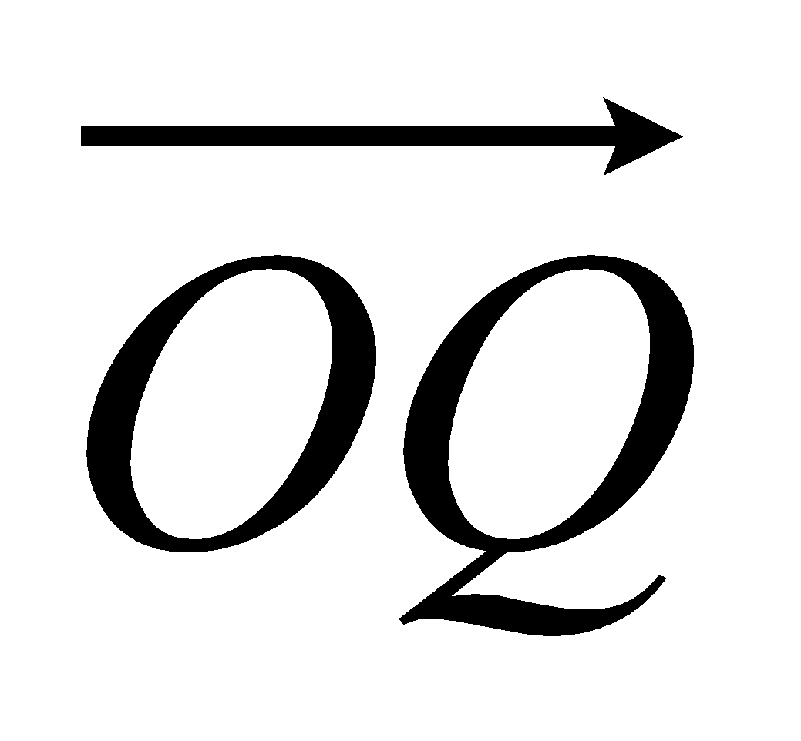 = q

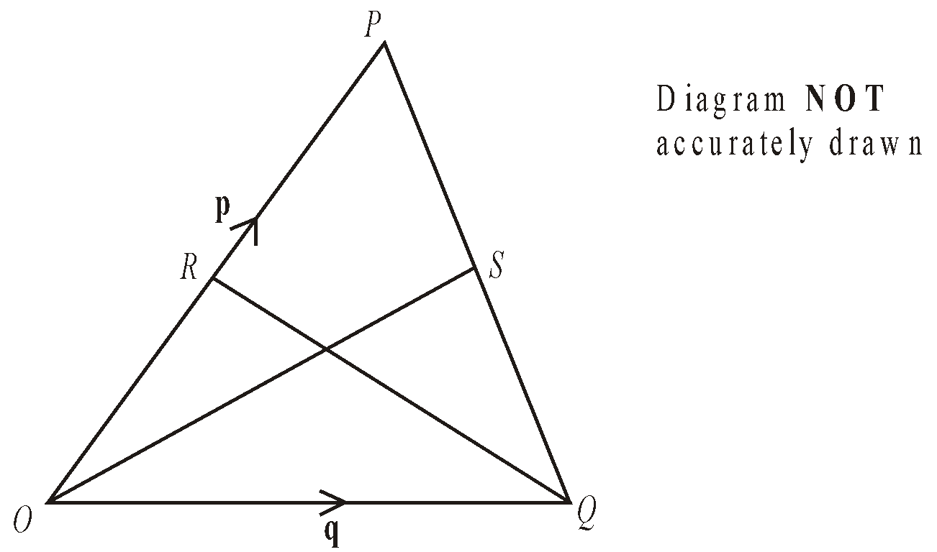
- Find 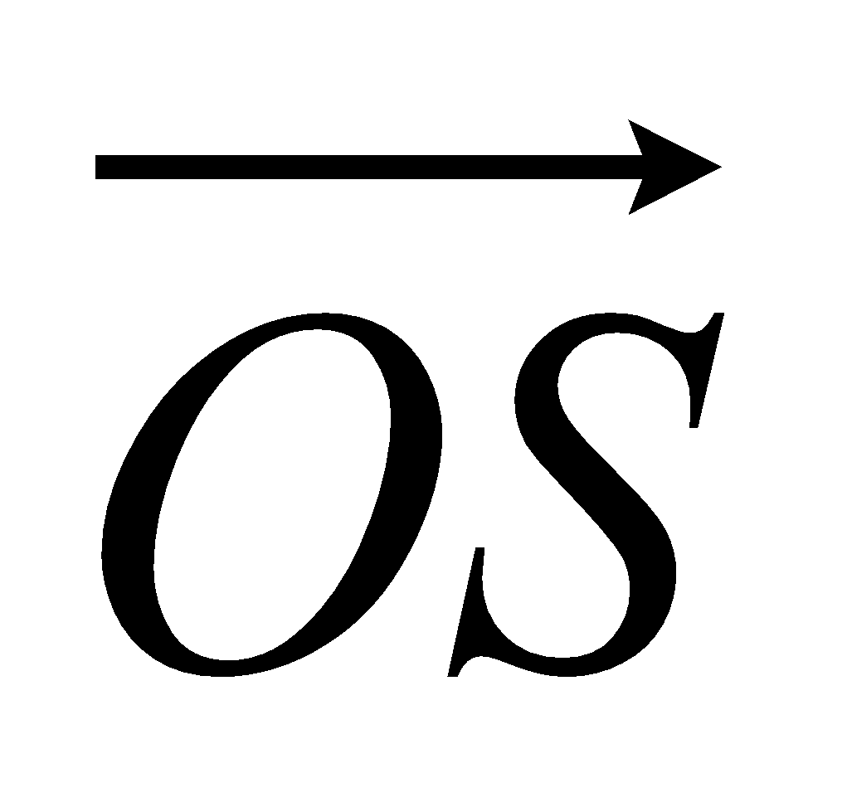 in terms of p and q.

= ...........................................................
(ii) Show that RS is parallel to OQ.

(Total 5 marks)

5. OPQR is a trapezium with PQ parallel to OR.
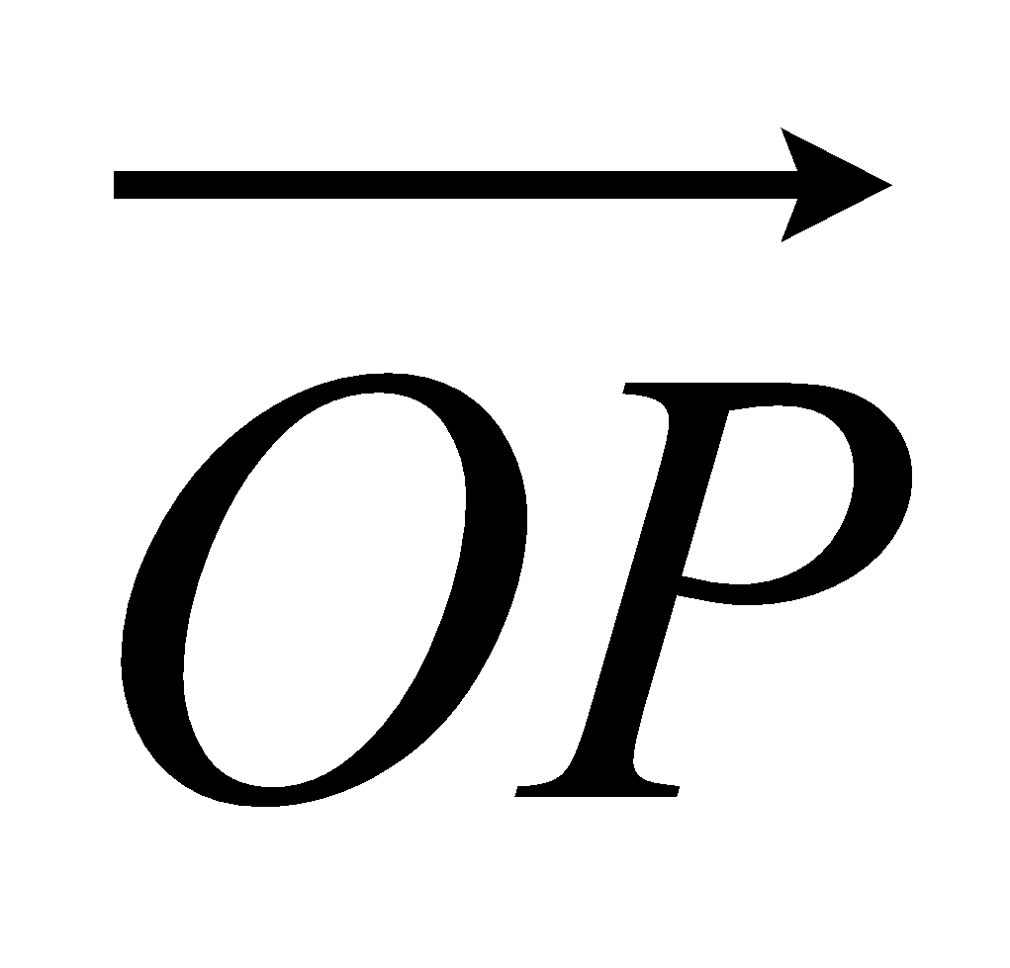 = 2b 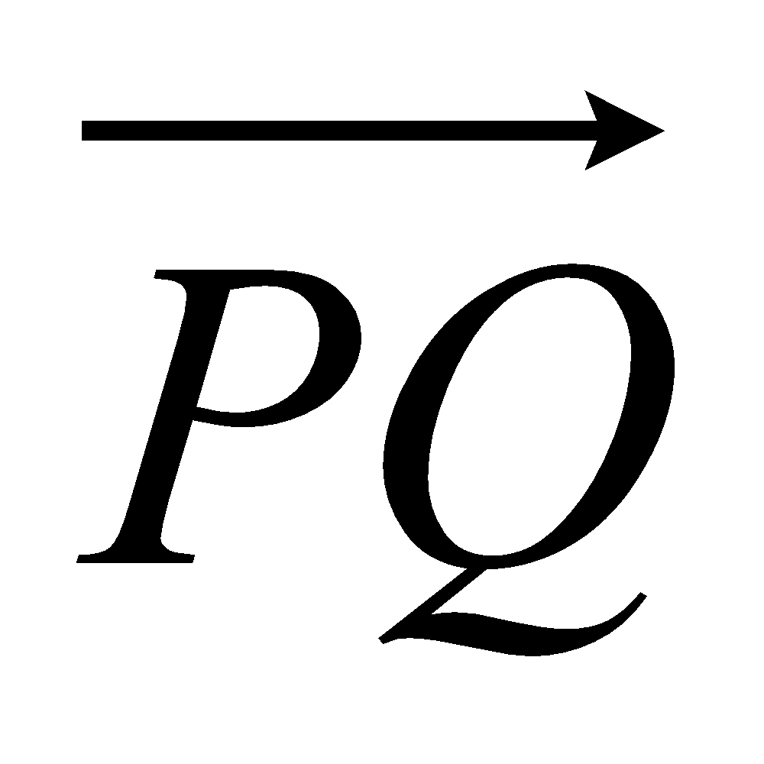 = 2a 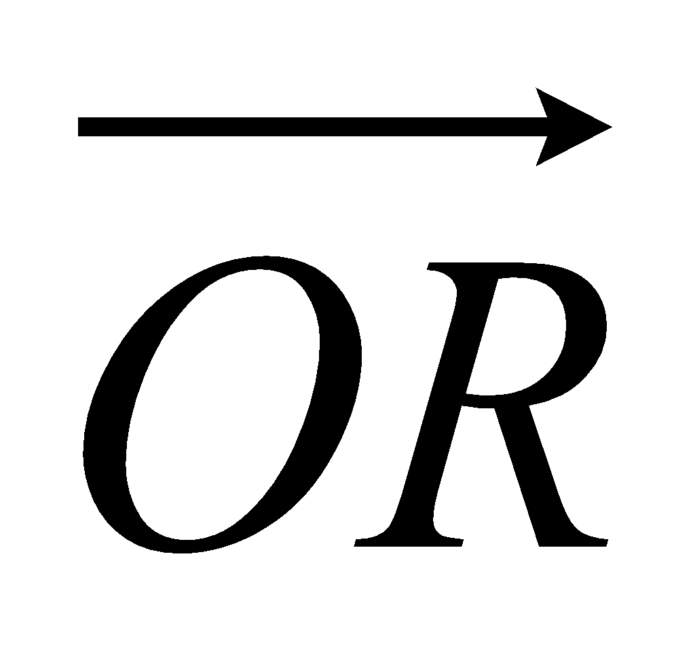 = 6a
M is the midpoint of PQ and N is the midpoint of OR.
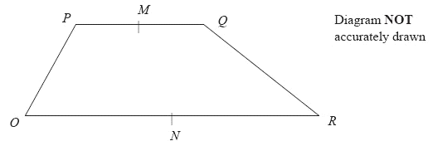
(a) Find the vector 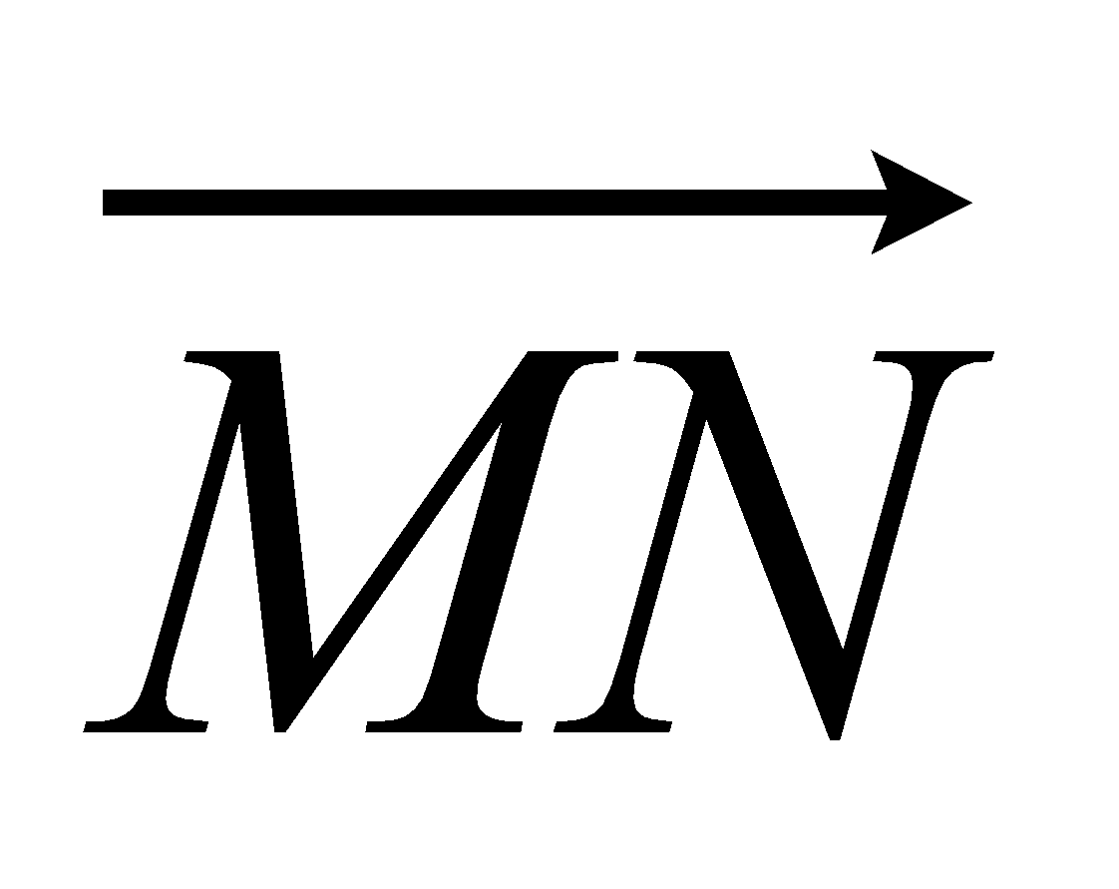 in terms of a and b.

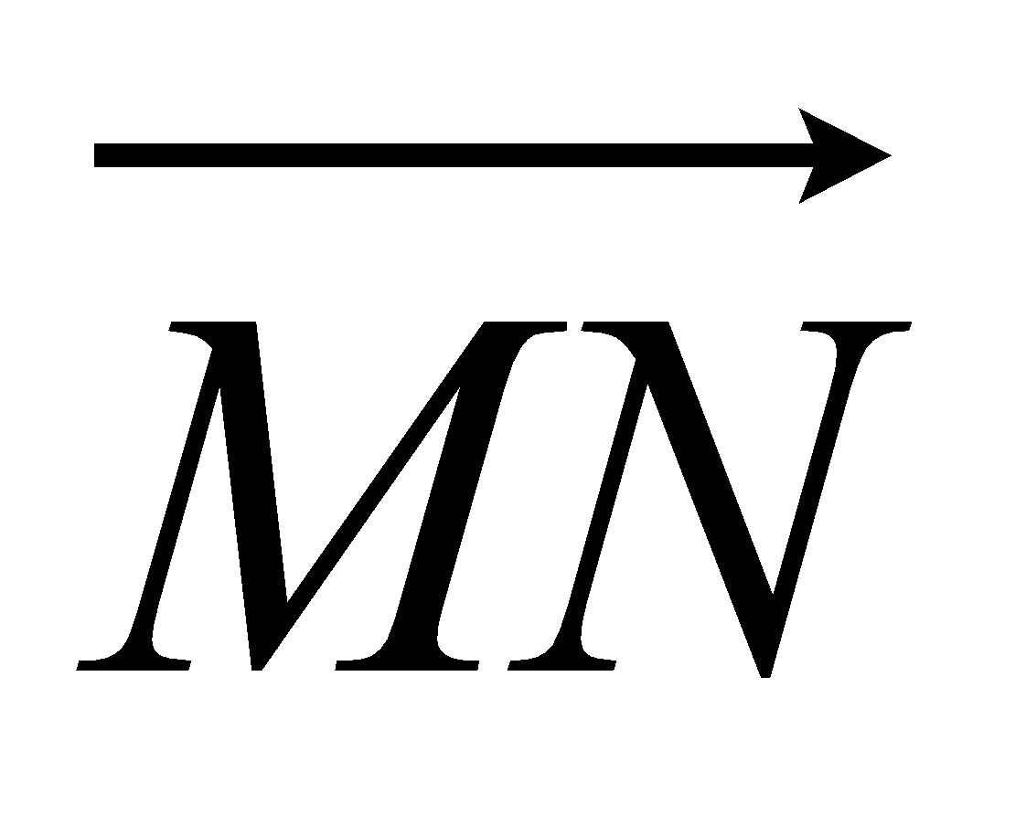 = ...........................................................
(2)
X is the midpoint of MN and Y is the midpoint of QR.
(b) Prove that XY is parallel to OR.

(2)
(Total 4 marks)

6. ABCD is a straight line.
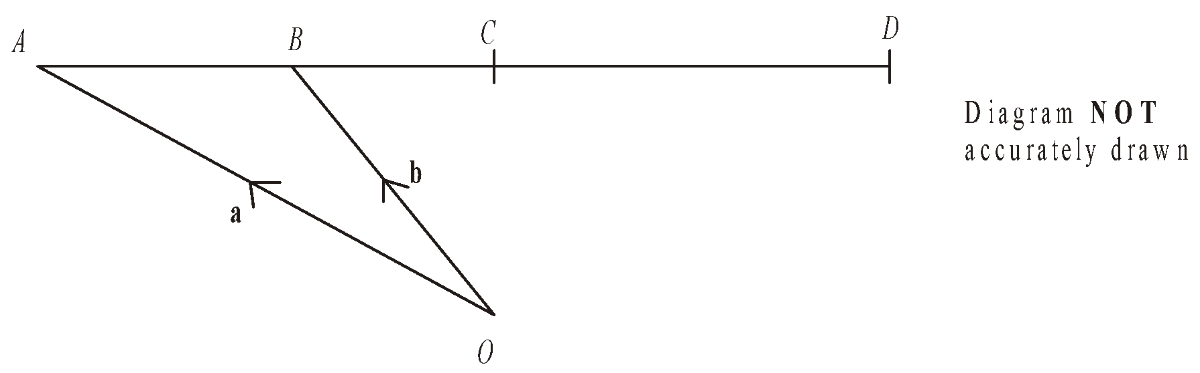
O is a point so that 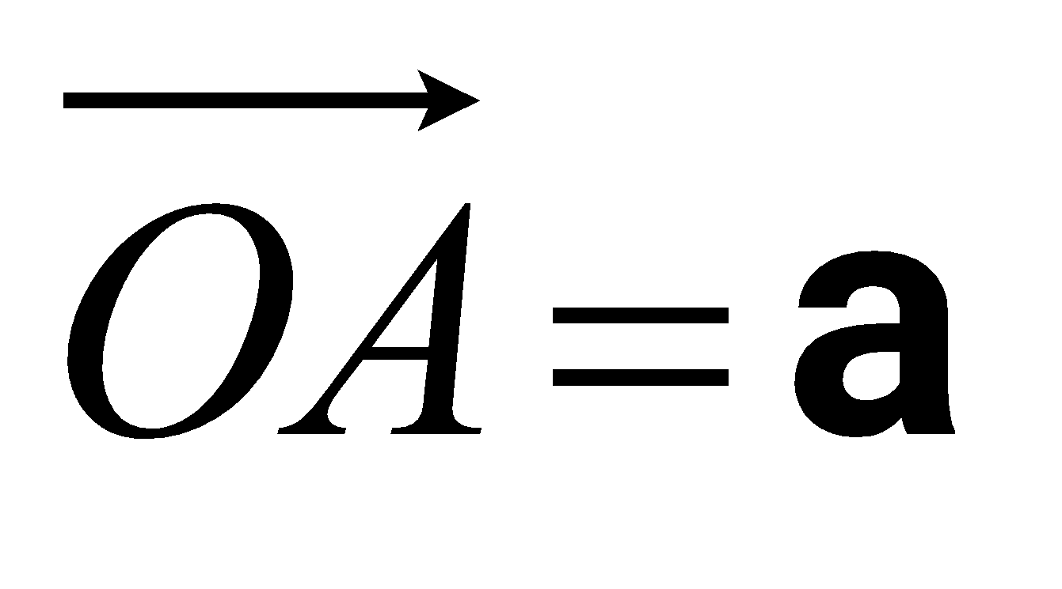 and 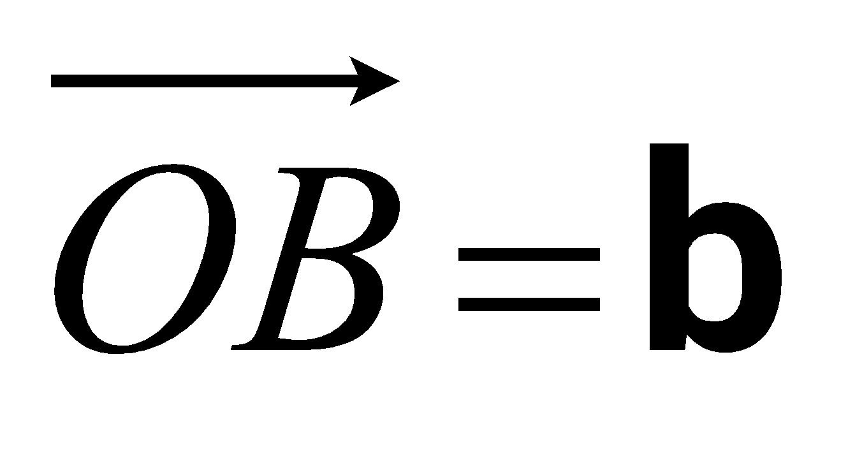.
B is the midpoint of AC.
C is the midpoint of AD.
Express, in terms of a and b, the vectors
(i) 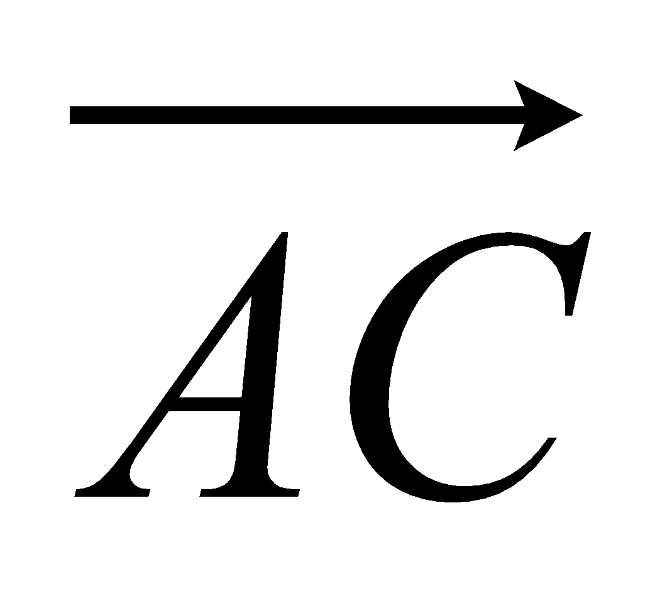

...........................................................
(ii) 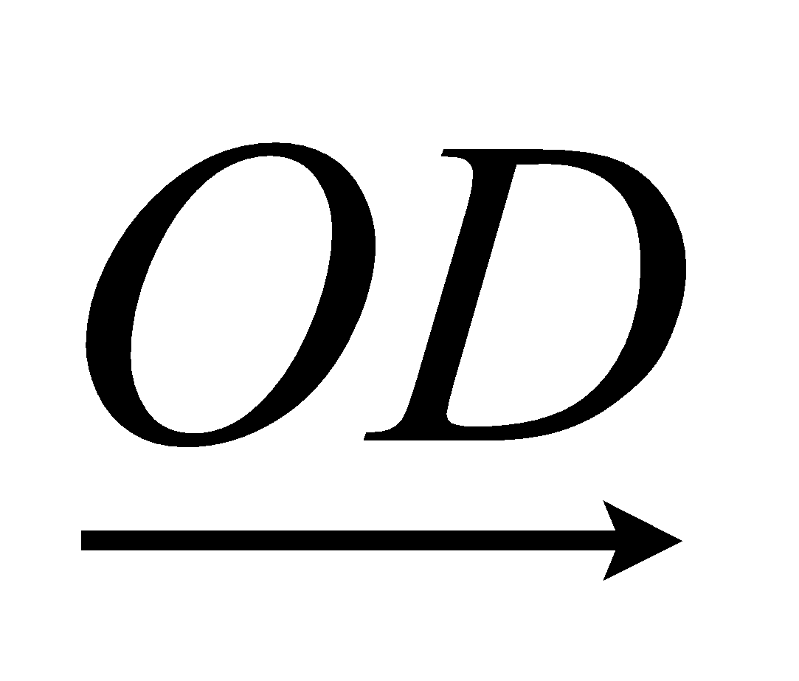

...........................................................
(Total 3 marks)

7. Diagram NOT accurately drawn
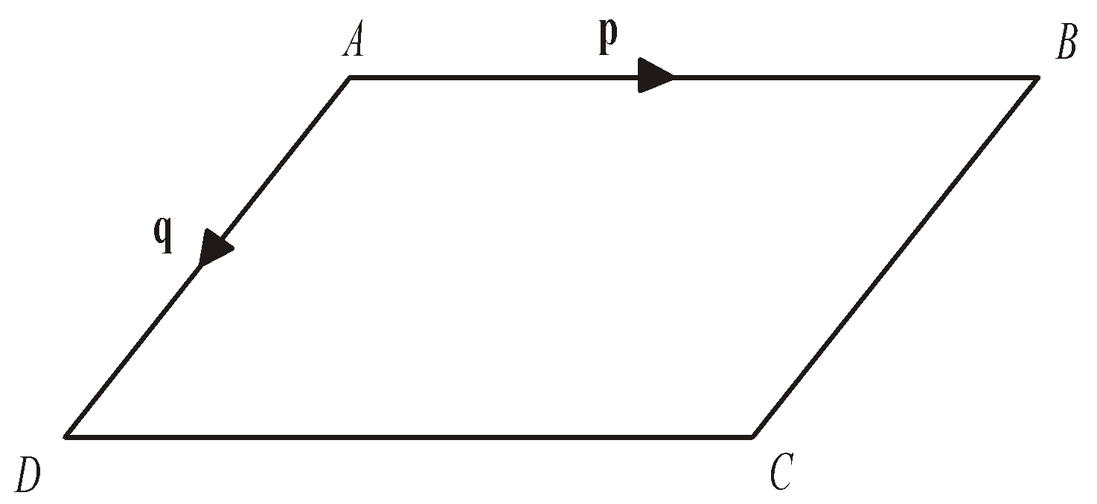
ABCD is a parallelogram.
AB is parallel to DC.
AD is parallel to BC.
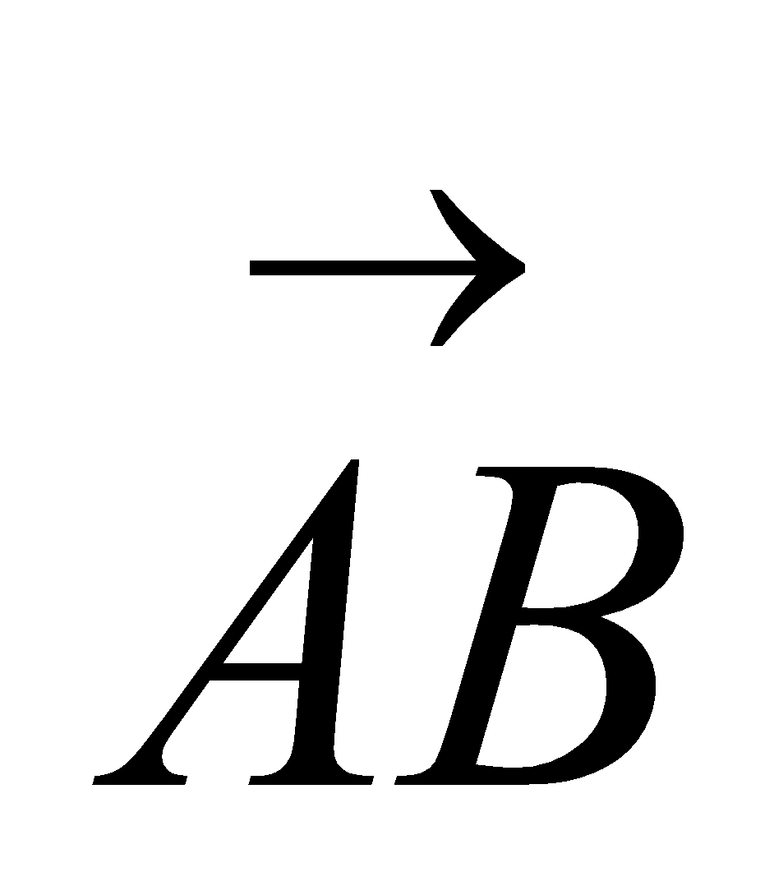 = p
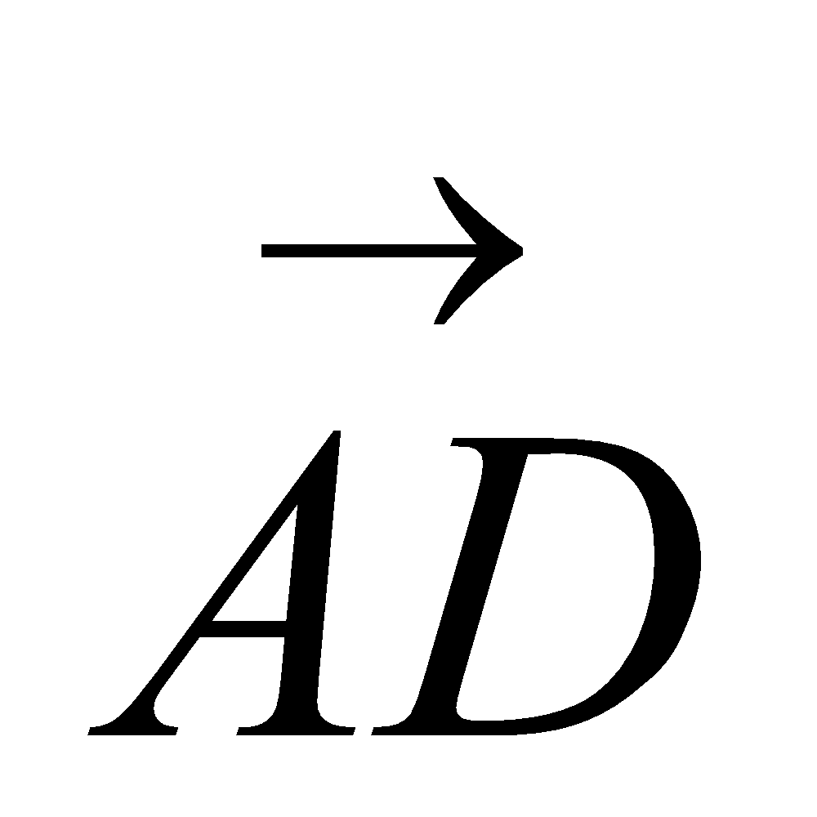 = q
(a) Express, in terms of p and q
(i) 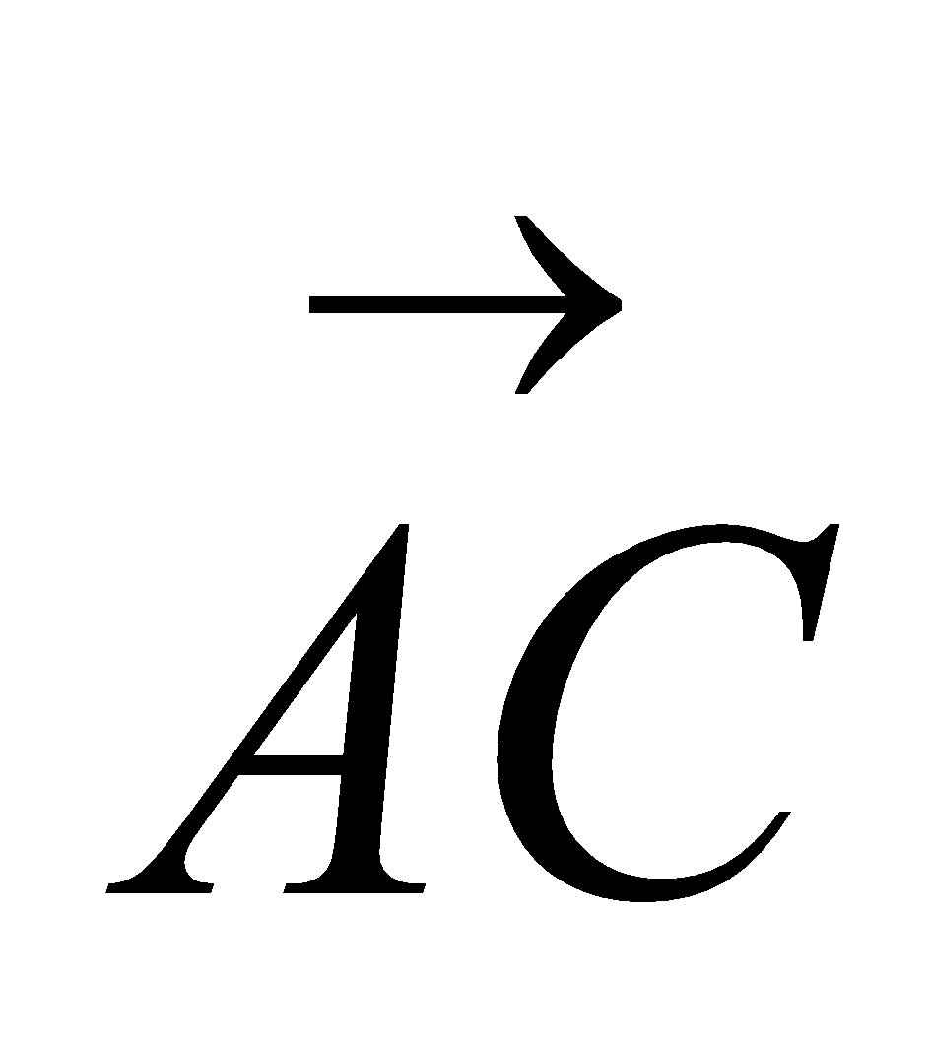

...........................................................
(ii) 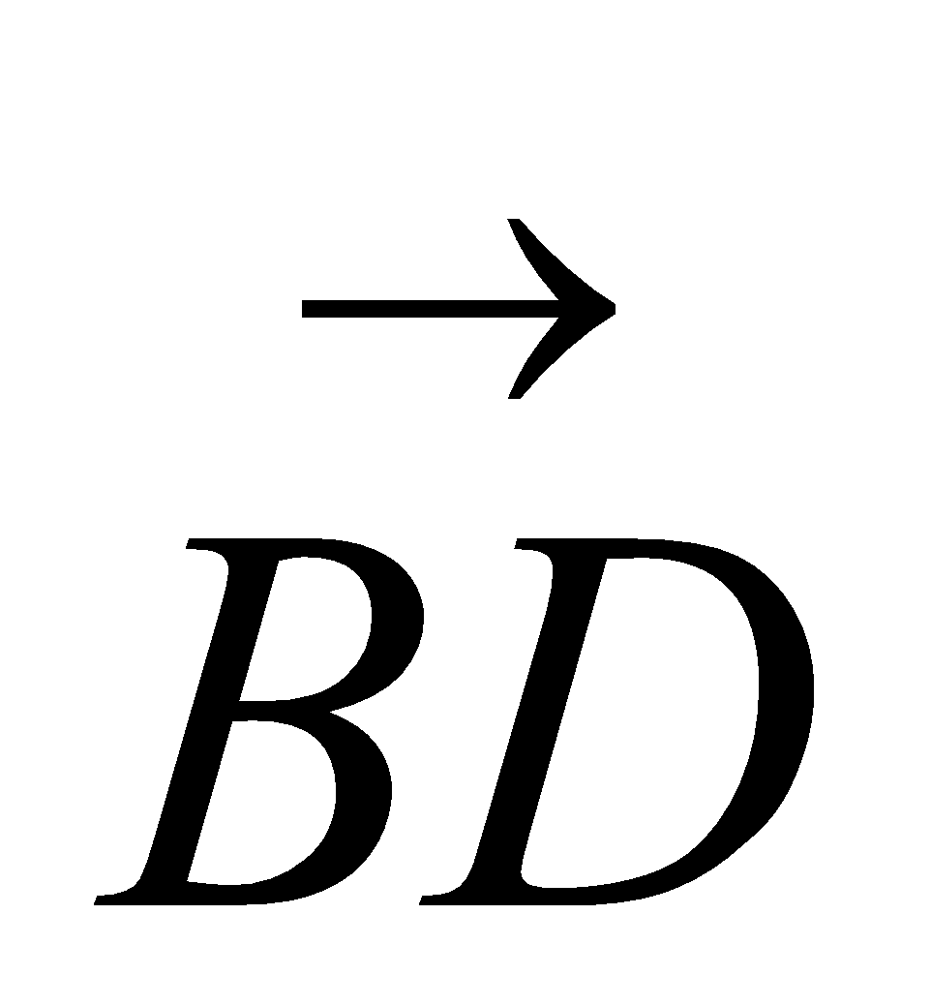

...........................................................
(2)
Diagram NOT accurately drawn
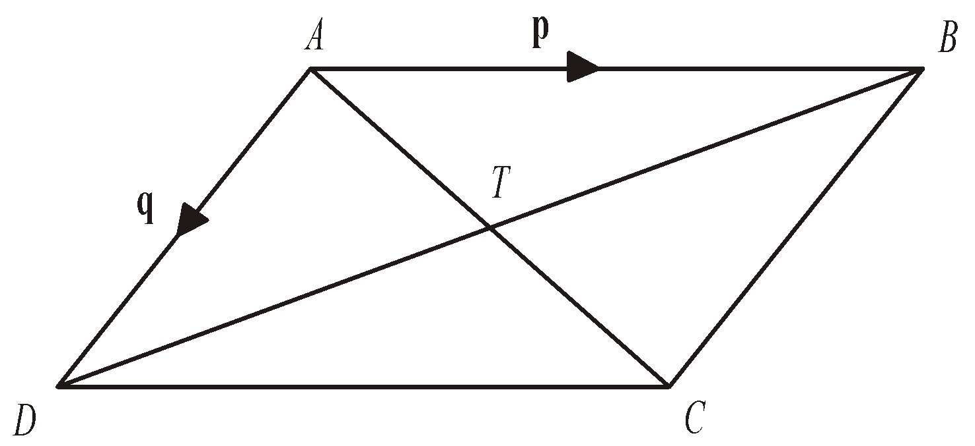
AC and BD are diagonals of parallelogram ABCD.
AC and BD intersect at T.
(b) Express 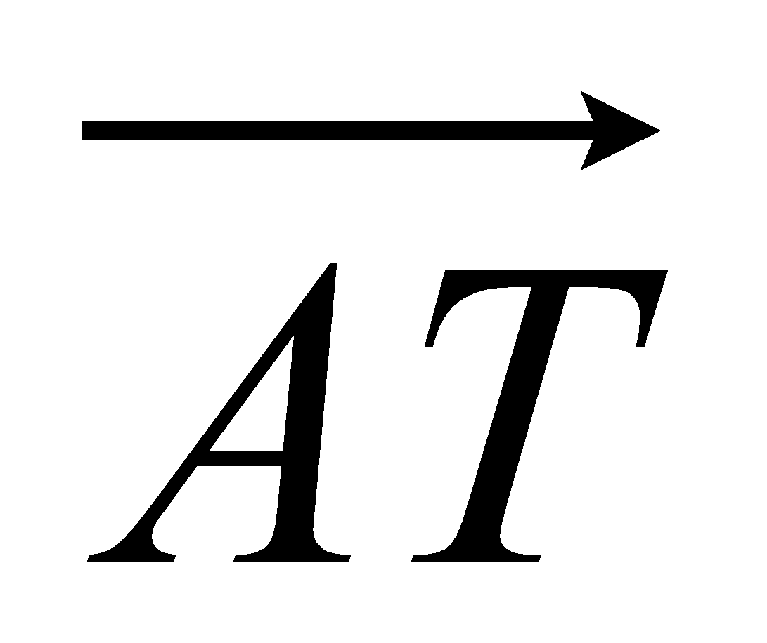 in terms of p and q.

...........................................................
(1)
(Total 3 marks)
8. Diagram NOT accurately drawn
OAB is a triangle.
B is the midpoint of OR.
Q is the midpoint of AB.
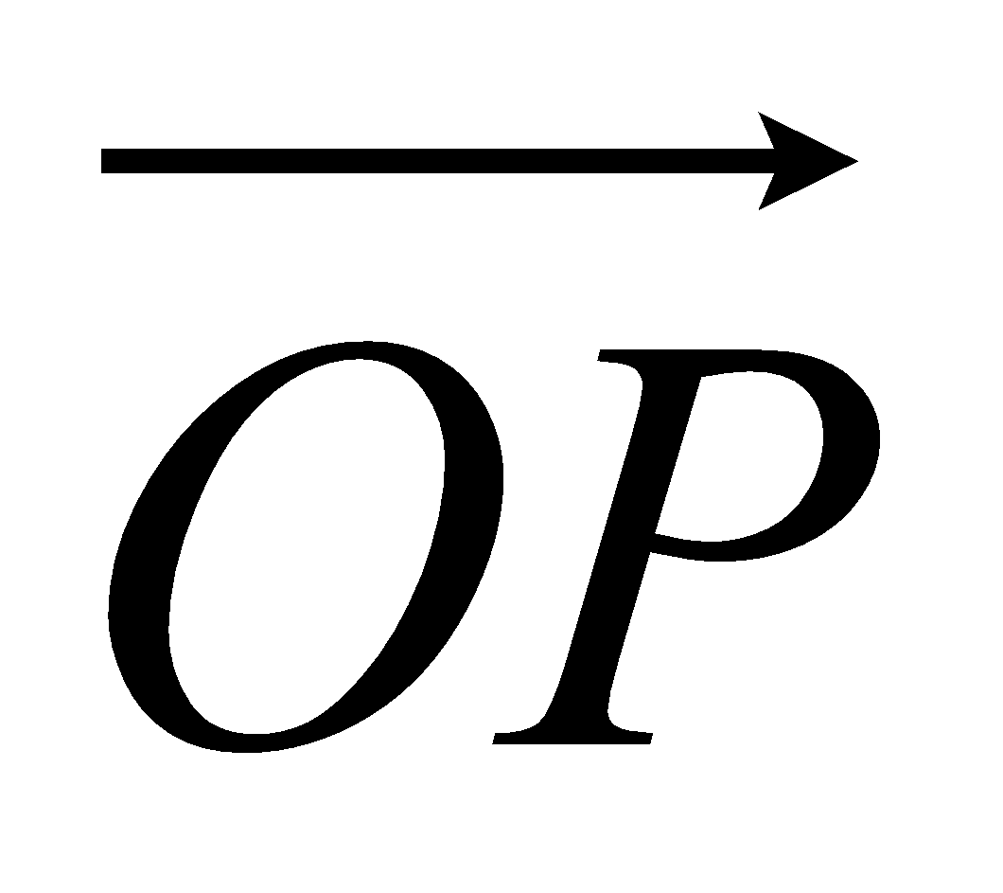 = 2a 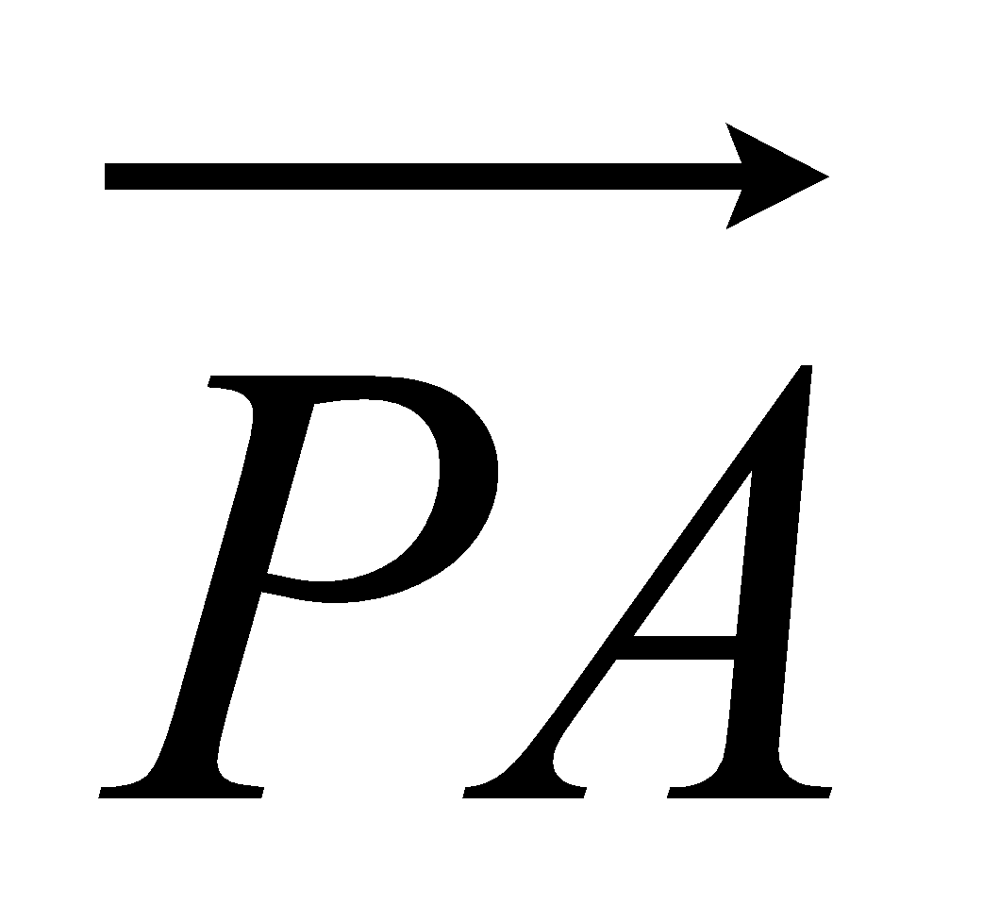 = a 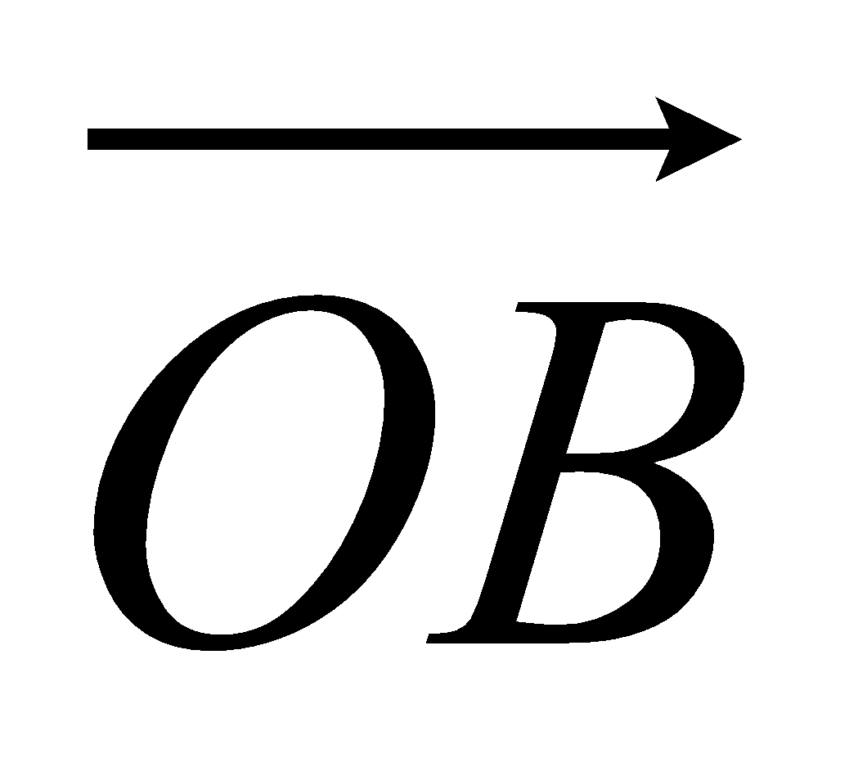 = b

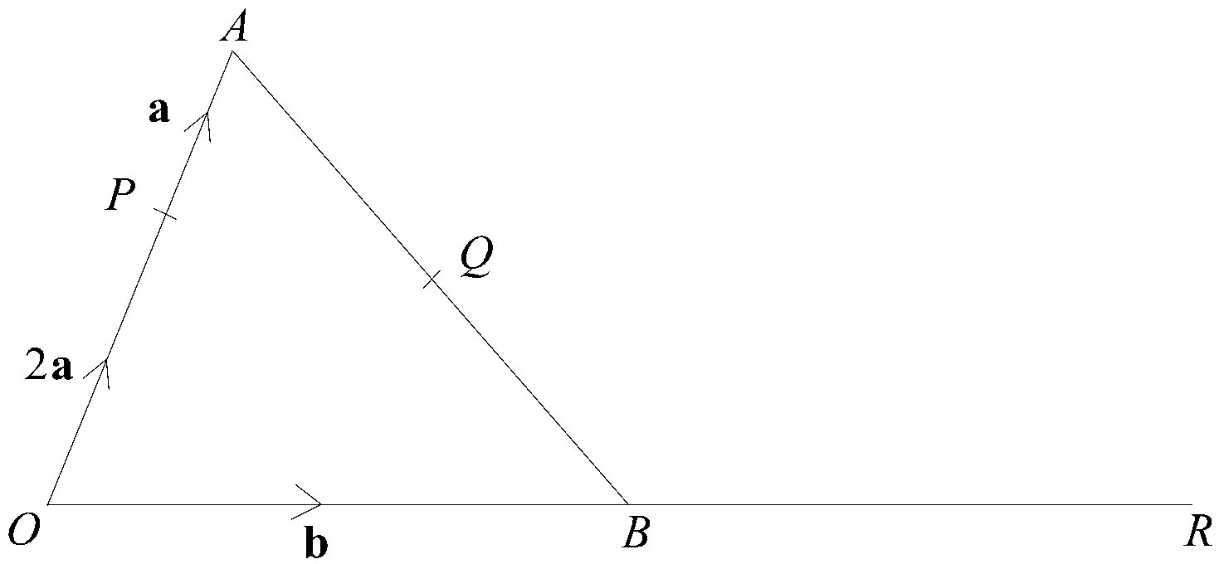
(a) Find, in terms of a and b, the vectors
(i) 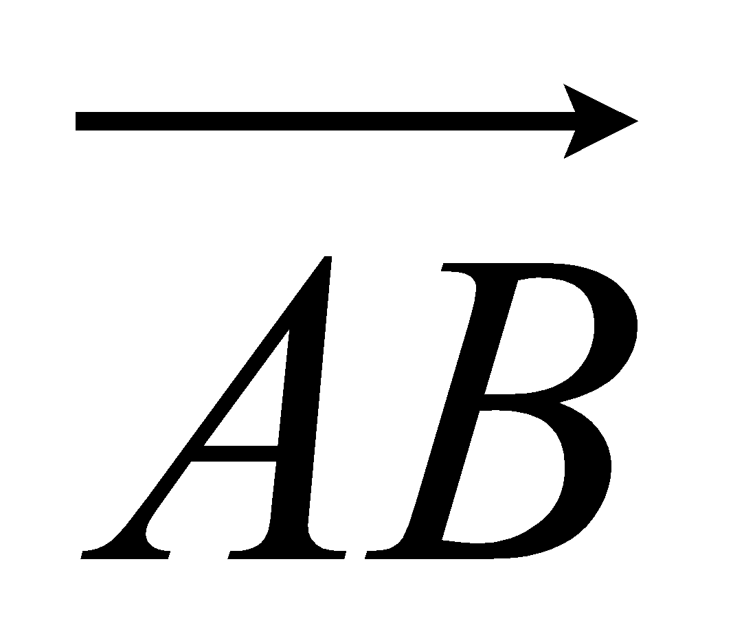,
...........................................................
(ii) 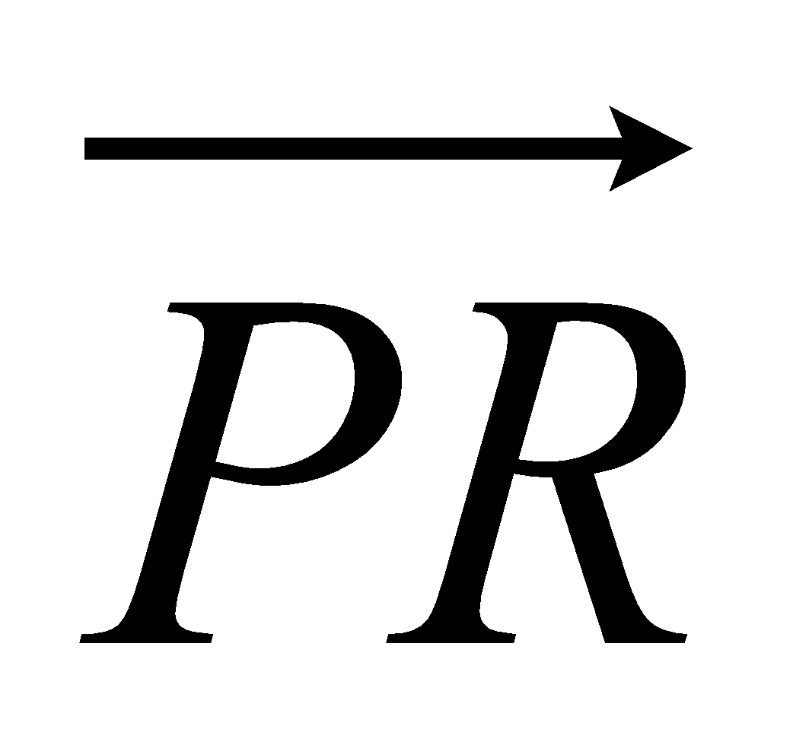,
...........................................................
(iii) 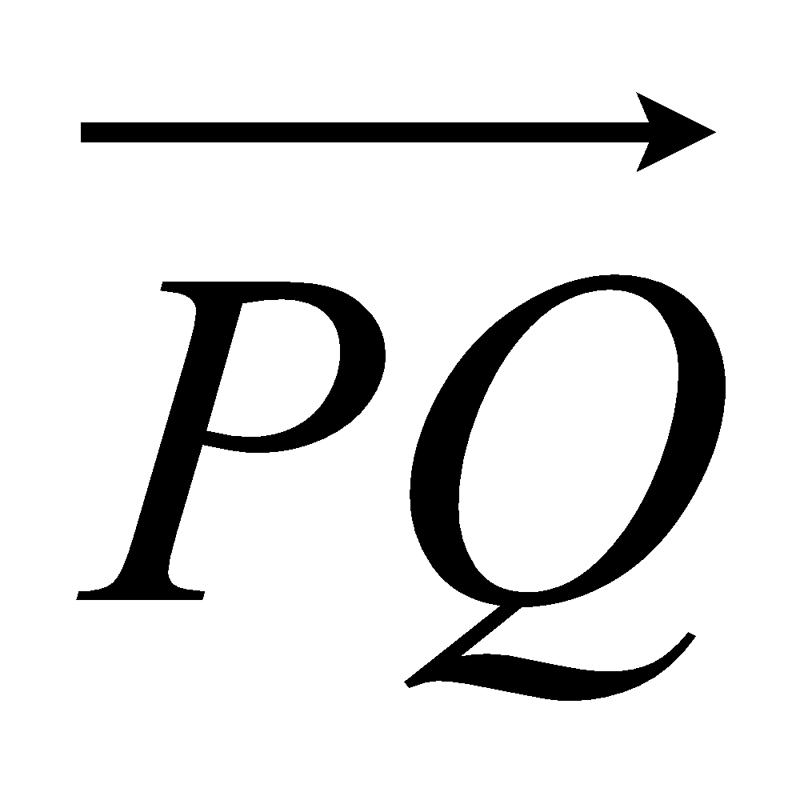.
...........................................................
(4)
(b) Hence explain why PQR is a straight line.

(2)
The length of PQ is 3 cm.
(c) Find the length of PR.

........................................................... cm
(1)
(Total 7 marks)

Sine and Cosine Rules
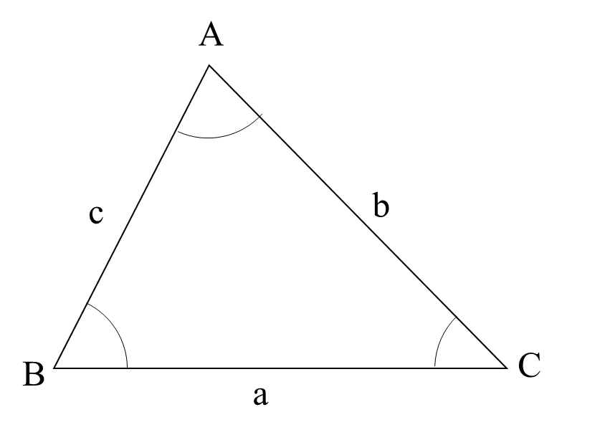
Things to remember:
- For any triangle ABC, a² = b² + c² - 2bc cosA
- For any triangle ABC, $\frac{a}{sinsin A }$ = $\frac{b}{sinsin B }$ = $\frac{c}{sinsin C }$
- For any triangle ABC, area = ½ a b sinC

Questions:
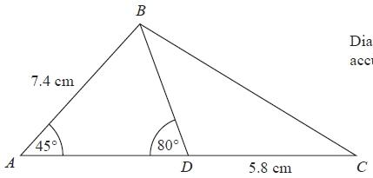
1. Diagram NOT accurately drawn
ABC is a triangle.
D is a point on AC.
Angle BAD = 45°
Angle ADB = 80°
AB = 7.4 cm
DC = 5.8 cm

Work out the length of BC.
Give your answer correct to 3 significant figures.
........................................................... cm
(Total for question = 5 marks)

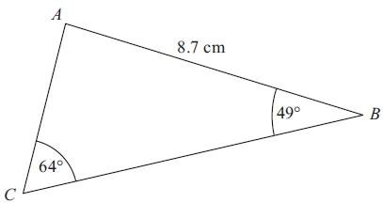
2. Diagram NOT accurately drawn
ABC is a triangle.
AB = 8.7 cm.
Angle ABC = 49°.
Angle ACB = 64°.
Calculate the area of triangle ABC.
Give your answer correct to 3 significant figures.

........................................................... cm²
(Total for Question is 5 marks)
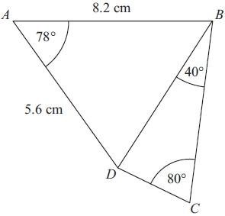
3. ABCD is a quadrilateral.
Diagram NOT accurately drawn
Work out the length of DC.
Give your answer correct to 3 significant figures.

........................................................... cm
(Total for Question is 6 marks)

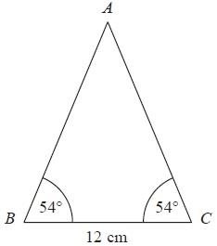
4. Diagram NOT accurately drawn
ABC is an isosceles triangle.
Work out the area of the triangle.
Give your answer correct to 3 significant figures.
........................................................... cm²
(Total for Question is 4 marks)
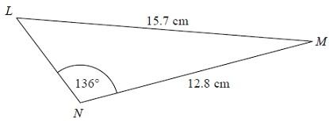
5. Diagram NOT accurately drawn
The diagram shows triangle LMN.
Calculate the length of LN.
Give your answer correct to 3 significant figures.
........................................................... cm
(Total for Question is 5 marks)

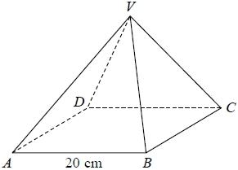
6. VABCD is a solid pyramid.
ABCD is a square of side 20 cm.
The angle between any sloping edge and the plane ABCD is 55°
Calculate the surface area of the pyramid.
Give your answer correct to 2 significant figures.
...........................................................cm²
(Total for question = 5 marks)
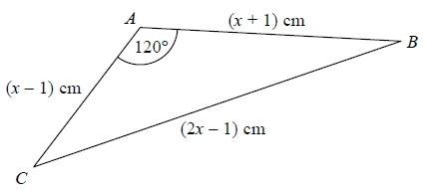
7. The diagram shows triangle ABC.
The area of triangle ABC is k√3 cm².
Find the exact value of k.
k = ...........................................................
(Total for question = 7 marks)

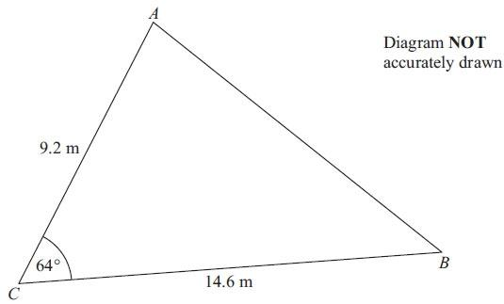
8. Diagram NOT accurately drawn

AC = 9.2 m
BC = 14.6 m
Angle ACB = 64°
(a) Calculate the area of the triangle ABC.
Give your answer correct to 3 significant figures.

.......................................................... m²
(2)
(b) Calculate the length of AB.
Give your answer correct to 3 significant figures.

..........................................................
(3)
(Total for Question is 5 marks)
Cumulative frequency and box plots

Things to remember:
- Use a running total – adding on to complete the cumulative frequency column;
- Plot at the end of the group;
- Join up with a smooth curve;
- To find the median find the value half way down the cumulative frequency, draw across to the line and then vertically down to find the value – always show these working lines;
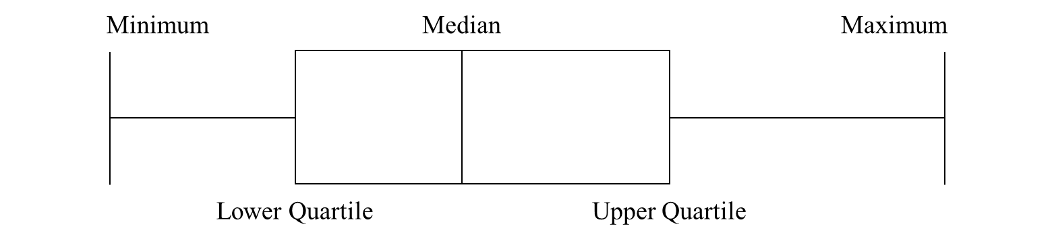
- To find the interquartile range find the upper quartile and the lower quartile and subtract them.
- To draw a box plot
- When comparing box plots, use the median and the IQR and keep words consistent with the question.

Questions:
1. The table shows information about the heights of 40 bushes.
Height (h cm) | Frequency | Cumulative Frequency
170 ≤ h < 175 | 5
175 ≤ h < 180 | 18
180 ≤ h < 185 | 12
185 ≤ h < 190 | 4
190 ≤ h < 195 | 1
(a) Complete the cumulative frequency table above.

(1)
(b) On the grid, draw a cumulative frequency graph for your table.
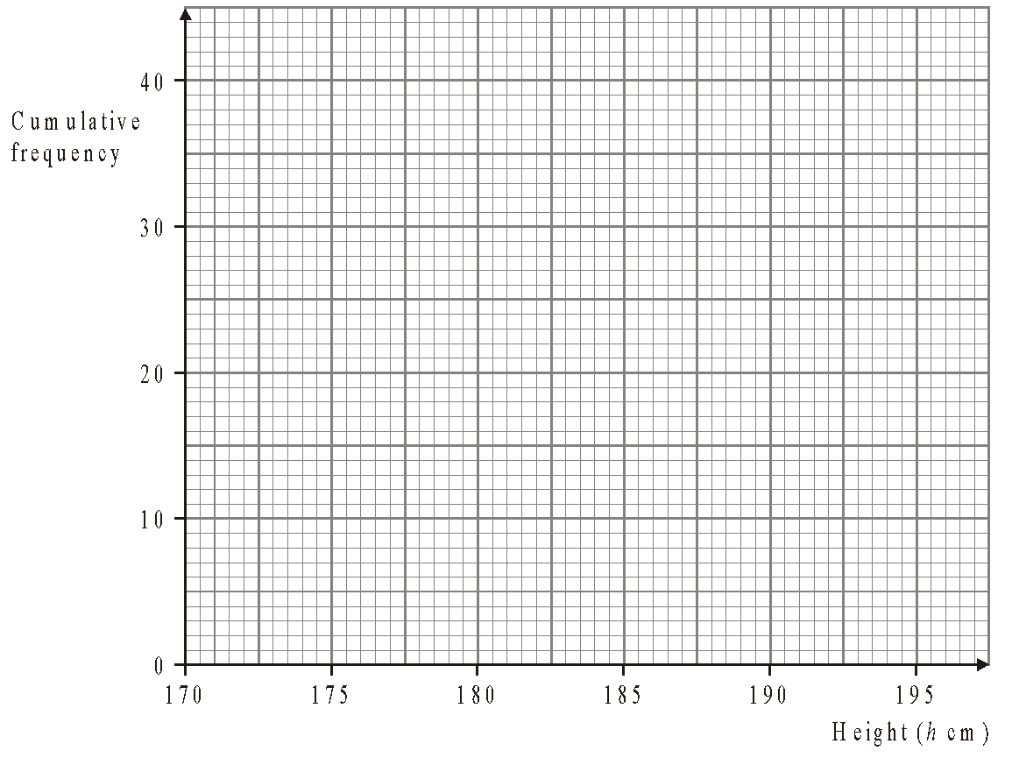
(2)
(Total 3 marks)
2. The table gives information about the ages of 160 employees of an IT company.
Age (A) in years | Frequency | Cumulative Frequency
15 < A ≤ 25 | 44
25 < A ≤ 35 | 56
35 < A ≤ 45 | 34
45 < A ≤ 55 | 19
55 < A ≤ 65 | 7

(a) Write down the modal class interval.
..........................................................
(1)
(b) Complete the cumulative frequency table.
(1)
(c) On the grid below, draw a cumulative frequency graph for your table.
(2)
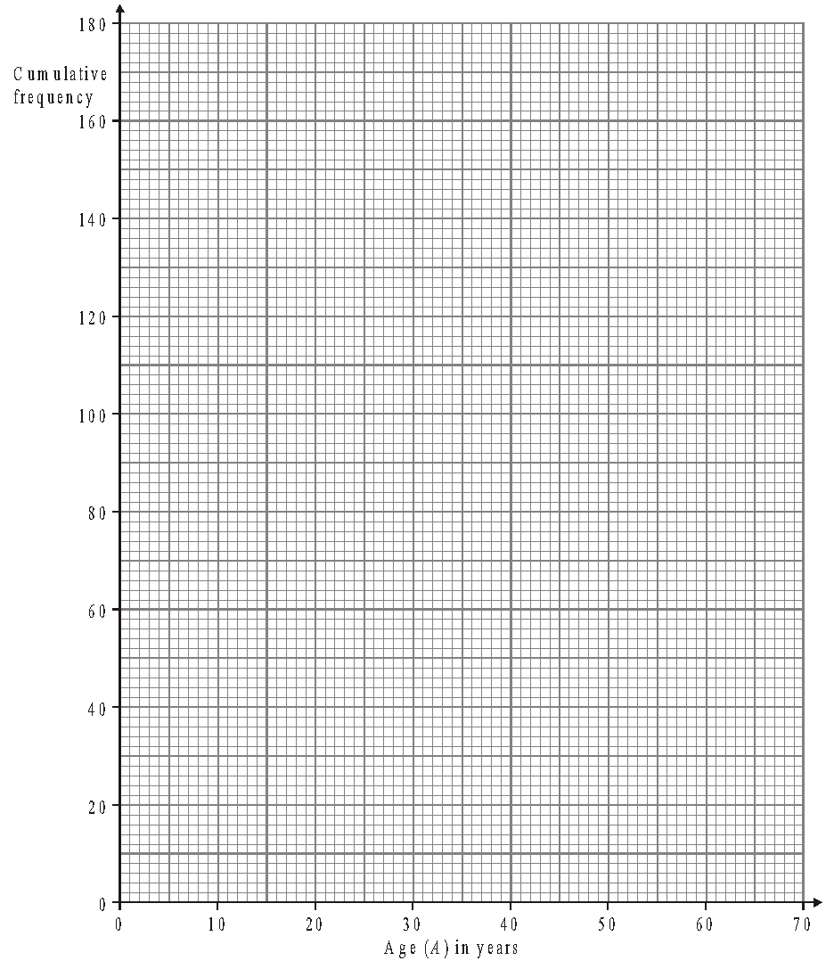
(d) Use your graph to find an estimate for
(i) the median age of the employees,
.......................................................... years
(i) the interquartile range of the ages of the employees.
.......................................................... years
(3)
Another IT company has 80 employees. The age of the youngest employee is 24 years. The age of the oldest employee is 54 years. The median age is 38 years. The lower quartile age is 30 years. The upper quartile age is 44 years.
(e) On the grid below, draw a box plot to show information about the ages of the employees.
(2)
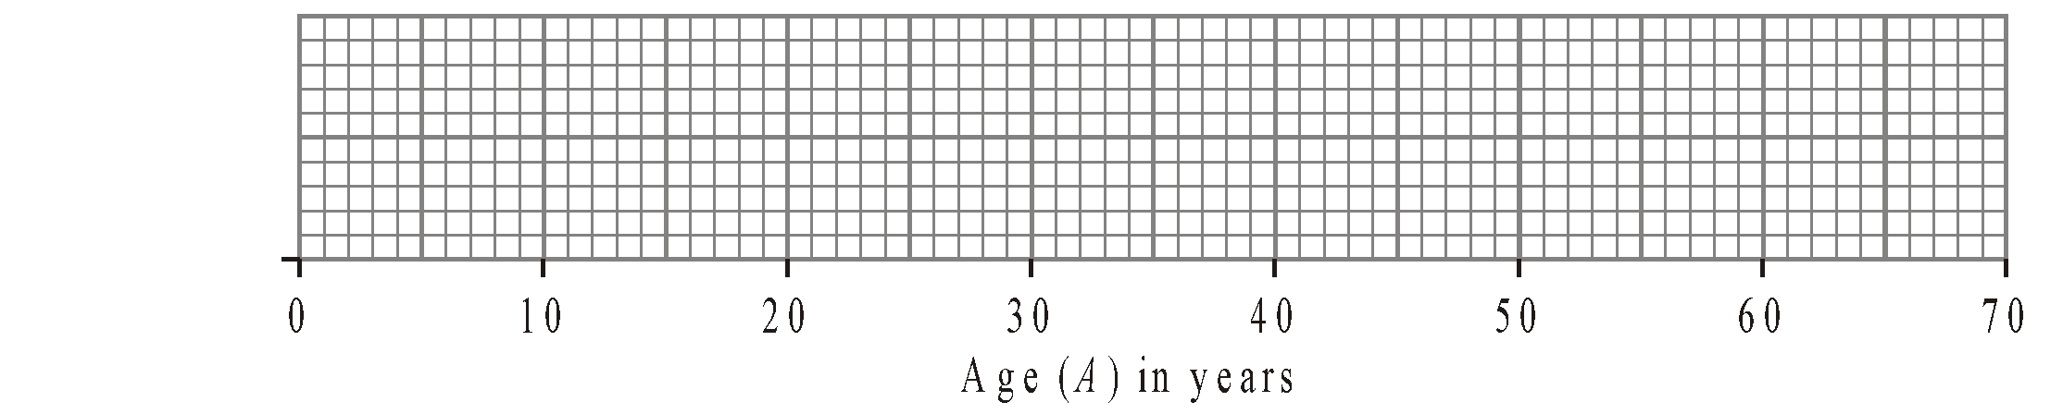
(Total 9 marks)

3. A company tested 100 batteries. The table shows information about the number of hours that the batteries lasted.

Time (t hours) | Frequency | Cumulative Frequency
50 ≤ t < 55 | 12
55 ≤ t < 60 | 21
60 ≤ t < 65 | 36
65 ≤ t < 70 | 23
70 ≤ t < 75 | 8

(a) Complete the cumulative frequency table for this information.
(1)
(b) On the grid, draw a cumulative frequency graph for your completed table.
(2)
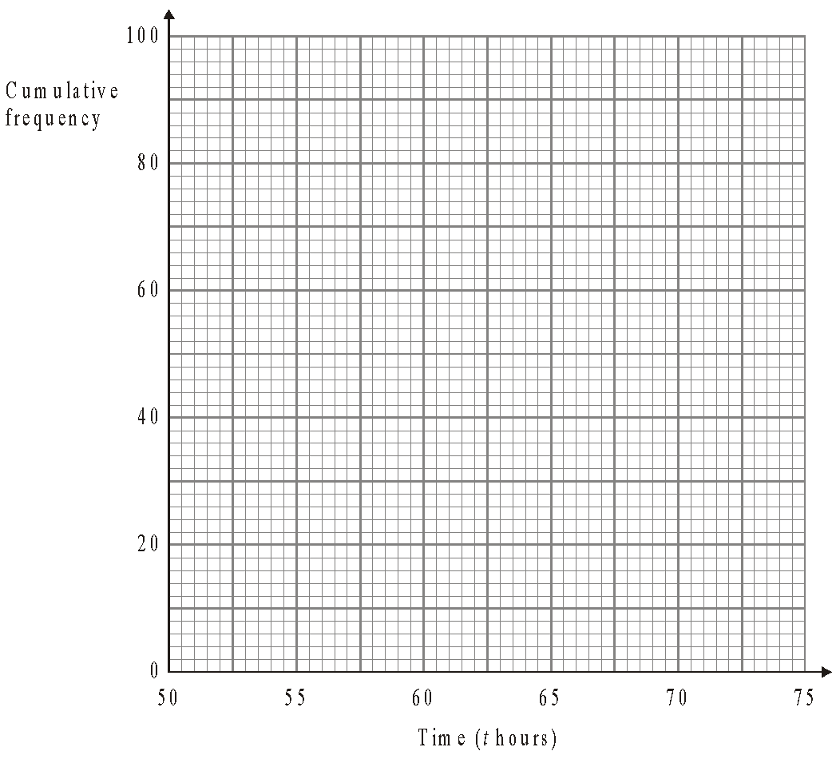
(c) Use your completed graph to find an estimate for the median time. You must state the units of your answer.
..........................................................
(2)
(Total 5 marks)
4. The table shows information about the ages of the 240 people at a club.

Age (t years) | Frequency | Cumulative Frequency
15 ≤ t < 20 | 95
20 ≤ t < 25 | 90
25 ≤ t < 30 | 35
30 ≤ t < 35 | 15
35 ≤ t < 40 | 5

(a) Complete the cumulative frequency table.
(1)
(b) On the grid, draw the cumulative frequency graph for your table.
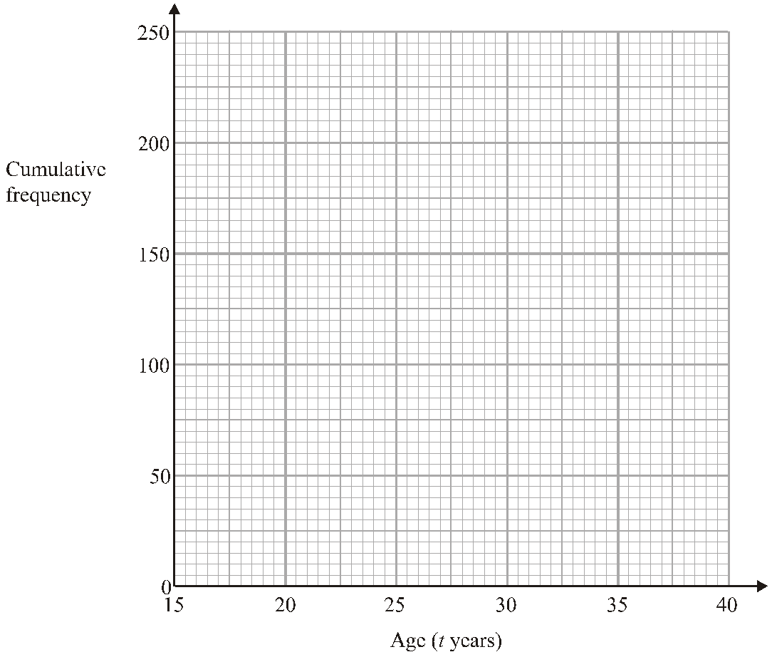
(2)
(c) Use your graph to find an estimate for the median age of the people.
.......................................................... years
(1)
(Total 4 marks)

5. An operator took 100 calls at a call centre. The table gives information about the time (t seconds) it took the operator to answer each call.

Time (t seconds) | Frequency | Cumulative Frequency
0 < t ≤ 10 | 16
10 < t ≤ 20 | 34
20 < t ≤ 30 | 32
30 < t ≤ 40 | 14
40 < t ≤ 50 | 4

(a) Complete the cumulative frequency table.
(1)
(b) On the grid, draw a cumulative frequency graph for your table.
(2)
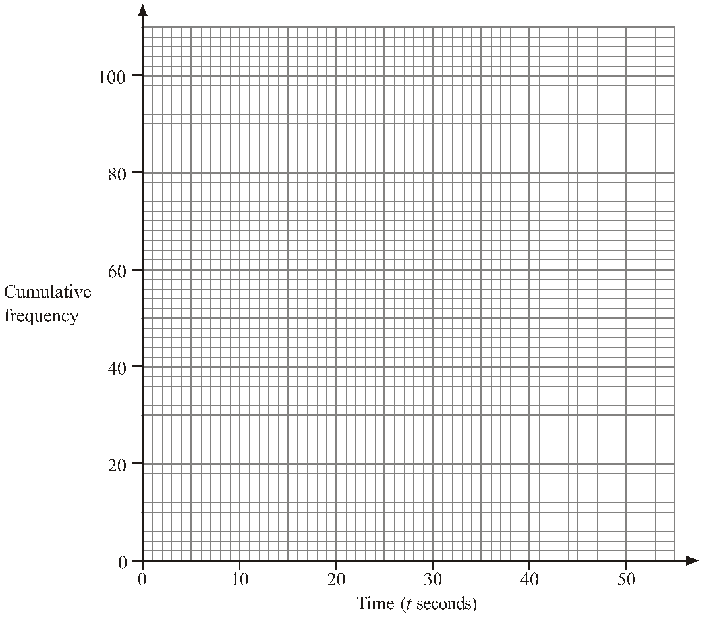
(c) Use your graph to find an estimate for the number of calls the operator took more than 18 seconds to answer.
..........................................................
(2)
(Total 5 marks)

6. 200 students took a test. The cumulative frequency graph gives information about their marks.

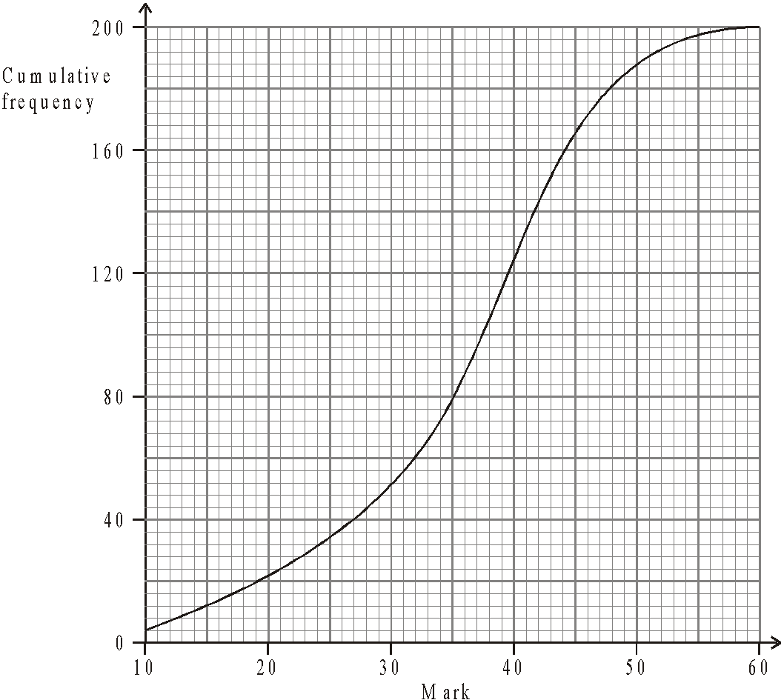

The lowest mark scored in the test was 10.
The highest mark scored in the test was 60.
Use this information and the cumulative frequency graph to draw a box plot showing information about the students’ marks.

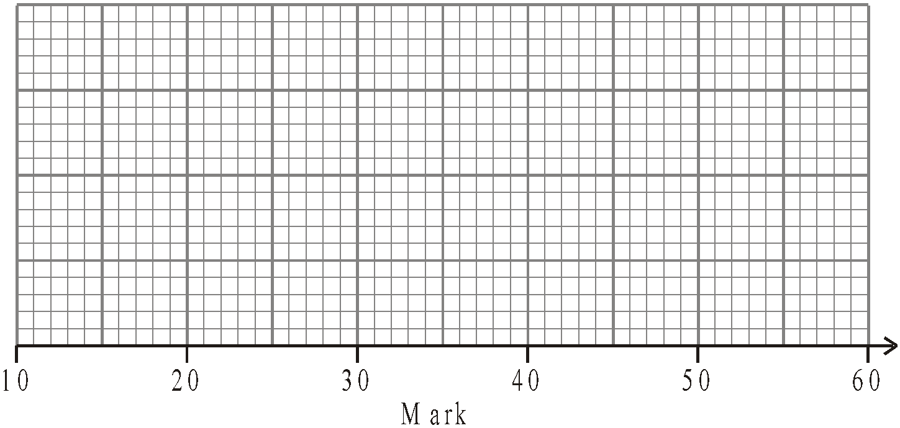
(Total 3 marks)

7. On Friday, Peter went to the airport.
He recorded the number of minutes that each plane was delayed.
He used his results to work out the information in this table.

 | Minutes
Shortest delay | 0
Lower quartile | 2
Median | 8
Upper quartile | 18
Longest delay | 41

(a) On the grid, draw a box plot to show the information in the table.

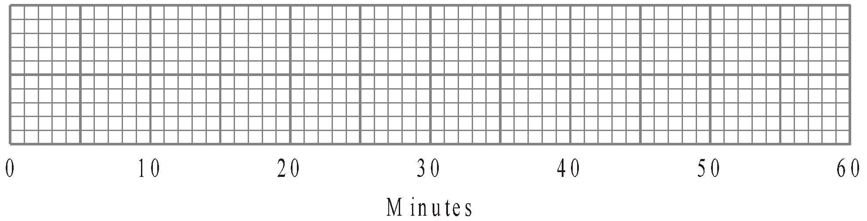
(2)
Peter also went to the airport on Saturday.
He recorded the number of minutes that each plane was delayed.
The box plot below was drawn using this information.
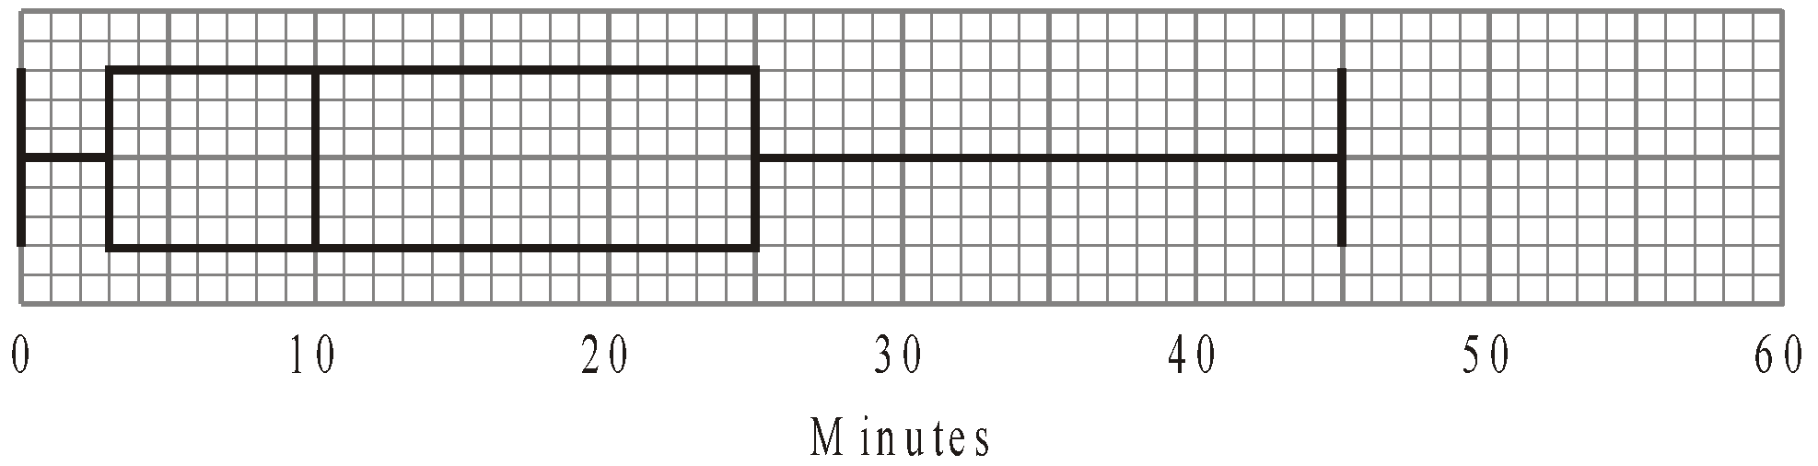

(b) Make two comparisons between the distributions of plane delays on Friday and on Saturday.

………………………......................................................................................................

………………………......................................................................................................

………………………......................................................................................................

………………………......................................................................................................
(2)
(Total 4 marks)

Histograms

Things to remember:
- Frequency = Frequency Density x Class Width;
- The y-axis will always be labelled “frequency density”;
- The x-axis will have a continuous scale.

Questions:
1. One Monday, Victoria measured the time, in seconds, that individual birds spent on her bird table. She used this information to complete the frequency table.

Time (t seconds) | Frequency
0 < t ≤ 10 | 8
10 < t ≤ 20 | 16
20 < t ≤ 25 | 15
25 < t ≤ 30 | 12
30 < t ≤ 50 | 6

(a) Use the table to complete the histogram.
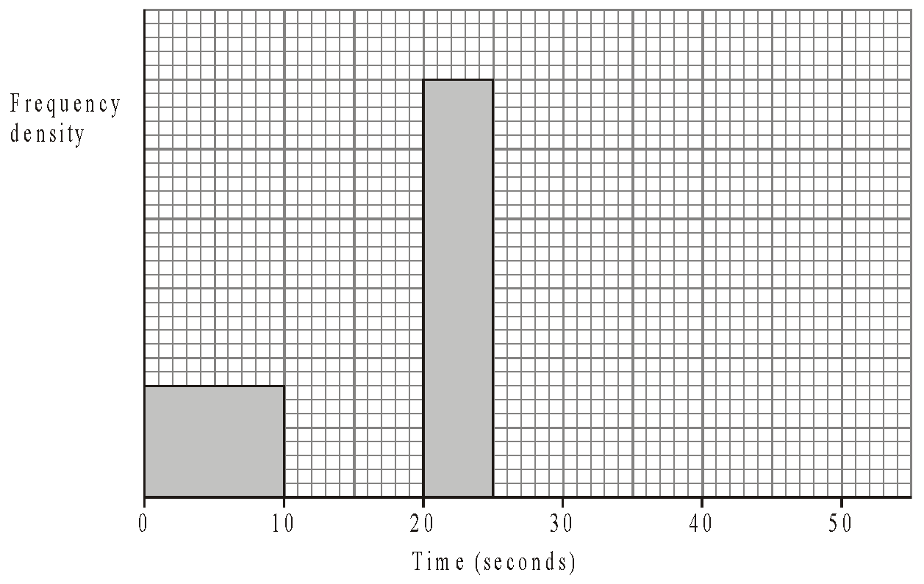
(3)

On Tuesday she conducted a similar survey and drew the following histogram from her results.
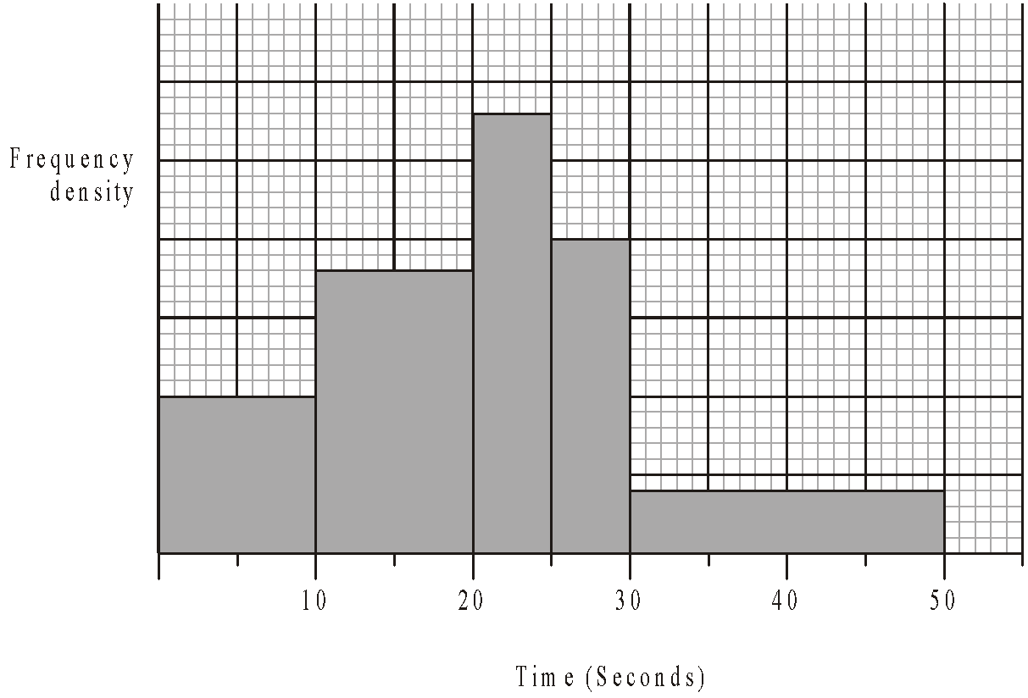

(b) Use the histogram for Tuesday to complete the table.

Time (t seconds) | Frequency
0 < t ≤ 10 | 10
10 < t ≤ 20
20 < t ≤ 25
25 < t ≤ 30
30 < t ≤ 50
(2)
(Total 5 marks)

2. This histogram gives information about the books sold in a bookshop one Saturday.
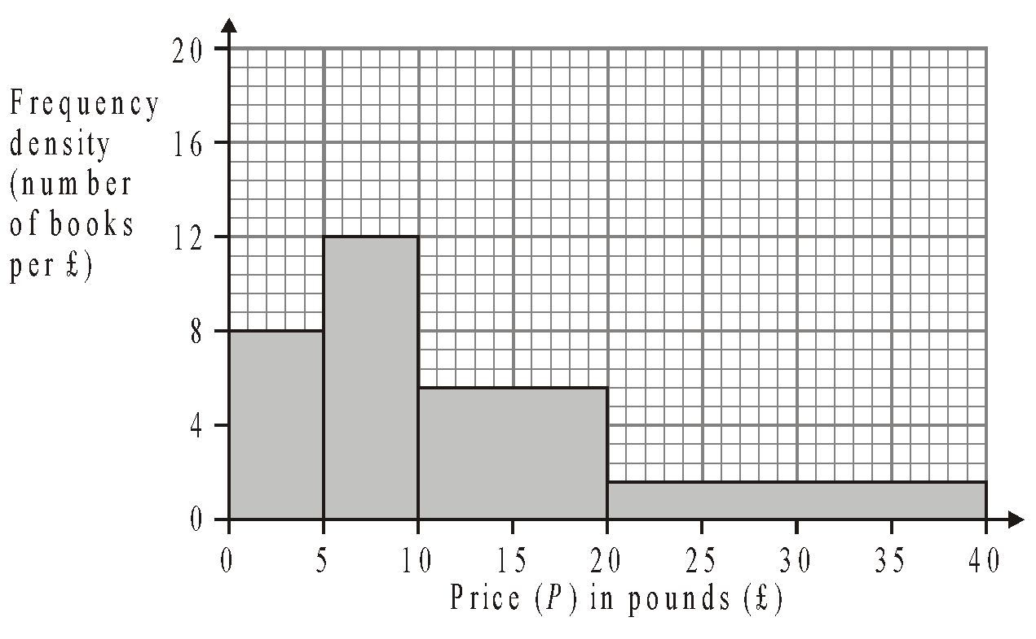
(a) Use the histogram to complete the table.
Price (P) in pounds (£) | Frequency
0 < P ≤ 5
5 < P ≤ 10
10 < P ≤ 20
20 < P ≤ 40
(2)
The frequency table below gives information about the books sold in a second bookshop on the same Saturday.
Price (P) in pounds (£) | Frequency
0 < P ≤ 5 | 80
5 < P ≤ 10 | 20
10 < P ≤ 20 | 24
20 < P ≤ 40 | 96
(b) On the grid below, draw a histogram to represent the information about the books sold in the second bookshop.
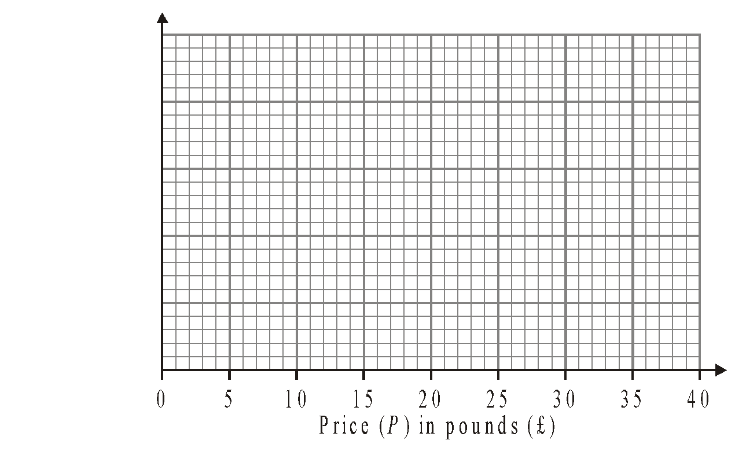
(3)
(Total 5 marks)

3. The incomplete table and histogram give some information about the distances walked by some students in a school in one year.

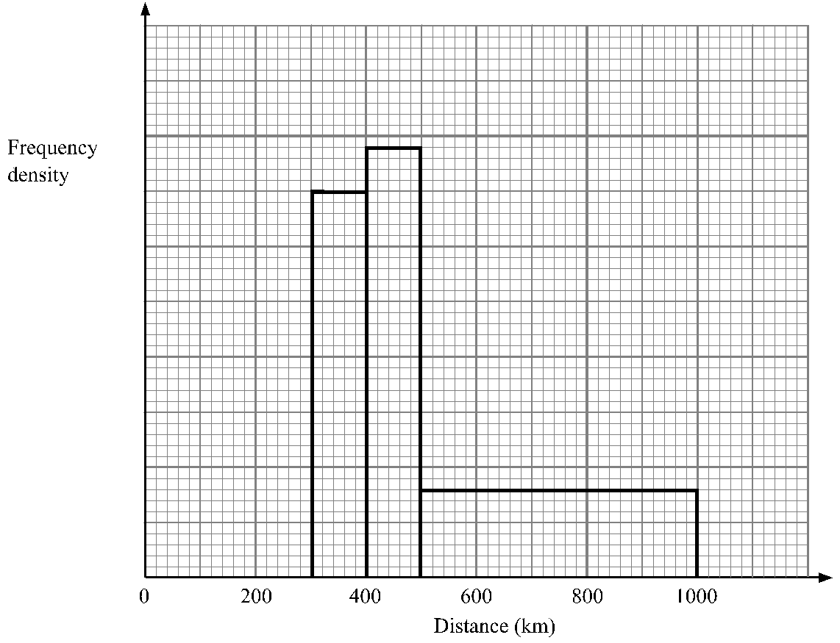

(a) Use the information in the histogram to complete the frequency table.

Distance (d) in km | Frequency
0 < d ≤ 300 | 210
300 < d ≤ 400 | 350
400 < d ≤ 500
500 < d ≤ 1000
(2)
(b) Use the information in the table to complete the histogram.
(1)
(Total 3 marks)

4. The incomplete histogram and table show information about the weights of some containers.

Weight (w) in kg | Frequency
0 < w ≤ 1000 | 16
1000 < w ≤ 2000
2000 < w ≤ 4000
4000 < w ≤ 6000 | 16
6000 < w ≤ 8000
8000 < w ≤ 12000 | 8

(a) Use the information in the histogram to complete the table.
(2)
(b) Use the information in the table to complete the histogram.
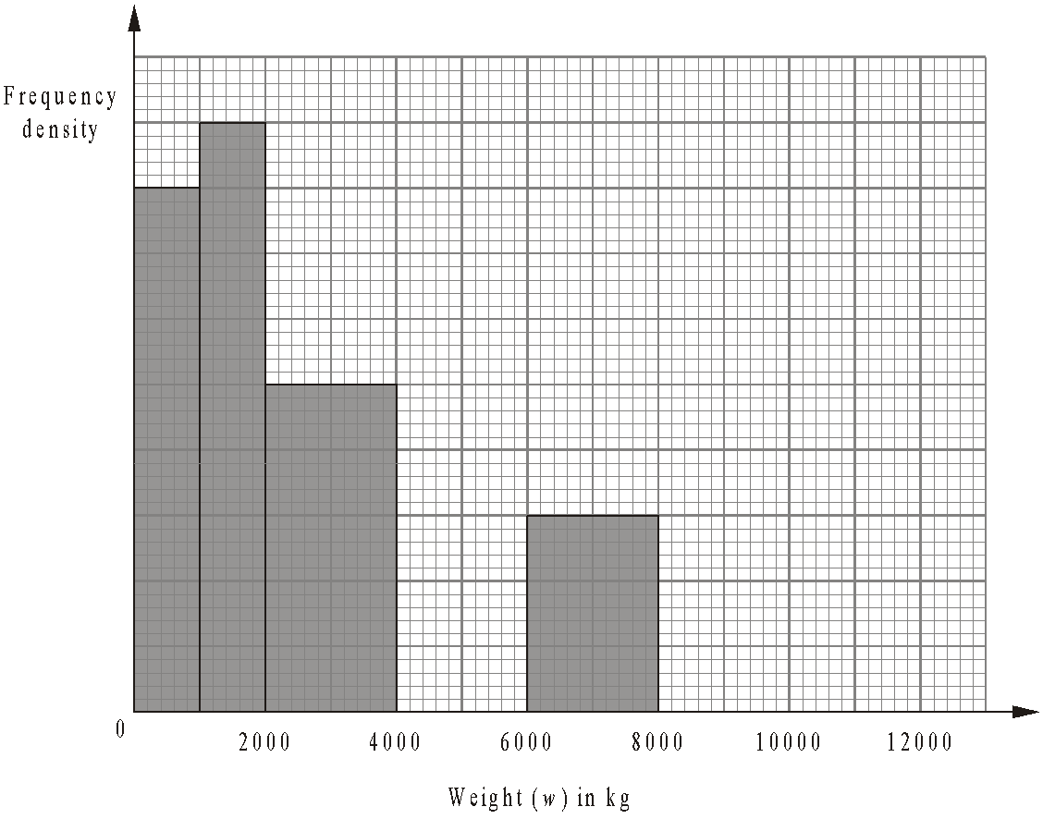
(2)
(Total 4 marks)

5. The incomplete histogram and table give some information about the distances some teachers travel to school.

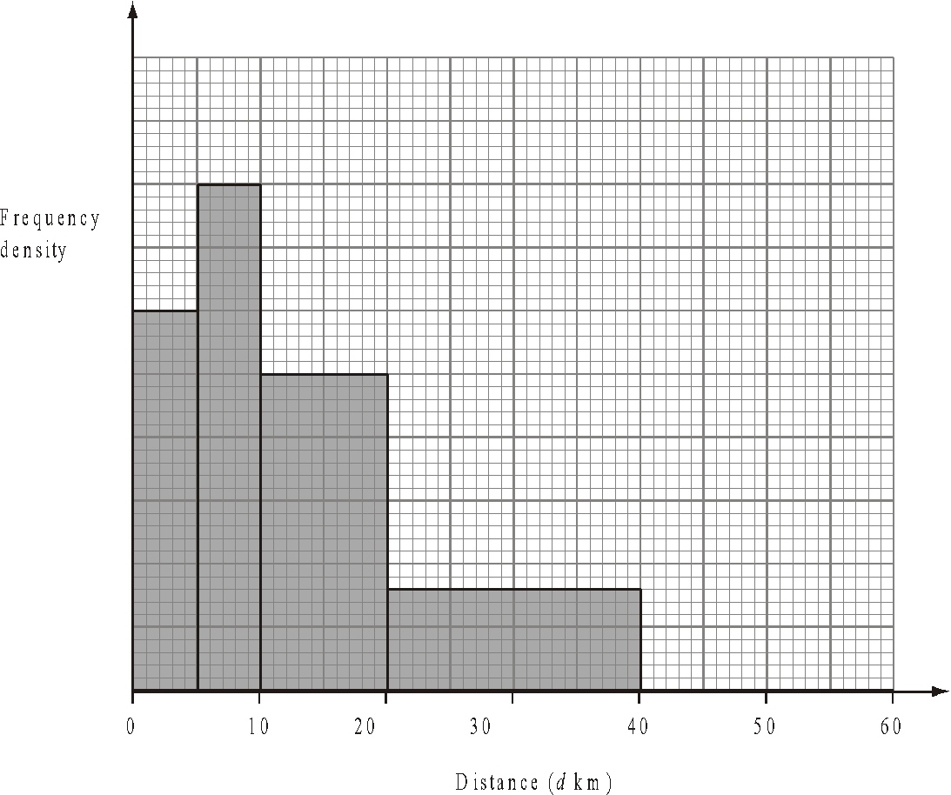
(a) Use the information in the histogram to complete the frequency table.

Distance (dkm) | Frequency
0 < d ≤ 5 | 15
5 < d ≤ 10 | 20
10 < d ≤ 20
20 < d ≤ 40
40 < d ≤ 60 | 10
(2)
(b) Use the information in the table to complete the histogram.
(1)
(Total 3 marks)

6. The table gives information about the heights, in centimetres, of some 15 year old students.

Height (h cm) | 145 < h ≤ 155 | 155 < h ≤ 175 | 175 < h ≤ 190
Frequency | 10 | 80 | 24

Use the table to draw a histogram.

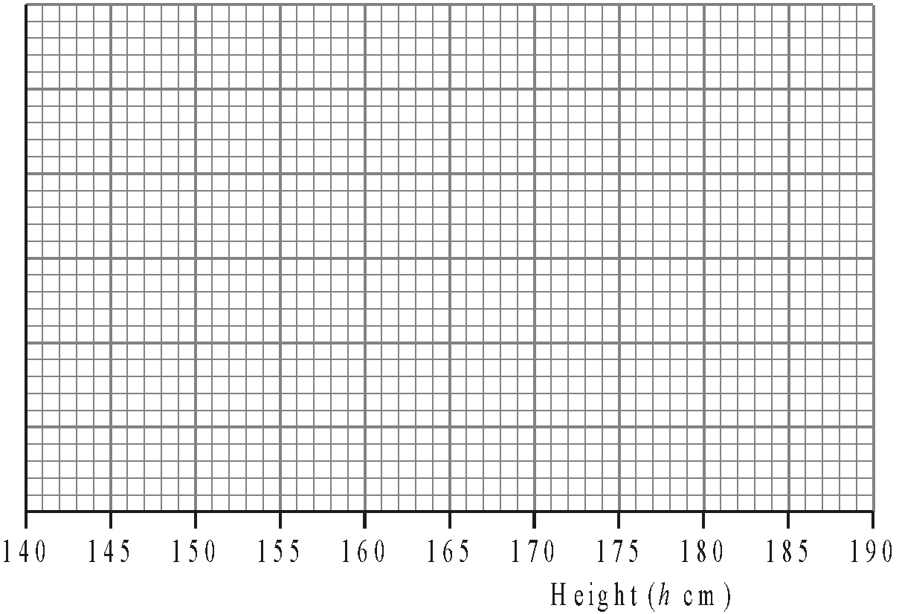
(Total 3 marks)

7. A teacher asked some year 10 students how long they spent doing homework each night.
The histogram was drawn from this information.
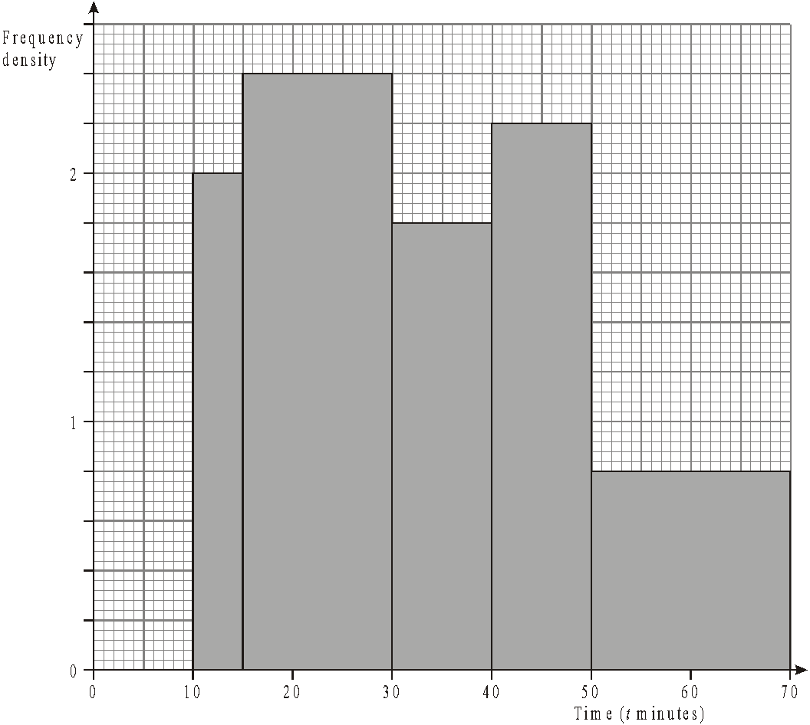
Use the histogram to complete the table.

Time (t minutes) | Frequency
10 ≤ t < 15 | 10
15 ≤ t < 30
30 ≤ t < 40
40 ≤ t < 50
50 ≤ t < 70
(Total 2 marks)

Set Theory

Things to remember:
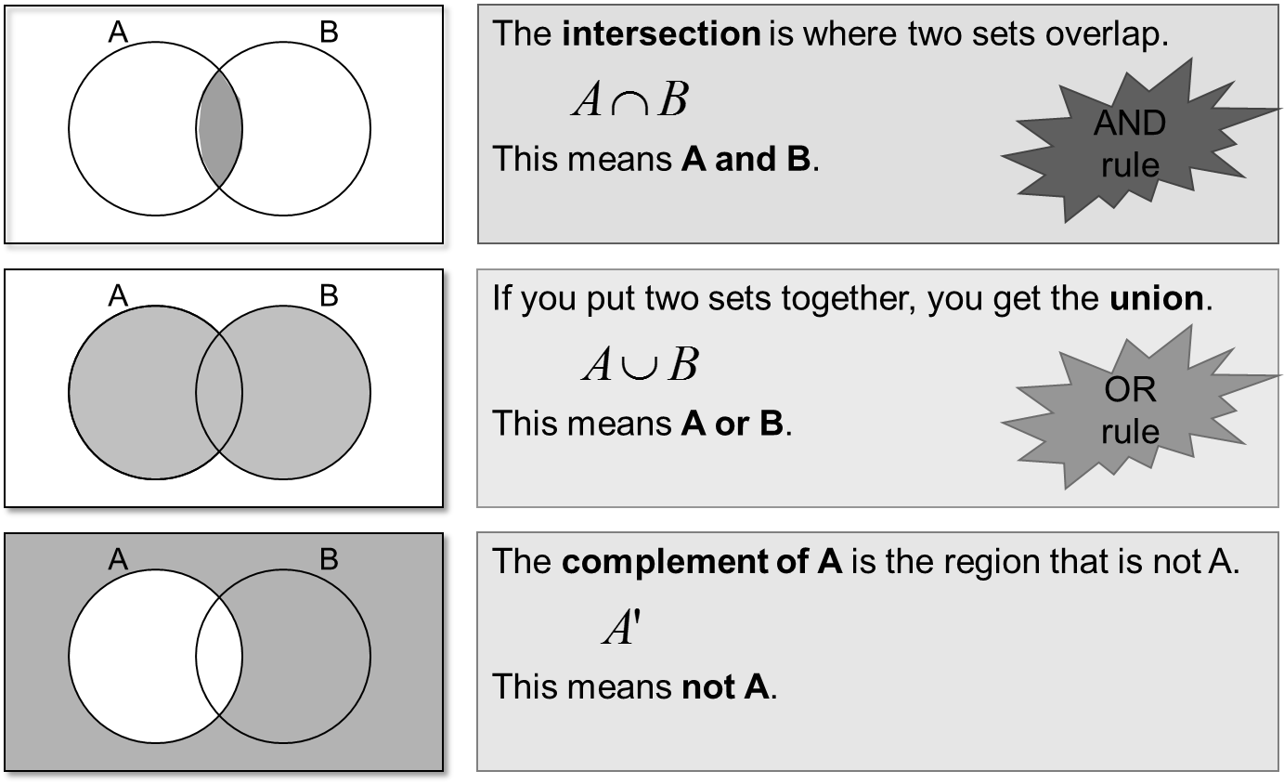

Questions:
1.
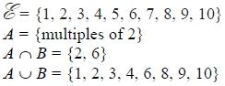
Draw a Venn diagram for this information.

(Total for question is 4 marks)

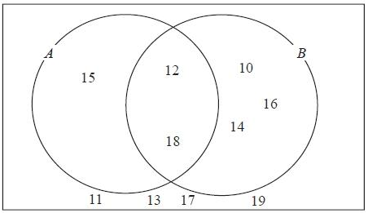
2. Here is a Venn diagram.

(a) Write down the numbers
that are in set
(i) A ∪ B

.............................................

(ii) A ∩ B
.............................................
(2)

One of the numbers in the diagram is chosen at random.
(b) Find the probability that the number is in set A'

...........................................................
(2)
(Total for question = 4 marks)

3. Sami asked 50 people which drinks they liked from tea, coffee and milk.
All 50 people like at least one of the drinks
19 people like all three drinks.
16 people like tea and coffee but do not like milk.
21 people like coffee and milk.
24 people like tea and milk.
40 people like coffee.
1 person likes only milk.
Sami selects at random one of the 50 people.
(a) Work out the probability that this person likes tea.

...........................................................
(4)
(b) Given that the person selected at random from the 50 people likes tea, find the probability that this person also likes exactly one other drink.

...........................................................
(2)
(Total for question = 6 marks)

Proportion

Things to remember:
- Start by checking the question for squares, cubes and roots;
- “x is directly proportional to y” looks like x α y or x = ky
- “x is inversely proportional to y” looks like x α $\frac{1}{y}$or x = $\frac{k}{y}$

Questions:
1. The shutter speed, S, of a camera varies inversely as the square of the aperture setting, f.
When f = 8, S = 125
(a) Find a formula for S in terms of f.

...........................................................
(3)
(b) Hence, or otherwise, calculate the value of S when f = 4

S = ...........................................................
(1)
(Total 4 marks)
2. In a factory, chemical reactions are carried out in spherical containers.
The time, T minutes, the chemical reaction takes is directly proportional to the square of the radius, R cm, of the spherical container.
When R = 120, T = 32
Find the value of T when R = 150

T = ...........................................................
(Total 4 marks)

3. d is directly proportional to the square of t.
d = 80 when t = 4
(a) Express d in terms of t.

...........................................................
(3)
(b) Work out the value of d when t = 7

d = ...........................................................
(1)
(c) Work out the positive value of t when d = 45

t = ...........................................................
(2)
(Total 6 marks)

4. The distance, D, travelled by a particle is directly proportional to the square of the time, t, taken. When t = 40, D = 30
(a) Find a formula for D in terms of t.

D = ...........................................................
(3)
(b) Calculate the value of D when t = 64

...........................................................
(1)
(c) Calculate the value of t when D = 12
Give your answer correct to 3 significant figures.

...........................................................
(2)
(Total 6 marks)
5. The time, T seconds, it takes a water heater to boil some water is directly proportional
to the mass of water, m kg, in the water heater. When m = 250, T = 600
(a) Find T when m = 400

T = ...........................................................
(3)
The time, T seconds, it takes a water heater to boil a constant mass of water is inversely proportional to the power, P watts, of the water heater.
When P = 1400, T = 360
(b) Find the value of T when P = 900

T = ...........................................................
(3)
(Total 6 marks)

6. A ball falls vertically after being dropped.
The ball falls a distance d metres in a time of t seconds.
d is directly proportional to the square of t.
The ball falls 20 metres in a time of 2 seconds.
(a) Find a formula for d in terms of t.

d = ...........................................................
(3)
(b) Calculate the distance the ball falls in 3 seconds.

........................................................... m
(1)
(c) Calculate the time the ball takes to fall 605 m.

........................................................... seconds
(3)
(Total 7 marks)
7. In a spring, the tension (T newtons) is directly proportional to its extension (x cm). When the tension is 150 newtons, the extension is 6 cm.
(a) Find a formula for T in terms of x.

T = ...........................................................
(3)
(b) Calculate the tension, in newtons, when the extension is 15 cm.

...........................................................newtons
(1)
(c) Calculate the extension, in cm, when the tension is 600 newtons.

...........................................................cm
(1)
(Total 5 marks)

8. f is inversely proportional to d.
When d = 50, f = 256
Find the value of f when d = 80

f = ...........................................................
(Total 3 marks)
Percentages – compound interest

Things to remember:
Number of years
- ${New amount=original amount x multiplier}^{n}$

Questions:
1. Henry invests £4500 at a compound interest rate of 5% per annum.
At the end of n complete years the investment has grown to £5469.78.
Find the value of n.

...........................................................
(Total 2 marks)

2. Bill buys a new machine.
The value of the machine depreciates by 20% each year.
(a) Bill says ‘after 5 years the machine will have no value’.
Bill is wrong. Explain why.

.......................................................................................................................................

.......................................................................................................................................

.......................................................................................................................................
(1)
Bill wants to work out the value of the machine after 2 years.
(b) By what single decimal number should Bill multiply the value of the machine when new?

...........................................................
(2)
(Total 3 marks)

3. Gwen bought a new car. Each year, the value of her car depreciated by 9%.
Calculate the number of years after which the value of her car was 47% of its value when new.

...........................................................
(Total 3 marks)
4. The value of a car depreciates by 35% each year.
At the end of 2007 the value of the car was £5460
Work out the value of the car at the end of 2006

£ ...........................................................
(Total 3 marks)
5. Toby invested £4500 for 2 years in a savings account.
He was paid 4% per annum compound interest.
(a) How much did Toby have in his savings account after 2 years?

£ ...........................................................
(3)
Jaspir invested £2400 for n years in a savings account.
He was paid 7.5% per annum compound interest.
At the end of the n years he had £3445.51 in the savings account.
(b) Work out the value of n.

...........................................................
(2)
(Total 5 marks)

6. Mario invests £2000 for 3 years at 5% per annum compound interest.
Calculate the value of the investment at the end of 3 years.

£ ...........................................................
(Total 3 marks)

Percentages – reverse

Things to remember:
- Work out what the multiplier would have been;
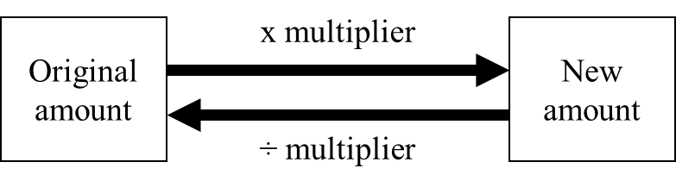

Questions:
1. Loft insulation reduces annual heating costs by 20%.
After he insulated his loft, Curtley’s annual heating cost was £520.
Work out Curtley’s annual heating cost would have been, if he had not insulated his loft.

£ ...........................................................
(Total 3 marks)

2. In a sale, normal prices are reduced by 20%.
SALE - 20% OFF
Andrew bought a saddle for his horse in the sale.
The sale price of the saddle was £220.
Calculate the normal price of the saddle.

£ ...........................................................
(Total 3 marks)

3. Hajra’s weekly pay this year is £240
This is 20% more than her weekly pay last year.
Bill says ‘This means Hajra’s weekly pay last year was £192’.
Bill is wrong,
(a) Explain why.

.......................................................................................................................................

.......................................................................................................................................
(1)
(b) Work out Hajra’s weekly pay last year.

£ ...........................................................
(2)
(Total 3 marks)
4. The price of all rail season tickets to London increased by 4%.
(a) The price of a rail season ticket from Cambridge to London increased by £121.60
Work out the price before this increase.

£ ...........................................................
(2)
(b) After the increase, the price of a rail season ticket from Brighton to London was £2828.80
Work out the price before this increase.

£ ...........................................................
(3)
(Total 5 marks)

5. In a sale, normal prices are reduced by 25%.
The sale price of a saw is £12.75
Calculate the normal price of the saw.

£ ...........................................................
(Total 3 marks)

6. In a sale, normal prices are reduced by 12%.
The sale price of a DVD player is £242.
Work out the normal price of the DVD player.

£ ...........................................................
(Total 3 marks)

7. A garage sells cars.
It offers a discount of 20% off the normal price for cash.
Dave pays £5200 cash for a car.
Calculate the normal price of the car.

£ ...........................................................
(Total 3 marks)
Useful websites:

www.mathswatchvle.com

www.methodmaths.com

www.hegartymaths.com

www.mymaths.co.uk

www.drfrost.com

www.bbc.co.uk/schools/gcsebitesize
/maths

Remember: Do your best;
it is all you can do ☺

